CIS 3g Accommodation Plan Entry Screen Graphic for Reasonable Accommodation, Reasonable Modification in Policies, Practices, or Procedures, and Auxiliary Aids and Services (RA/RM/AAS)
CIS 3g Wellness and Accommodation Plan and Notes Entry Screen
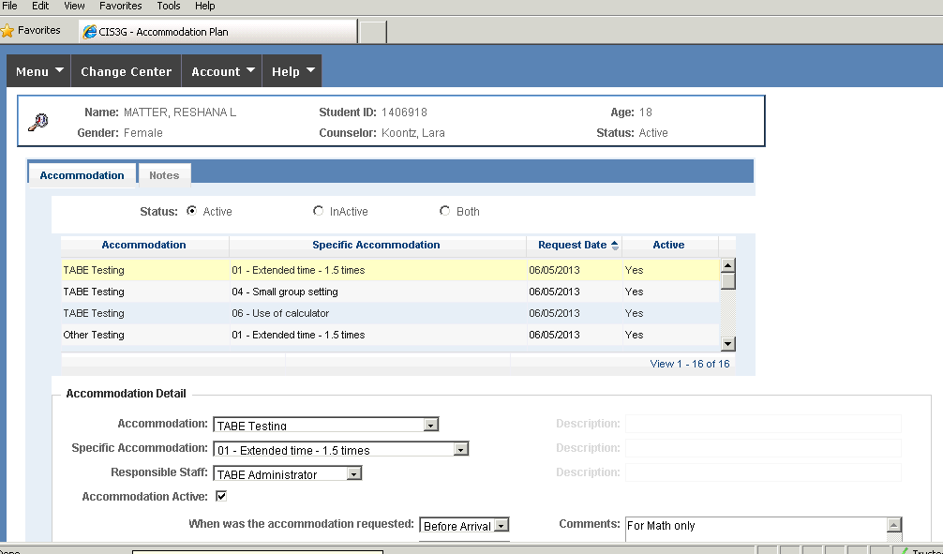
Notes Tab
Purpose: Allows Disability Coordinator and/or designee to document the Disability Accommodation process for students with accommodation plans. Notes should include pre-entry contact information, updates on effectiveness, Disability Accommodation Committee (DAC) meetings with the student and transition meetings.
Who Can Access: Only Disability Coordinator(s) and/or designee.
Authorization in CIS: WelAcc - Accommodation Plan, Module: Health & Wellness

Accommodation Plan Entry Drop-Down Menu
Purpose: Allows Disability Coordinator and/or designee to enter approved RA/RM/AAS for a student with a disability. Diagnostic information or specifics of the underlying condition must not be included.
Who Can Access: Only Disability Coordinator(s) and/or designee.
Authorization in CIS: WelAcc - Accommodation Plan, Module: Health & Wellness

Accommodation Drop Down Options
Accommodation:  TABE | Accommodation:  Instructional/Assignment | Accommodation:  Behavioral | Accommodation:  Assistive Technology | Accommodation:  Organizational
Specific Accommodation:  01 - Extended time - 1.5 times  02 - Double time  03 - Unlimited time  04 - Small group setting  05 - Secluded testing  06 - Use of calculator  07 - Accessible format  08 - Proctor read test  09 - Audio-taped administration  10 - Frequent breaks  11 - Adapted equipment  12 - Accessible seating  13 - Shorter but more frequent testing periods  14 - Clarify Directions  15 - Read Directions  16 - Repeat Directions | Specific Accommodation:  01 - Verification of understanding of instructions, rules, assignments  02 - Movement breaks  03 - Break large projects/assignments into smaller sections  04 - Instructional supports  05 - Reduced content  06 - Increased wait time for responses  07 - Consumables-questions & answer spaces on same page  08 - Study guides  09 - Copies of notes  10 - Extended time for assignment completion  11 - Avoid penalizing for poor penmanship/spelling  12- Provide teacher note/key points from board/presentation | Specific Accommodation:  01 - Rules/expectations in accessible format  02 - Verification of understanding of expectations, rules, consequences.  03 - Student/staff cues for need of time-out or break or to re-direct often  04 - Time-out/break area  05 - Positive behavior supports  06 - Feedback on progress  99 - Other | Specific Accommodation:  01 – Computer for word processing or other task completion  02 – Calculator  03 – Graph paper  04 – Highlighter  05 – Reading pen  06 – Reading support with voice output (e.g., software)  07 – Video tapes of lessons  08 – Audio tape of course content or other center materials  09 – Books on tape  10 – Speech input software (Dragon Naturally Speaking)  11 – Writing Software  12 – Talking adaptive devices  13 – Adaptive Equipment  14 – General adaptations  15 - Adaptive resource materials  16 – Adaptive combination locks  17 - Dictionary/Thesaurus, Spell Checker  99 - Other | Specific Accommodation:  01 - Planners  02 - Graphic organizers  03 - Checklists (e.g. dorms tasks, daily tasks, assignment checklist)  04 - Pocket notebook for directions/tasks  99- Other
Accommodation:  Other Testing | Accommodation:  Personal Supports | Accommodation:  Environmental | Accommodation:  Communication | Accommodation:  Other
Specific Accommodation:  01 - Extended time - 1.5 times  02 - Double time  03 - Unlimited time  04 - Use of calculator  05 - Simplify or clarify directions  06 - Read directions to student  07 - Frequent breaks  08 - Small group setting  09 - Secluded/Private testing  10 - Audio-taped administration  11 - Proctor read test  12 - Alternate/Accessible format  13 - Student provide oral responses to test items  14 - Multiple testing periods  15 - Accessible seating  16 - Schedule test at specific time of day  17 - Tape recorder to record writing assessment  18 - Adapted equipment  19 - Other | Specific Accommodation:  01 - Buddy/Mentor  99 - Other | Specific Accommodation:  01 - Pass  02 - Preferential seating  03 - Distraction free space  04 - Modified schedule  05 - Headphones  06 - Adaptive seating/furniture/workspace  07 - Dormitory-related  08 - Special lighting  99 - Other | Specific Accommodation:  01- Sign language interpreter  02- Relay services  03- i-communicator  04 - Alternate format  05 - Closed caption  99 - Other | Specific Accommodation:

