NAVIGATING DISABILITY DATA AND ACCOMMODATION PLANS IN CIS3G

CIS 3g Wellness and Accommodation Disability Data Collection Entry Screen

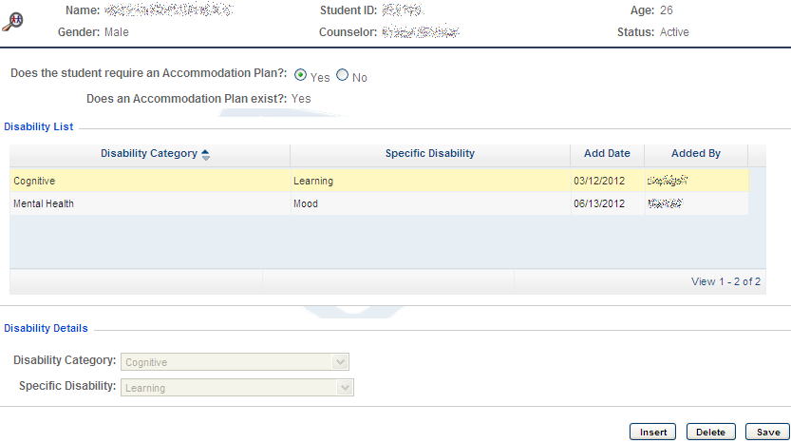
Disability Data Entry Drop-Down Menu
Purpose: Allows Disability Coordinator(s) to enter disability-related data on each student with a disability who enrolls in Job Corps regardless of whether an accommodation plan is provided.
Who Can Access: Only Disability Coordinator(s).
Authorization in CIS: WelAcc - Disability Data Collection, Module: Health & Wellness

CIS 3g Wellness and Accommodation Plan and Notes Entry Screen

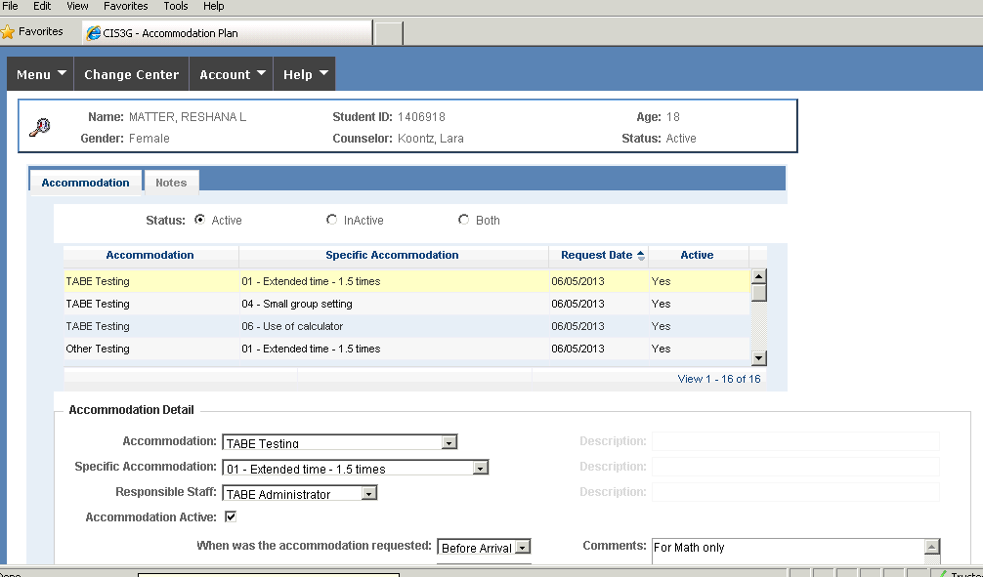
Accommodation Plan Entry Drop-Down Menu
Purpose: Allows Disability Coordinator and/or designee to enter approved Reasonable Accommodation, Reasonable Modification in Policies, Procedures, or Practices, and Auxiliary Aids and Services (RA/RM/AAS) for a student with a disability.
Who Can Access: Only Disability Coordinator(s) and/or designee.
Authorization in CIS: WelAcc - Accommodation Plan, Module: Health & Wellness.

Notes Tab
Purpose: Allows Disability Coordinator and/or designee to document the Disability Accommodation process for students with accommodation plans. Disability accommodation notes should “read like a book,” detailing the disability accommodation process from what occurred prior to entry until separation. This would include initial Disability Accommodation Committee (DAC) calls/meetings, subsequent Disability Accommodation Committee calls/meetings, accommodation effectiveness reviews, etc.
Who Can Access: Only Disability Coordinator(s) and/or designee.
Authorization in CIS: WelAcc - Accommodation Plan, Module: Health & Wellness

CIS 3g Wellness and Accommodation Plan and Notes Entry Screen

Disability Accommodations Active/Inactive
Purpose: Allows Disability Coordinator and/or designee to communicate with staff implementing the RA/RM/AAS, if the RA/RM/AAS is ‘active’ and needs to be implemented or ‘inactive’ and no longer needed to be implemented.
Who Can Access: Only Disability Coordinator(s) and/or designee.
Authorization in CIS: WelAcc - Accommodation Plan, Module: Health & Wellness.

Comments Section
Purpose: Allows Disability Coordinator and/or designee to specify the RA/RM/AAS staff are being asked to implement. This information is visible to all staff; and therefore, should not contain protected health/disability information (e.g., diagnosis, other medical information).
Who Can Access: Only Disability Coordinator(s) and/or designee.
Authorization in CIS: WelAcc - Accommodation Plan, Module: Health & Wellness.
Responsible Staff
Purpose: Allows Disability Coordinator and/or designee to document what staff/departments should be implementing the RA/RM/AAS listed.
Who Can Access: Only Disability Coordinator(s) and/or designee.
Authorization in CIS: WelAcc - Accommodation Plan, Module: Health & Wellness.

Example Accommodation Plan with Notes
Comment Added to Specify the
RA/RM/AAS the Student Needs

Staff Identified as Responsible for Implementing the RA/RM/AAS
Notes Documenting the Disability
Accommodation Process

Accommodation and Specific Accommodation Selected from the Drop- Down Boxes

