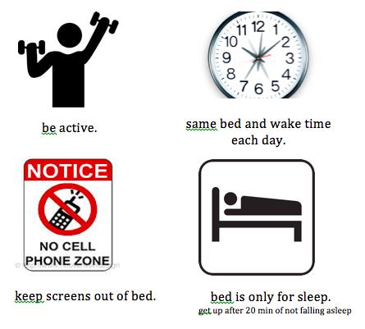

**SLEEP!**
**SLEEP!**

**SLEEP!**
**SLEEP!**
- Hungry? Have a small snack before bed  - Stressed? Write down your thoughts before you get into bed or talk to a close friend/family.  - Roommate Drama? Write down your concerns and ask to have a mediation meeting with your RA or Counselor or at Health and Wellness  - Using caffeine or alcohol? Refrain from consuming any after 2pm  - Can’t sleep? Get out of bed after 20 minutes of trying, sit on the floor and read a boring book or something you’ve read before. Get back in bed when you are tired.  - Tired at 4pm but not 10pm? Do not nap – go work out / get some exercise or eat a little food. Keep yourself up until the time you want to go to bed.  Make your room as much like a cave as possible: cool, dark, quiet. Have fun with your roommates to have a night time routine to create-the-cave.  **ZZZZZs**  - Hungry? Have a small snack before bed  - Stressed? Write down your thoughts before you get into bed or talk to a close friend/family.  - Roommate Drama? Write down your concerns and ask to have a mediation meeting with your RA or Counselor or at Health and Wellness  - Using caffeine or alcohol? Refrain from consuming any after 2pm  - Can’t sleep? Get out of bed after 20 minutes of trying, sit on the floor and read a boring book or something you’ve read before. Get back in bed when you are tired.  - Tired at 4pm but not 10pm? Do not nap – go work out / get some exercise or eat a little food. Keep yourself up until the time you want to go to bed.  Make your room as much like a cave as possible: cool, dark, quiet. Have fun with your roommates to have a night time routine to create-the-cave.  **ZZZZZs** | - Hungry? Have a small snack before bed  - Stressed? Write down your thoughts before you get into bed or talk to a close friend/family.  - Roommate Drama? Write down your concerns and ask to have a mediation meeting with your RA or Counselor or at Health and Wellness  - Using caffeine or alcohol? Refrain from consuming any after 2pm  - Can’t sleep? Get out of bed after 20 minutes of trying, sit on the floor and read a boring book or something you’ve read before. Get back in bed when you are tired.  - Tired at 4pm but not 10pm? Do not nap – go work out / get some exercise or eat a little food. Keep yourself up until the time you want to go to bed.  Make your room as much like a cave as possible: cool, dark, quiet. Have fun with your roommates to have a night time routine to create-the-cave.  **ZZZZZs**  - Hungry? Have a small snack before bed  - Stressed? Write down your thoughts before you get into bed or talk to a close friend/family.  - Roommate Drama? Write down your concerns and ask to have a mediation meeting with your RA or Counselor or at Health and Wellness  - Using caffeine or alcohol? Refrain from consuming any after 2pm  - Can’t sleep? Get out of bed after 20 minutes of trying, sit on the floor and read a boring book or something you’ve read before. Get back in bed when you are tired.  - Tired at 4pm but not 10pm? Do not nap – go work out / get some exercise or eat a little food. Keep yourself up until the time you want to go to bed.  Make your room as much like a cave as possible: cool, dark, quiet. Have fun with your roommates to have a night time routine to create-the-cave.  **ZZZZZs**

