## Job Corps Chronic Care Management Plan



# ASTHMA: A FACT SHEET FOR STUDENTS

What is asthma?

Asthma (AZ-ma) is a chronic (long-term) lung disease that inflames and narrows the airways. Asthma causes recurring periods of wheezing (a whistling sound when you breathe), chest tightness, shortness of breath, and [coughing](http://www.nhlbi.nih.gov/health/health-topics/topics/cough/). The coughing often occurs at night or early in the morning.

Asthma affects people of all ages, but it most often starts during childhood. In the United States, more than 22 million people are known to have asthma. Nearly 6 million of these people are children.

**Overview**

The [airways](http://www.nhlbi.nih.gov/health/health-topics/topics/hlw/) are tubes that carry air into and out of your lungs. People who have asthma have inflamed airways. This makes the airways swollen and very sensitive. They tend to react strongly to certain inhaled substances and should identify and avoid triggers (e.g., colds, allergens, pollen, tobacco smoke, cold air). Asthma can also be triggered by exercise.

When the airways react, the muscles around them tighten. This narrows the airways, causing less air to flow into the lungs. The swelling also can worsen, making the airways even narrower. Cells in the airways may make more mucus than normal. Mucus is a sticky, thick liquid that can further narrow your airways.

This chain reaction can result in asthma symptoms.

Sometimes, asthma symptoms are mild and go away on their own or after minimal treatment with an asthma medicine. Other times, symptoms continue to get worse.

Two types of inhalers are available, one for quick relief of symptoms and one for daily use for control or prevention of symptoms.

When symptoms get more intense and/or more symptoms occur, you're having an asthma attack. Asthma attacks also are called flareups or exacerbations (eg-zas-er-BA-shuns).

It's important to treat symptoms when you first notice them. This will help prevent the symptoms from worsening and causing a severe asthma attack. Severe asthma attacks may require emergency care, and they can be fatal.

**Outlook**

Asthma can't be cured. Even when you feel fine, you still have the disease and it can flare up at any time.

However, with today's knowledge and treatments, most people who have asthma are able to manage the disease. They have few, if any, symptoms. They can live normal, active lives and sleep through the night without interruption from asthma.

You can take an active role in managing your asthma. For successful, thorough, and ongoing treatment, build strong partnerships with your doctor and other health care providers.

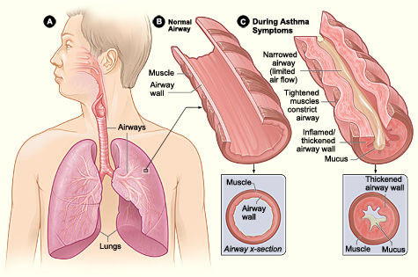

Figure A shows the location of the lungs and airways in the body. Figure B shows a cross-section of a normal airway. Figure C shows a cross-section of an airway during asthma symptoms.