## Job Corps Chronic Care Management Plan

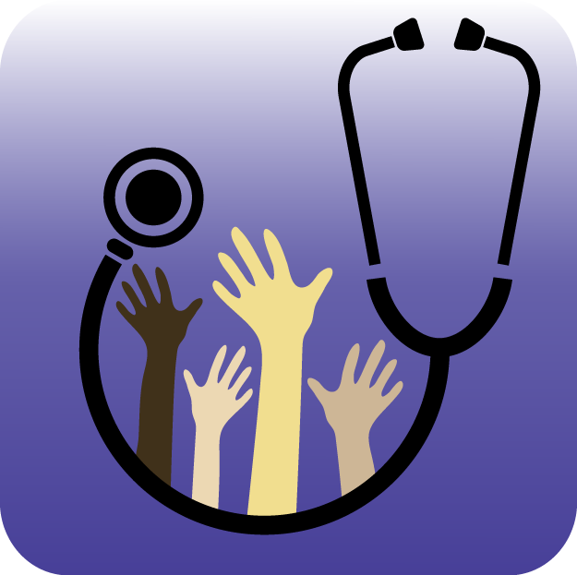

# DIABETES: A FACT SHEET FOR STUDENTS

What is diabetes?

Diabetes is a disease in which blood glucose levels are above normal. Most of the food we eat is turned into glucose, or sugar, for our bodies to use for energy. The pancreas, an organ that lies near the stomach, makes a hormone called insulin to help glucose get into the cells of our bodies.



When you have diabetes, your body either doesn't make enough insulin or can't use its own insulin as well as it should. This causes sugar to build up in your blood. Diabetes can cause serious health complications including heart disease, blindness, kidney failure, and lower-limb amputations. Diabetes is the seventh leading cause of death in the United States.

What are the types of diabetes?

Type 1 diabetes, which was previously called insulin-dependent diabetes mellitus (IDDM) may account for about 5% of all diagnosed cases of diabetes.

Type 2 diabetes, which was previously called non-insulin-dependent diabetes mellitus (NIDDM) may account for about 90% to 95% of all diagnosed cases of diabetes. Being overweight can greatly increase your risk of developing Type 2 diabetes.

What is the treatment for diabetes?

Healthy eating, physical activity, and insulin injections are the basic therapies for Type 1 diabetes. The amount of insulin taken must be balanced with food intake and daily activities. Blood glucose levels must be closely monitored through frequent blood glucose testing.

Healthy eating, physical activity, weight loss, and blood glucose testing are the basic therapies for Type 2 diabetes. In addition, many people with Type 2 diabetes require oral medication, insulin, or both to control their blood glucose levels.

People with diabetes must take responsibility for their day-to-day care, and keep blood glucose levels from going too low or too high. They should see a health provider who will monitor their diabetes control and help them learn to manage their diabetes. In addition, people with diabetes may see specialists in diabetes care, eye care and foot care, as well as dietitians and diabetes educators who teach the skills needed for daily diabetes management.

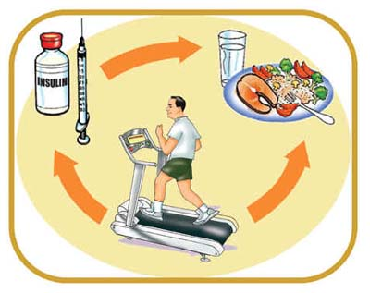

<http://www.cdc.gov/diabetes/consumer/learn.htm>