## Job Corps Chronic Care Management Plan

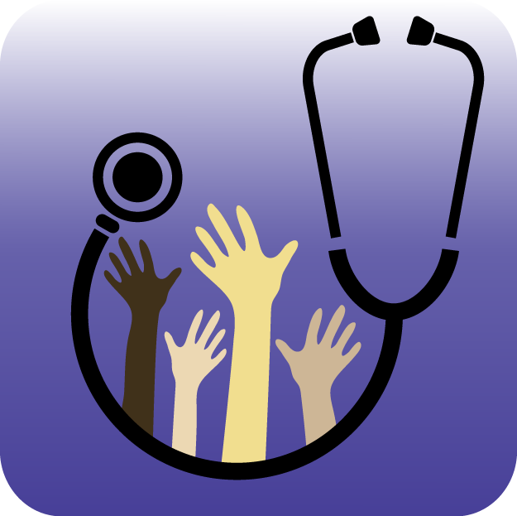

# EPILEPSY/SEIZURES: A FACT SHEET FOR STUDENTS

What is epilepsy?

Epilepsy is a disorder of the brain defined as having two or more seizures. The seizures happen when nerve cells in the brain signal abnormally, which may briefly alter a person’s consciousness, movements, or actions.

Epilepsy affects people of all ages, races and countries.

Epilepsy is not contagious.

Epilepsy can begin at any time of life.

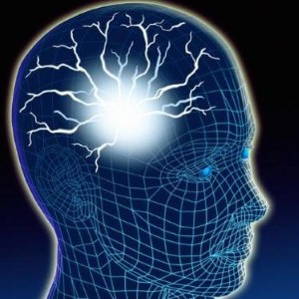

While medications and other treatments help many people who live with epilepsy, people continue to have seizures that can severely limit their school achievements and employment.

Women should consult their doctor before becoming pregnant, so that the safest treatment regimens can be prescribed. The vast majority of women with epilepsy have normal, healthy babies.

Despite major progress in diagnosis and treatment, many people continue to have misunderstandings about epilepsy. That is why awareness—and talking about it—is so important.

Self-help measures

Try to avoid known trigger factors for seizures. This may mean eating regular meals, trying to control stress, getting enough sleep, and taking your medication regularly.

Always tell the pharmacist you are taking medication for epilepsy before buying over-the-counter medicines. Some of these can interact with your treatment.

If your epilepsy cannot be controlled completely, think about safety in your surroundings and possible changes you can make.

* Transportation
* No driving unless seizures are well controlled for an interval specified by state DMV
* Wear bicycle helmets and protective gear
* Stay clear of the platform edge when using public transportation
* Bathroom safety
* Showering instead of bathing
* Shatterproof glass in shower doors
* Shatterproof bottles (shampoo, etc.)
* No electrical equipment near water
* Non-skid strips in shower stall
* Kitchen safety
* Cook with a partner
* Use back burners of the stove to prevent burns
* Use shatterproof containers
* Limit use of knives and other sharp kitchen utensils

Try not to let epilepsy prevent you from doing everyday things in your life. Most people with epilepsy lead full and active lives.

First aid for seizures involves responding in ways that can keep the person safe until the seizure stops by itself:

* Keep calm and reassure other people who may be nearby
* Prevent injury by clearing the area around the person of anything hard or sharp
* Ease the person to the floor and put something soft and flat, like a folded jacket, under his/her head
* Remove eyeglasses and loosen ties or anything around the neck that may make breathing difficult
* Do not hold the person down or try to stop his/her movements
* Do not put anything in the person’s mouth
* Turn the person gently onto one side. This will help keep the airway clear

<http://www.epilepsyfoundation.org/resources/newsroom/upload/WhatisEpilepsy.pdf>