## Job Corps Chronic Care Management Plan

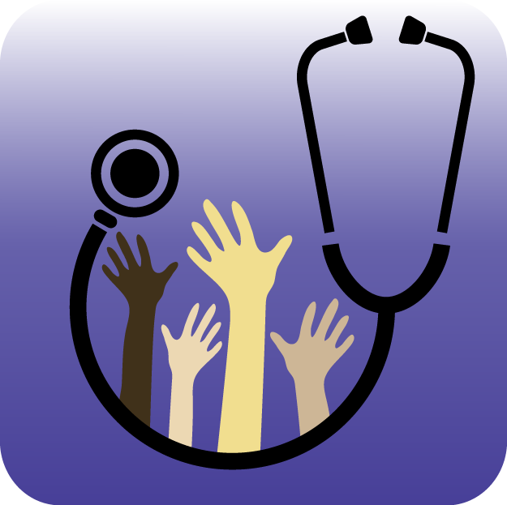

# HIV Infection/AIDS: A FACT SHEET FOR STUDENTS

What is HIV?

The human immunodeficiency virus (HIV) attacks the body’s immune system. A healthy immune system is what keeps you from getting sick. Because HIV damages your immune system, you are more likely to get sick from bacteria and viruses. It is also harder for your body to fight off these infections when you do get them, so you may have trouble getting better sooner. HIV is the infection that causes acquired immunodeficiency syndrome (AIDS). But people with HIV can take medicines to control the virus, keep their immune system strong, and stay healthy for many years.

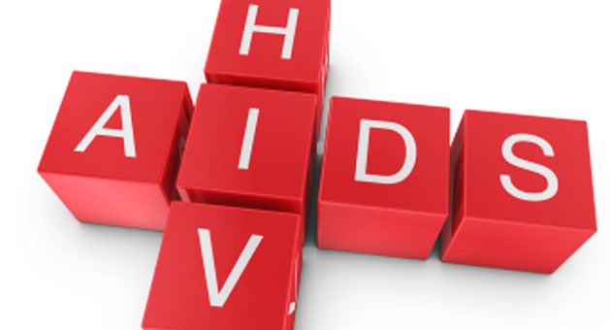

What is AIDS?

AIDS is a progression of HIV infection. When HIV moves into its later stages, it is considered to be AIDS. People who have AIDS are at an even higher risk of getting sick, and their bodies are even less able to fight off infections. They may die of an infection or cancer.

What happens after a person gets HIV infection?

After being infected with HIV, your body works hard to attack the virus. The usual blood tests will be normal. However, during this time, the virus is still attacking your body’s immune system.

Over approximately 10 years, untreated HIV infection can kill so many CD4 cells (CD4 cells are cells that help your body fight infections) that your body can no longer fight off infections. When your CD4 cell count is 200 or less, you have AIDS (a normal count is 600-1000). Once you have AIDS, you can easily catch many serious infections.

How is HIV treated and managed?

There are several different kinds of medicines to help treat HIV infection but there is no cure. Different kinds of drugs (called anti-retroviral medicines) are often combined to help reduce the amount of the HIV virus in the body. Your doctor will often watch how these medicines affect you, check for new symptoms, and follow your CD4 count as well as other laboratory tests.

Always tell your doctor if you experience any new symptoms such as nausea, vomiting, fatigue, fever, headache, chills, night sweats, cough, shortness of breath, or diarrhea. Other signs such as weight loss, mouth sores (such as thrush, which is a yeast infection) or bigger lymph nodes (glands located in your neck, armpits, and groin) should also be reported to your doctor.

What can I do to prevent spreading HIV to other people?

You should be honest with your sexual partners and tell them that you have HIV infection. You can reduce the chance of spreading HIV to other people by using a condom every time you have vaginal, anal, or oral sex, and by not sharing razors or toothbrushes or drug needles and syringes.

Source: FamilyDoctor.org, Up To Date