## Job Corps Chronic Care Management Plan



# TOBACCO CESSATION: A FACT SHEET FOR STUDENTS

Why should I quit tobacco use?

Quitting tobacco use can improve your health, but it can be hard. It can lower your chances of getting or dying from heart disease, lung disease, or cancer. It can also lower your chances of getting brittle bones. It can help your skin look younger and your teeth healthier without tobacco stains. There are nicotine replacement therapies, medicines, and counseling that can make it easier. Talk to your doctor about which option is best for you.

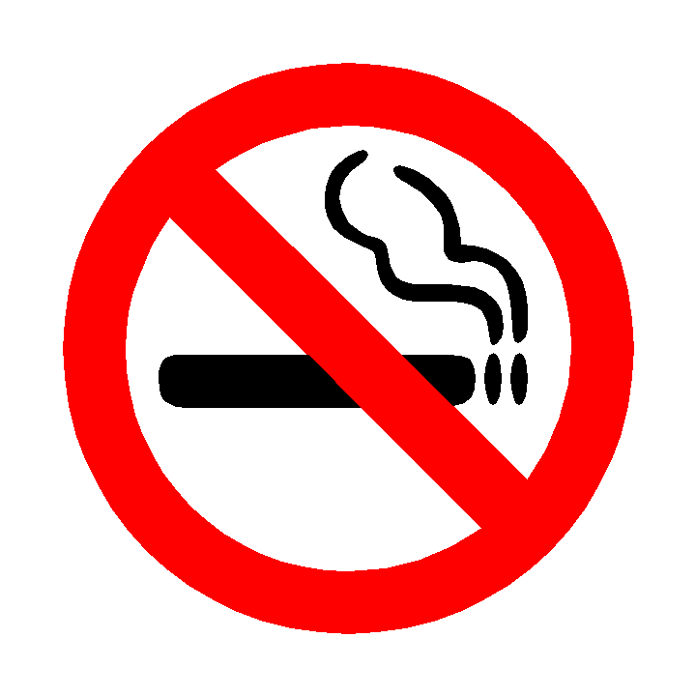

What can I do to quit tobacco use?

Enrolling in your center’s Tobacco Use Prevention Program (TUPP) can be helpful in your quest to quit tobacco. The program promotes a tobacco-free environment through educational materials and activities that support delay or cessation of tobacco use.

Nicotine replacement therapies or NRTs contain less nicotine than cigarettes. Replacing cigarette or nicotine products with an NRT can help lessen cravings and ease withdrawal symptoms. NRTs are available as skin patches, chewing gum, nasal sprays, inhalers, and lozenges. You can buy some of them over the counter.

If you smoke more than 10 cigarettes per day, an NRT may be a good option for you. It is important to follow the package directions to make sure that you are using the right amount. If you use other forms of nicotine, such as chewing tobacco or cigars, you should also talk to your doctor about the right form of NRT for you.

If you are younger than 18 years old, are pregnant or breastfeeding, or have serious health conditions (for example, diabetes or heart, lung, kidney, or liver disease), you should talk to your doctor about the safety of using an NRT.

Will there be side effects when I stop tobacco use?

Withdrawal is your body’s reaction to not getting nicotine after it has become used to it. Symptoms of withdrawal vary in different people. You may feel irritable, nervous, jittery, or sleepy. You may have trouble concentrating or sleeping. Some people may feel more hungry than usual. These symptoms are usually worse during the first week after you quit. They may last two weeks to one month.

Nervousness is one of the most common side effects, but you may also become nervous because you know you are tackling a difficult habit. The effects of caffeine, including nervousness, are more severe after you stop using nicotine.

Some people feel down because they miss smoking or chewing tobacco. If you have had depression in the past, quitting tobacco may trigger it again. If you feel depressed, you should talk to your doctor about your symptoms.

Many people gain a small amount of weight gain when they quit smoking (usually no more than 10 pounds). You may eat more than usual as a substitute for smoking. Planning out healthy meals and exercising more can help you prevent weight gain.