Guidance on Entrance Health and Wellness Services for Students Returning
to Job Corps from Virtual Learning

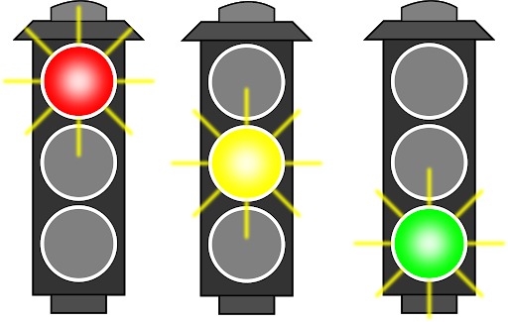
The following table provides guidance for administering health and wellness services to students who were enrolled in Job Corps prior to COVID-19, engaged in virtual learning, then returned to center.

These students received complete health and wellness services on entry to Job Corps. The physical exam and most medical tests do not need to be repeated, though may be offered to students, as it has been over a year since these services were originally performed.

Recommendation for Returning Students | PRH 2.3 R2 Requirements for New Students  Notes and Rationale
Do not repeat | - ETA 6-53 Job Corps Health Questionnaire  This document is completed prior to entrance and is part of the student’s permanent record.  - Sickle cell screening  Screening results will not change; needed once only.  - Pap smear (females > age 21)  New clinical guidelines advise no cervical cancer screening until age 25 years.  - Entry Drug Testing  An entry drug test is conducted only upon a student’s initial entrance to Job Corps. Follow-up and suspicion drug tests may be completed.

Recommendation for Returning Students | PRH 2.3 R2 Requirements for New Students  Notes and Rationale
Repeat if clinically indicated  (or may encourage repeat testing) | - Job Corps Health History Form  Students have been off center since March 2020 and their health information may have changed. Document changes to health history in Student Health Record, including medications and chronic illnesses.  - Complete physical examination  Offer if > 12 months since initial examination. Required annually only for contact sports participation.  - Hemoglobin or hematocrit  Values are normally stable; repeat for clinical indications only.  - HIV antibody test  Encourage repeat test based upon risk assessment. Required to consider HIV pre-exposure prophylaxis (PrEP).  - Syphilis serology (optional)  Optional to repeat if risk factors. Consider if syphilis prevalence high in community of origin.  - Urine dipstick for glucose/protein  Repeat if clinically indicated.  - Urine dipstick for leukocyte esterase (males)  Repeat if clinically indicated. If positive, send urine for gonorrhea and Chlamydia (males).  - Urine test for Chlamydia  Encourage repeat testing. CDC recommends annual screening for sexually active females age 25 or younger. During pandemic, there has been limited access to screening.  - Urine test for Gonorrhea  Encourage repeat testing. During pandemic, there has been limited access to screening.  - Urine pregnancy test  Repeat if clinically indicated.  - Dental readiness inspection  Offer if > 12 months since initial examination.  - TEAP Formalized Assessment  Repeat if clinically indicated. TEAP specialist to conduct a formalized assessment on any student who scores a 2 or more on the CRAFFT of the updated SIF as well as any student with a positive entry urine drug screen.  - Health Education during Career Preparation Period (CPP)  Repeat information or center processes that have changed.  - Immunizations  Ensure vaccinations are up to date. Most students should be up to date on vaccinations. Offer boosters as needed.

Recommendation for Returning Students | PRH 2.3 R2 Requirements for New Students  Notes and Rationale
Repeat | - Tuberculin (TB) testing  Repeat if > 12 months since last test. TB screening reduces risk of infectious disease in a residential program.  - Social Intake Form (SIF)  Review the previously completed Social Intake Form (SIF) in the SHR with students. Students have been off center since March 2020 and their health information may have changed.  - Mental Health Assessments for Referred Students  Students have been off center since March 2020 and their mental health information may have changed.  - Mental Health Promotion/Education during Career Preparation Period (CPP). Remind students how to access mental health services and how to recognize and respond to a mental health crisis.  - Screening for substance use risk via MAST and DAST. Students have been off center since March 2020 and their substance use may have changed.  - TUPP Referral  Offer referral to TUPP for students identified as tobacco users.

Note: Entry drug screening should be performed only if test has not occurred.
For students currently on center who did not have an entry drug screen collected, collect the entry drug test immediately. If positive on this entry drug test, provide the PRH-required intervention services then conduct the follow-up drug test in 37-40 days.
For returning students who did not have an entry drug screen collected, collect the entry drug test within one day of return to center. If positive on this entry drug test, provide the PRH-required intervention services then conduct the follow-up drug test in 37-40 days.

