SYMPTOMATIC MANAGEMENT GUIDELINES FOR NON-HEALTH STAFF
BEHAVIOR CHANGES/UNUSUAL BEHAVIOR
Authorized non-health staff may manage changes in behavior or unusual behavior as follows:

WHAT TO DO FIRST
If Behavior is Obviously Dangerous or Threatening to Self/Others
- If the student is agitated or their behavior cannot be managed (due to risk of harm to self/others), take steps to ensure your safety and the student’s safety. For example, make sure that others are around, that you have access to a telephone, and can exit the room or area if needed. Do not leave the student unsupervised. If you must keep your distance, always keep an eye on the student. Contact center security for assistance or follow your center operating procedures (COP) for Mental Health Emergencies. Alert the health and wellness director (HWD).
- If the student expresses thoughts of harm to self or has made any suicidal gesture, follow the Suicidal Self-Directed Violence Symptomatic Management Guideline (SMG). Alert the HWD. Do not leave the student alone.
If Behavior is Not Dangerous, Just Strange or Unusual
Examples

- Student’s thoughts are odd, jumbled, strange or “crazy.”
- Student expresses ideas that do not seem to match reality such as:
- “My instructor/RA/roommate is trying to poison me.”
- “The cell phone towers are broadcasting my thoughts before I think them.”
- “Billie Eilish was talking directly to me and telling me what to do in her song.”
- “I got a Victory Royale in Fortnite and that was a sign that I’m the Chosen One for this world.”
- Student’s facial expressions do not match their conversation and mood (for example, they are laughing while talking about their best friend’s recent death)
- Student appears unable to move or looks to be in a trance without an obvious physical injury and does not respond to their name or repeated verbal commands
- Move the student to a private, supportive space where you can assess the student’s symptoms and behaviors and where the student will feel safe to talk. Alert the HWD.
- Give the student as much personal space and sense of control as possible.
- Take steps to avoid engaging in behaviors that the student may perceive as threatening. For example, allow the student to have adequate personal space and avoid situations where the student may feel trapped or blocked from leaving the area.
- Avoid offering advice, lecturing, or trying to “fix” the situation. Listening in a concerned way is the most helpful thing you can do to calm and comfort a student.
- Speak clearly and use short sentences in a calm tone of voice and without judgment. Ask the 6 yes/no screening questions for Behavior Changes/Unusual Behavior on the last page.
- If the student is willing to talk, allow the student to express their current feelings and concerns. Acknowledge the student’s feelings. For example, “I can see you’re having a hard time right now” or “I can see how that could be upsetting.”
- In a supportive and concerned way, share your observations and concerns with the student. If it is during normal business hours, explain to the student that you would like for them to go with you to the health and wellness center (HWC). Alert the HWD and share the information that you gathered from talking to the student. If the student is willing to go to the HWC, seek assistance from appropriate staff to escort the student to the HWC. If it is after hours or on the weekend, contact on-call health and wellness staff and follow instructions from on-call health staff, which may include transportation to the closest emergency facility. Do not leave the student alone.
- If the student is not willing to answer questions or go to the HWC, ask the student if they would be willing to talk with the center mental health consultant (CMHC) (if available) or if there is a trusted staff member who could provide support, then determine if that staff member is available to come assist. Alert the HWD. Contact center security for standby assistance or follow your COP for Mental Health Emergencies. If it is after hours or on the weekend, contact on-call health and wellness staff and follow instructions from on-call health staff, which may include transportation to the closest emergency facility. Do not leave the student alone.
Additional Considerations
- If alcohol or drug use is suspected, follow the Alcohol and Drug Use Behavior SMG.
- If the student shows signs of depression but is not stating that they want to harm themselves or no longer want to live, be supportive and refer the student to the HWC for further evaluation and intervention by the CMHC and/or center physician. If it is after hours or weekend, contact the on-call health and wellness staff for further consultation.
- Immediately alert HWD or on-call health staff:
- if the student shows signs of depression, mania (very energetic, pressured speech, not sleeping), or psychotic behavior (unusual thoughts and/or odd behaviors or dramatic changes in behaviors)
- if the student expresses the desire to hurt self/others
- if the student appears very confused

WHAT TO DO NEXT
- After the student has been taken care of, talk to other students who may have witnessed or been involved and provide reassurance that the student who was in distress is safe and getting help. Privacy rights must be protected. Do not share specific health information.
- After the episode has resolved (within 1-2 days), consult with health and wellness staff for information how to best support the student going forward.
- Take care of yourself. If you are feeling stressed or upset about the situation, consider contacting the center’s HR representative for information about Employee Assistance Program (EAP) services.

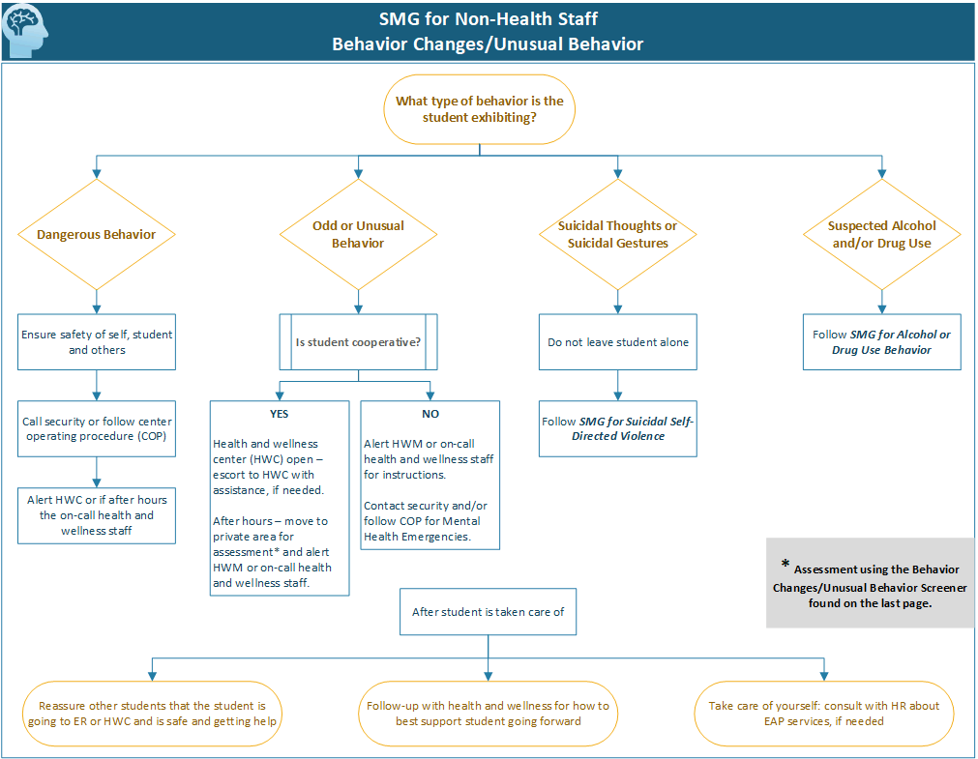

Behavior Changes/Unusual Behavior Screener*
Please answer each of the following brief questions by circling Yes or No.
- Have you been confused at times whether something you experienced was real or imaginary? | Yes No
- Do you hold beliefs that other people would find unusual or bizarre? | Yes No
- Have you felt that you are not in control of your own ideas or thoughts? | Yes No
- Do you feel that other people are watching you or talking about you? | Yes No
- Do you worry at times that something may be wrong with your mind? | Yes No
- Have you seen things that other people can't see or don't seem to see? | Yes No

* Taken from the Prodromal Questionnaire – Brief Version (PQ-B). Loewy, RL & Cannon, TD. (2010). The Prodromal Questionnaire, Brief Version (PQ-B). University of California

