Automated

Field
Testing
Interface
System

Job Corps AFTIS User Manual

Marian Tully ♦ Customer Service Manager  11603 Crosswinds Way, Suite 100  San Antonio, TX 78233  (888) 858-8663 Ext. 18104  Marian.Tully@cddmedical.com | Barbara Castro ♦ Account Administrator  11603 Crosswinds Way, Suite 100  San Antonio, TX 78233  (888) 858-8663 Ext. 11496  Barbara.Castro@cddmedical.com

Enrique “Henry” Silvas ♦ Account Administrator
11603 Crosswinds Way, Suite 100
San Antonio, TX 78233
(888) 858-8663 Ext. 11481

Silvas.Enrique@cddmedical.com

CDD AFTIS

CDD has developed an easy-to-use automated computer system for requesting laboratory tests. This system is known as the Automated Field Testing Interface System (AFTIS). This electronic requisitioning system allows you to requisition patient laboratory tests and check status of lab results at any time.

AFTIS was created to enhance the quality of services CDD provides to you. AFTIS is 100% HIPAA compliant and allows you to access patient information at your convenience, 24 hours per day, 7 days per week.

This manual provides detailed instructions on how to:

- Order Laboratory testing
- Ship Specimens to CDD
- Retrieve Patient Results
- Have CDD Bill Patient Insurance
- Track Supply Inventory
- Contact CDD for Support

And much more!!

AFTIS was designed using our client’s input. Enjoy, and please give us your feedback.

Table of Contents

Logging In To AFTIS…………………………………………………………………………………………………. | 4
AFTIS Navigation…………………………………………………………………………………………………….. | 5
Patient Entry……………………………………………………………….………………………………………….. | 6-17
Printing Barcodes……………………………………………………………………………………………………. | 18-19
Shipping Specimens………………………………………………………………………………………………… | 20-24
Patient Reports………………………………………………………………………………………………………. | 25
Retrieving Reports via Email…………………………………………………………………………………… | 26-28
Web Sign On – Advanced Search…………………………………………………………………………….. | 29-32
Web Sign On – Inventory………………………………………………………………………………………… | 33
Web Sign On – Updating Information……………………………………………………………………… | 34
Web Sign On – Forms & References……………………………………………………………………….. | 35-36
End of Day………………………………………………………………………………………………………………. | 37

Logging In To AFTIS

By Clicking on the CDD AFTIS icon on your desktop, you will be directed to the AFTIS – Login Screen.

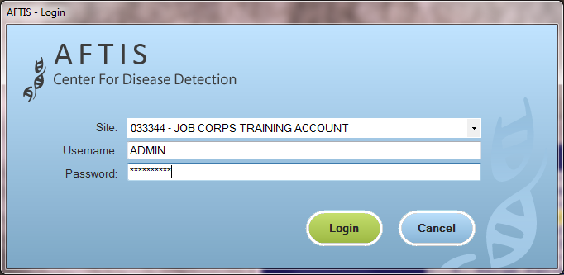

Note: Authorized personnel at each site are given a unique, secure Username and Password. If you do not have a Username and/or Password, please contact CDD Client Care.

1. Enter Username & Password (Case Sensitive)
2. Click “Login”

After successfully logging in to the CDD AFTIS software, you will be directed to the Patient Entry screen to begin inputting patient and test information.

AFTIS Navigation

At the top of the CDD AFTIS screen are the Menu Bar and the Icon Navigation Buttons.

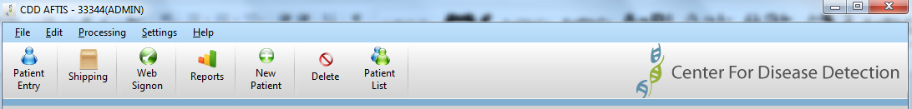

Menu Bar

The Menu Bar contains the following:
- File
- Edit
- Processing
- Settings
- Help

Icon Navigation Buttons

The Icon Navigation Buttons may vary depending on what screen is being displayed in the software. The three main options that will display are the following:
- Patient Entry
- Shipping
- Web Signon

Other icons will include:
- Patient List
- Reports
- New/Delete Patients
- Shipment Manifest
- New/Delete Shipments

Each of these tools, and when to use will be discussed during the appropriate section in the User Manual.

Patient Entry Screen

Registering Patients and Ordering Tests

This window gives you the opportunity to pre-register future patients or register waiting patients. You will complete all patient information as well as select the appropriate tests. Fields shaded in light green are required, white fields are optional.

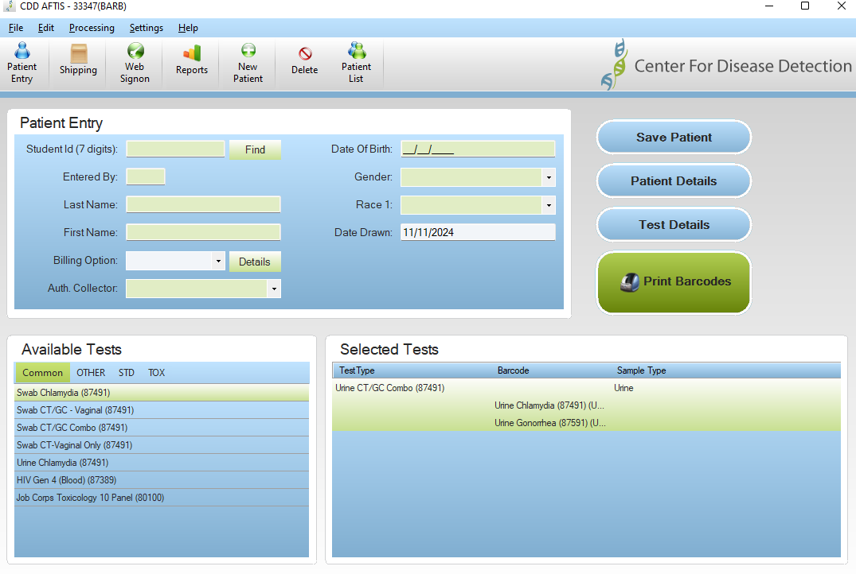

Required fields may vary from the screen above based on your specific site set up, available tests and state requirements for surveillance reporting.

Navigation Tip: You can use your mouse to click on a field to enter data or tab from field to field on the Patient Entry screen. Drop down lists contain specific values that may be selected.

Patient Entry

Patient demographics and collection information are entered in the Patient Entry section.

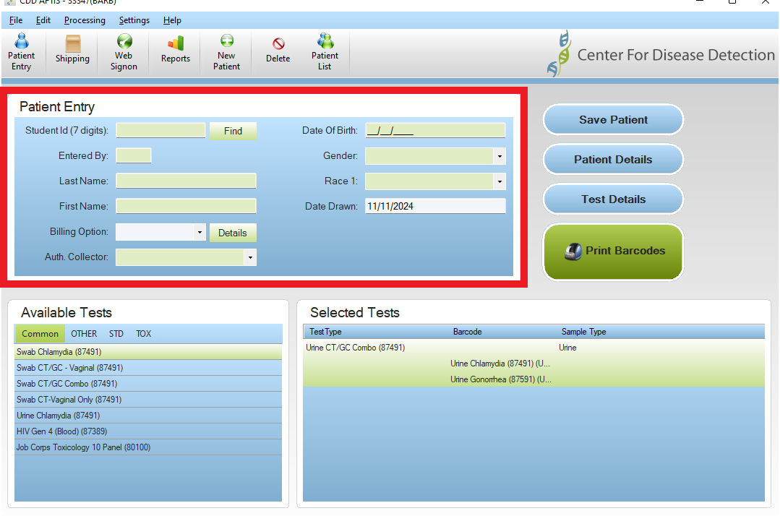

Once you have entered the patient’s information, click on Save Patient to save the information. Utilizing a clinic assigned Patient ID and clicking on the Find button, previously entered patient demographics will be displayed. This will reduce data entry time in the future.

Note: Additional patient information may be required depending on certain test selections. These required fields will appear in the Test Details or the Patient Details sections within the Patient Entry Screen.

The Date Drawn field will default to today’s date (based on your current PC date/time setting), but may be manually entered for up to 3 days in advance or 21 days in the past.

Available Tests

In this section you will find a listing of all test(s) that are available to the patient along with the CPT Code for the test. Once the information in Patient Entry has been completed, select the test(s) to be ordered by double clicking on the test in the Available Tests section.

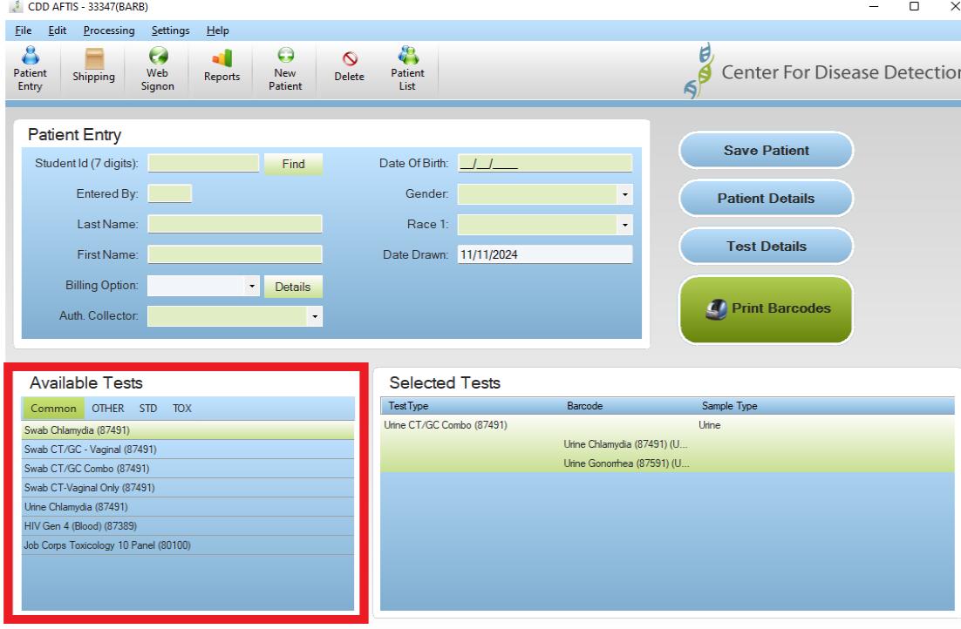
CPT Code

Once an Available test has been selected, the test will be moved over to the next section on the patient entry screen, Selected Tests.

Note: There are multiple tabs for your site’s contracted tests with CDD. Additional tests may be listed under different tabs. The Common tab can be customized for your site by contacting CDD Client Care.

Selected Tests

By double clicking on the desired test(s) under the Available Test section, they will be listed in the Selected Tests Section, along with the Sample Type required for that particular test (Urine Cobas, 4 ml SST, etc.).

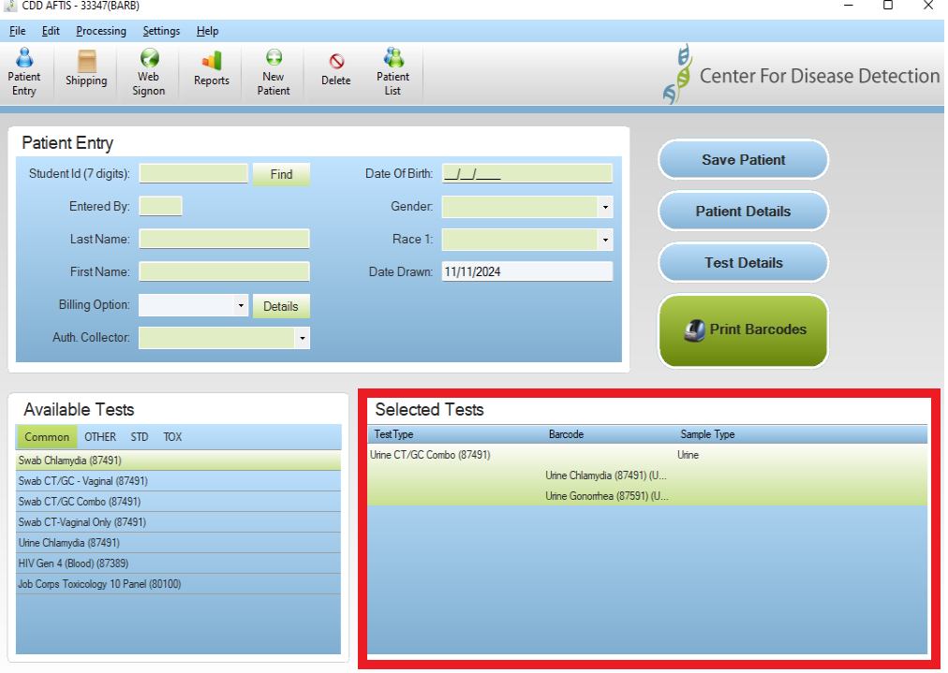

Save Patient Button

At any time during the patient entry process, your work may be saved by clicking on the Save Patient Button.

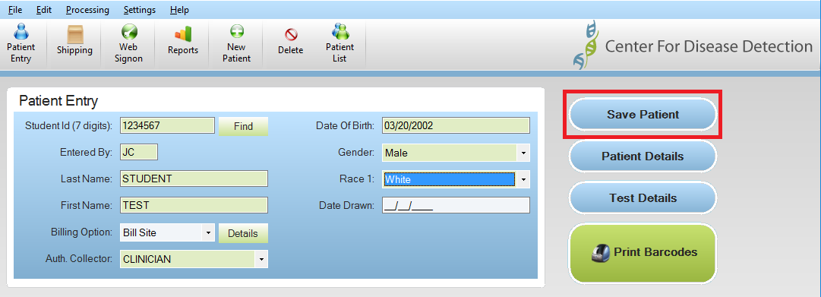

Once the Patient information has been saved, all fields on the Patient Entry screen will clear so that the next patient may be entered. To pull up a previously saved patient, you will need to select the Patient List Icon on the toolbar.

Patient List

Upon completion of entering patient information, or saving patient information, you may click on the Patient List button to access a list of patients.

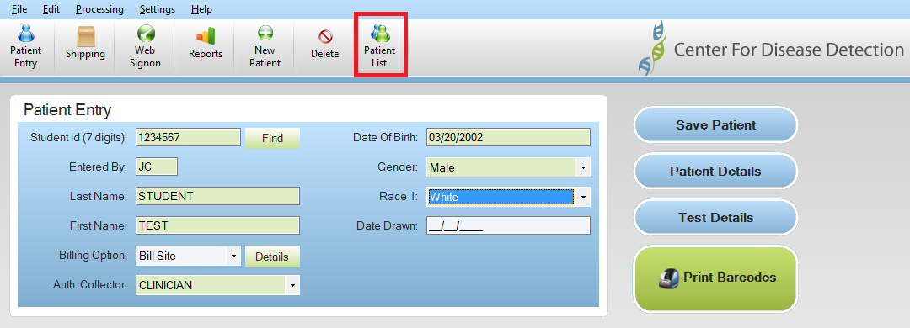

The Patient List contains patients that have been entered in the AFTIS software who have yet to be transmitted CDD. The three status types are:
Pre-Registered – Barcodes have not been printed, tests not ordered
Ordered – Barcodes have been printed, tests ordered

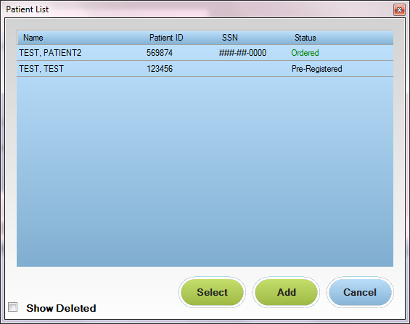

To select a patient from the Patient List, either double-click on the record or highlight the record and click on the “Select” button.

Patients will remain in the Patient List until data is transmitted, errors are corrected or patient is deleted.

Patient Details Button

Additional Patient Details are available by clicking on the Patient Details button. Certain fields may be required and some are optional based on the test being ordered.

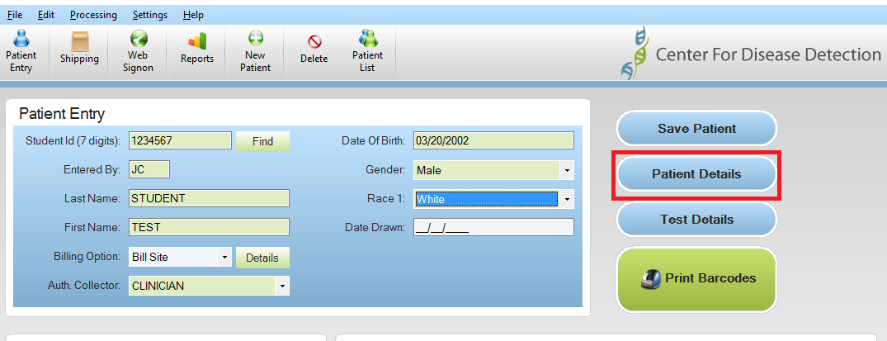

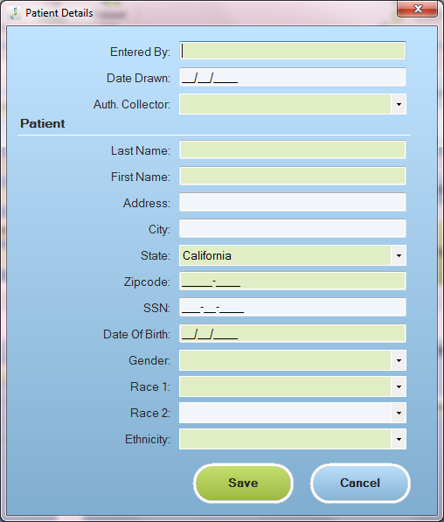

Complete all required fields, including the questions from the drop down lists below.

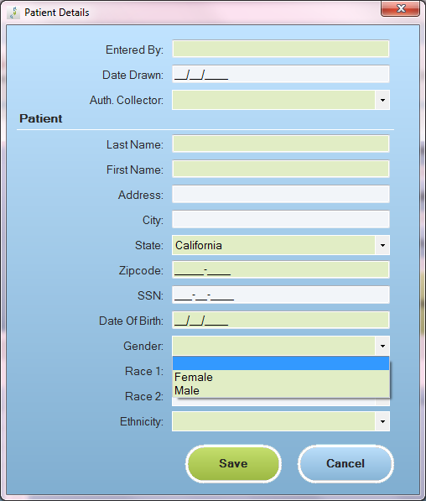

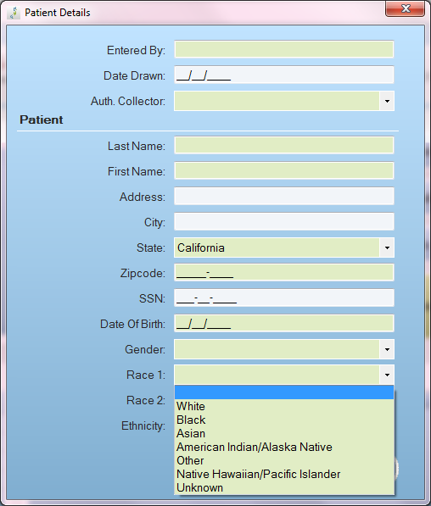

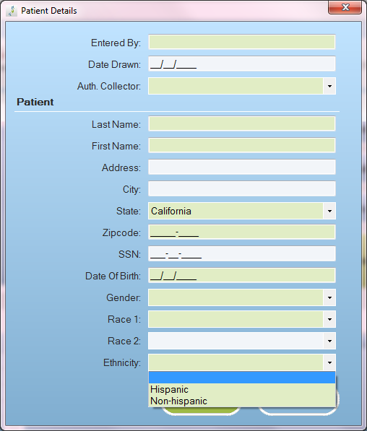

Test Details Button

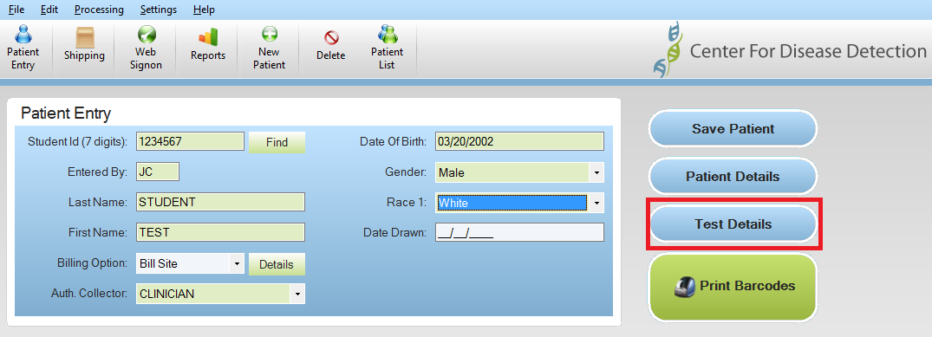

Some tests will have additional required fields that must be completed prior to ordering, while some other fields are optional.

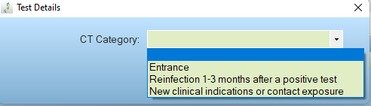

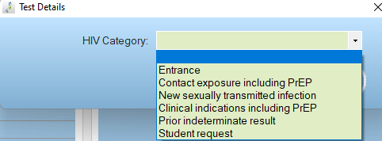

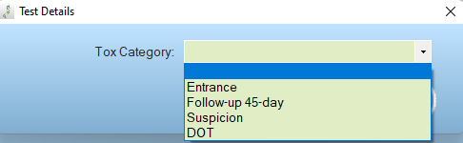

Deleting Patients

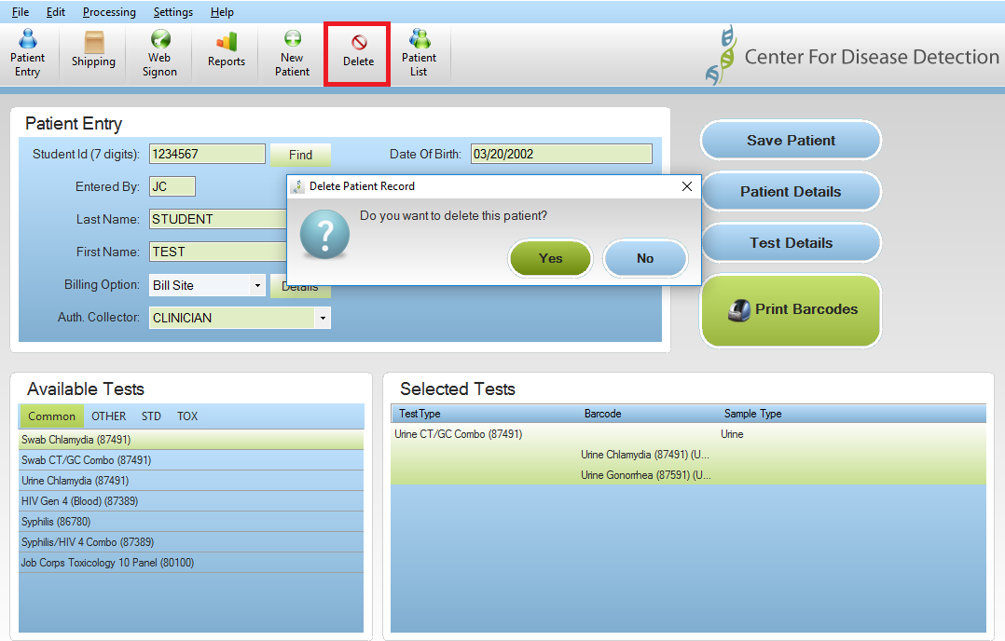

You are able to delete a patient at any time by simply clicking on the Delete icon on the top tool bar.

Deleting or Adding Tests to Patients

You may add or delete a test to an already processed patient. Simply double click the test to be added under the Available Tests section, or double click an already selected test under the Selected Tests section to delete a test. Be sure to click Print Barcodes to print the new barcode labels for the specimen(s).

Printing Barcoded Labels

Once you are sure that the patient information is entered correctly, the correct tests are selected, and you are ready to collect your specimen from the patient, you will click the Print Barcodes button. Each requested test will have one label for each specimen collected and a label for the patient’s file. If insurance was selected, an additional barcode will be printed.

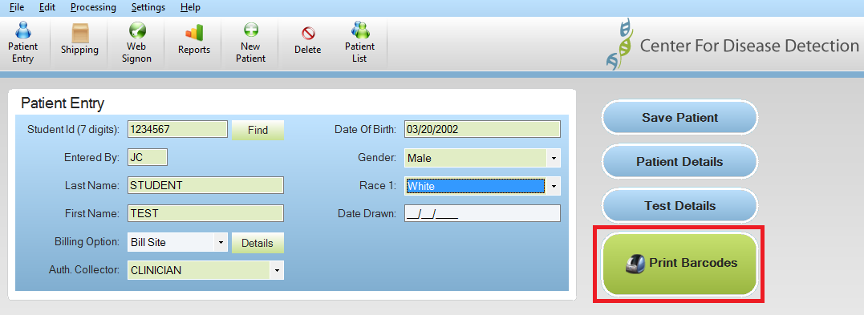

Once Barcodes have been printed, the Patient Entry screen will be cleared for the next patient to be entered. The Patient information for the patient just ordered will be moved to the Patient List with a status of Ordered.

If the record is modified after the Barcodes have already been printed, you may have to reprint the barcodes. If this is required, such as changing Name, DOB, Test ordered, etc., you will be prompted to save the record and reprint the labels before continuing.

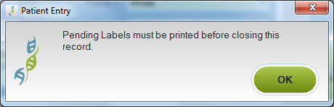

Barcoded Labels

The following is an example of the bar-coded labels:

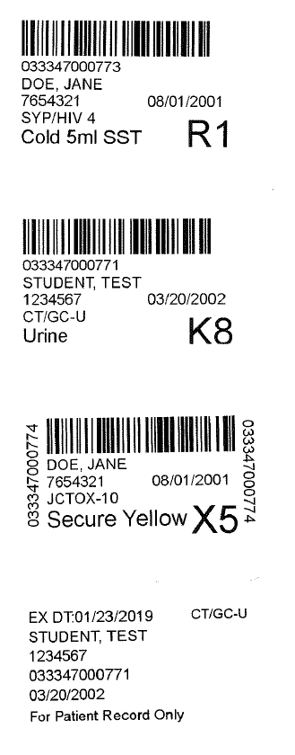
Combo tests with ONE label
Label includes Patient Name, Patient I.D., barcode number, and Patient DOB
Label for your patient files (includes Exam Date and all tests performed)
Type of collector required listed on the label

Note: Barcodes should be placed lengthwise on the tube, not wrapped. Please do not cover the expiration date or fill lines on the tube with a label if possible.

Shipping Screen

Shipping Specimens to CDD
When you are ready to send your specimen shipments to CDD, you will electronically submit the patient and test data directly through the AFTIS software. To ship your specimens, you will need to access the Shipping Icon on the toolbar.

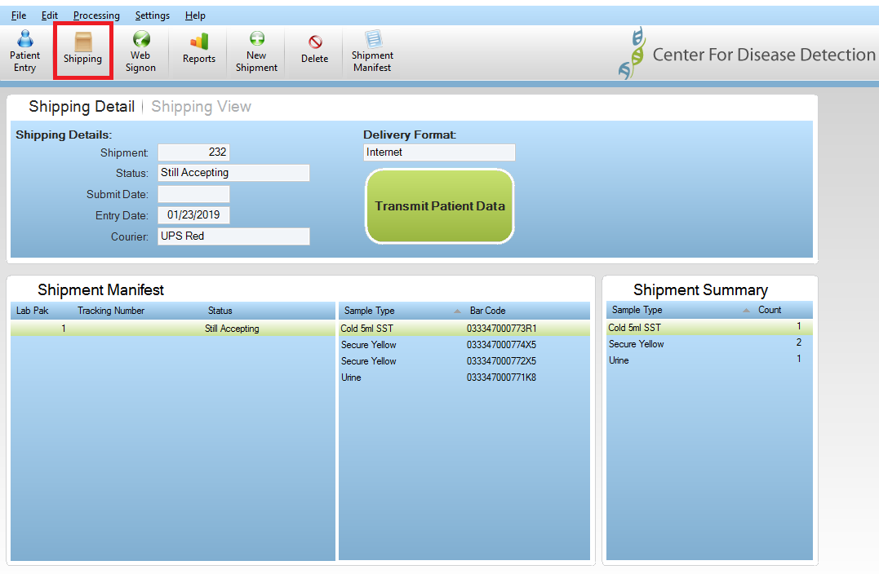

The Shipping tab contains two sections, Shipping Detail and Shipping View. When the Shipping icon is selected, the Shipping Detail screen will be displayed.

The Shipping Detail section displays the details and summary information of the current shipment only.

The Shipping View section displays a historical list of all previous shipments and contents.

Shipping Detail Tab

When you are ready to send your specimen shipments to CDD, verify that all information is correct, including the count of each specimen type in the Shipment Summary and click Transmit Patient Data.

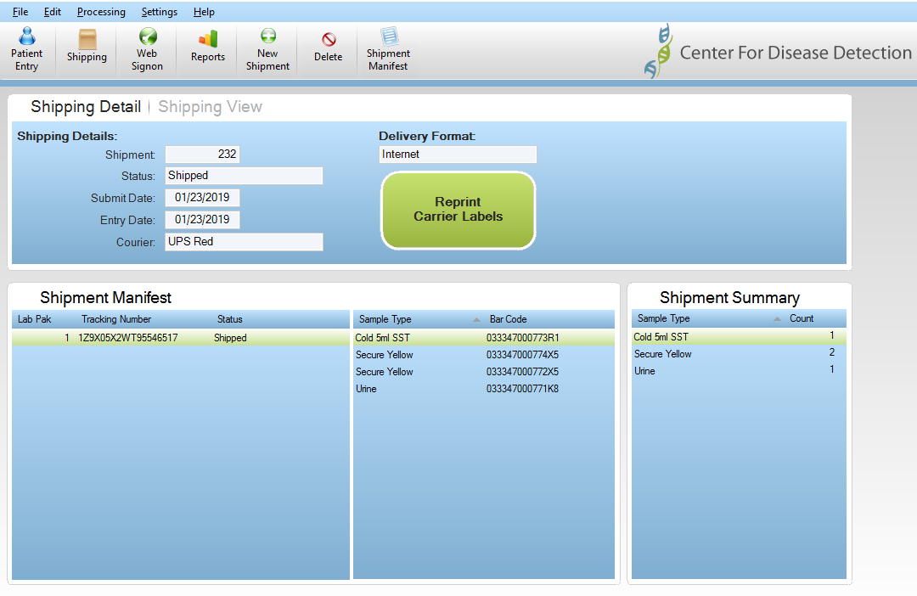
The carrier tracking number will appear here and your carrier label will print from your 8 x 11.5 printer.

AFTIS will connect and transmit the information. CDD will confirm successful transmissions with the following message.

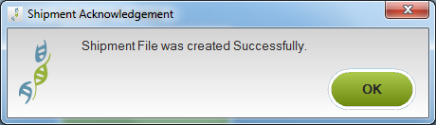

A Dymo label with the Shipment ID and Tracking number will print for your records.
After the transmission to CDD is successful, AFTIS will then check for any data or program updates. If any new updates are available, the following message will be displayed.

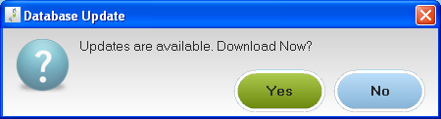

You may choose to download now or later at your convenience.
You will then see the overnight label appear on your screen with a print pop-up box requesting you to print the label. Make sure the label will print to the correct printer and click Print.

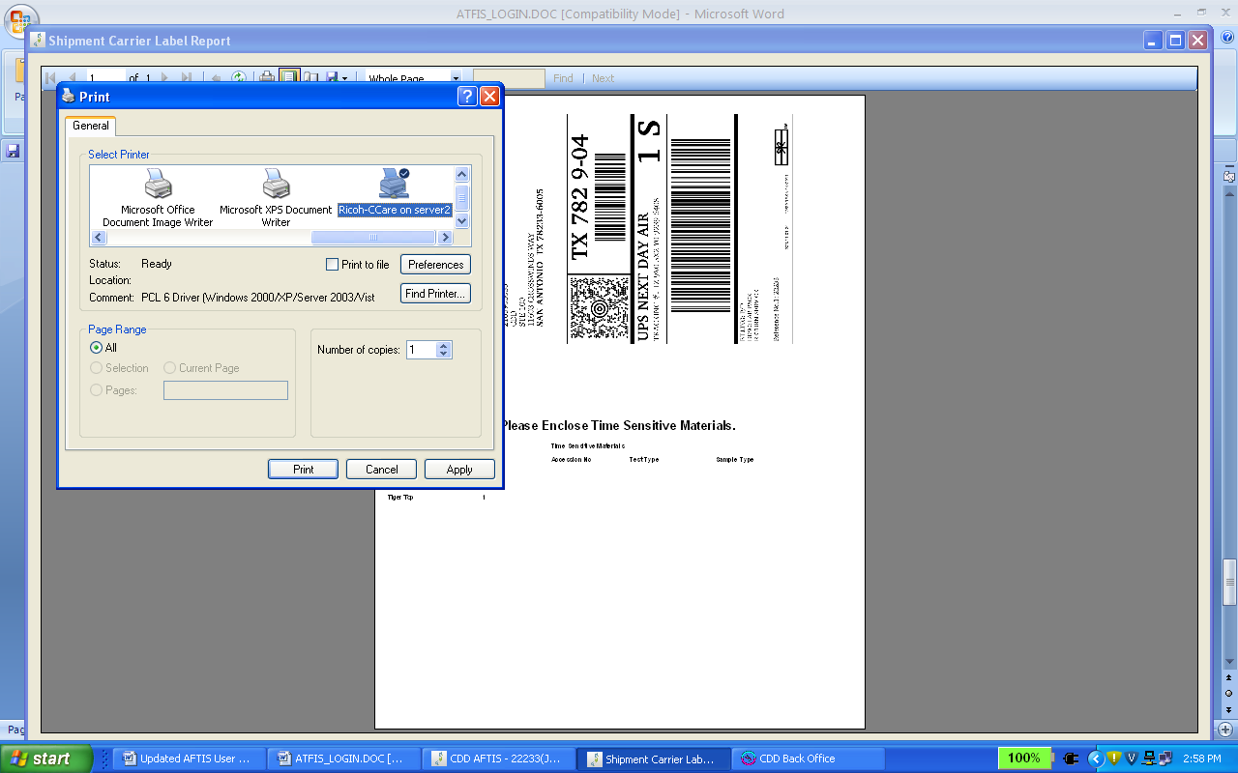

The carrier’s overnight label will print to the requested printer.

- Fold the 8 ½ x11 sheet in half displaying the printed information and carrier bar code.
- Insert the printed overnight label into the clear plastic pouch.
- Peel off both pieces from the back of the clear plastic pouch and attach the pouch to the shipping bag. Check the pouch to verify the printed label can not fall out.

Failed Transmissions – 2D Barcode Report

If for any reason transmission of patient data to CDD was not successful, you will be prompted to print a page or multiple pages of 2-D barcodes to your 8.5 x 11 printer.

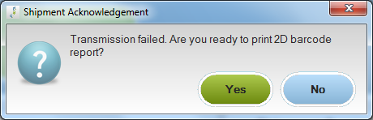

Please attach the page(s) of the 2-D barcodes (encrypted patient data) to the outside of the CDD box with a rubber band and send along with the carrier package.

Shipping View Tab

The Shipping View section allows you to track and view previous shipments. This is a great resource for looking up Patient Names and/or Tracking Numbers for a specific date.

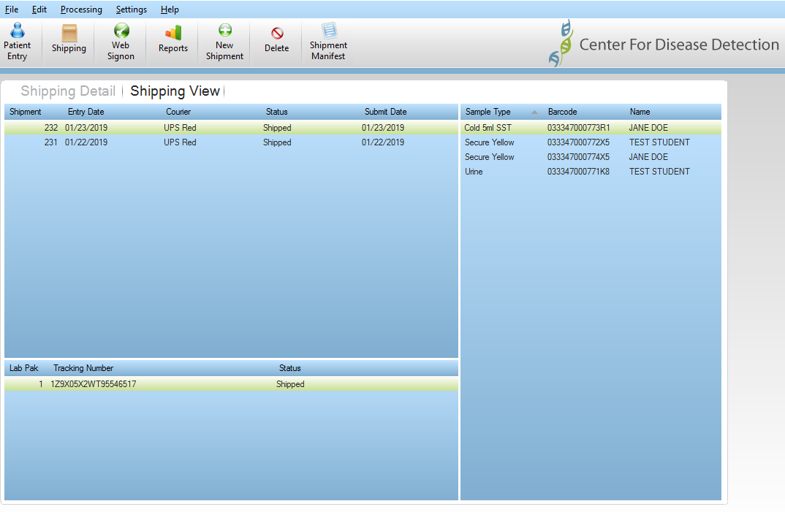

You can also click on Shipment Manifest to print or view a detailed listing of the shipment.

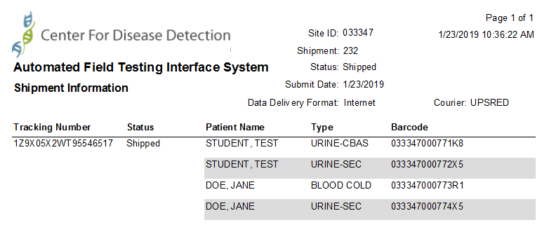

Patient Reports Screen

Reports

CDD Provides 2 reports within the CDD AFTIS software directly. Patients Recently Drawn and Patients Not Drawn. These reports can be accessed by clicking on the Reports icon in the Top Toolbar.

Note: Lab Logs, Statistical Summaries and Result Reports are not located in this area and will be accessed via secure login.

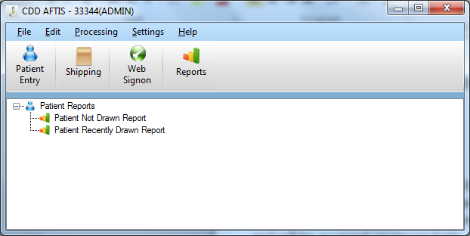

Double-click on the requested report to view a PDF file of the report data. You may print the report or save the file.

The Patient Not Drawn Report displays all patients that have been Pre-Registered in AFTIS, but no barcode or order sent.

The Patient Recently Drawn Report displays a list of all patients that have been ordered in the last 7 days.

Retrieving Results, Lab Logs, Invoices, Stats

CDD will send the approved user(s) an email notification that will allow access to reports such as results, lab logs, monthly stats, and invoices. The Subject of the email notification will describe the purpose for the email.

Steps to retrieve various Reports via email

Click the Hyperlink within the email to access CDD’s secure web site

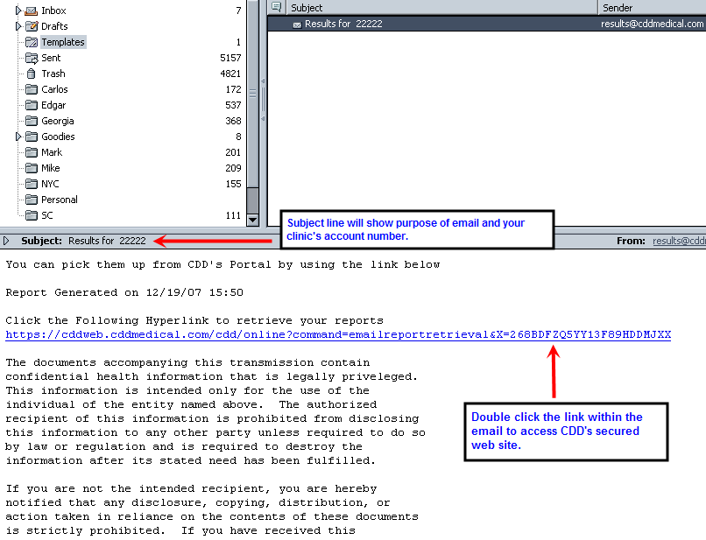

Note: Contact CDD if you cannot access the link due to your system’s restrictions.

Enter your User ID and Password to retrieve your reports. Then click Submit button.

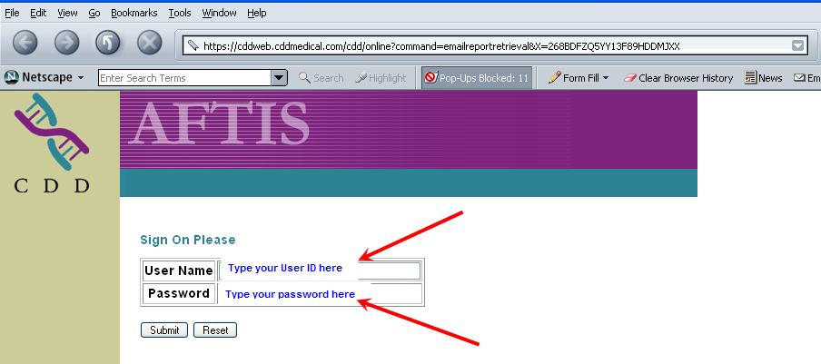

Click on “Click here to Retrieve Queued Results” or Click “Download” to access various reports.

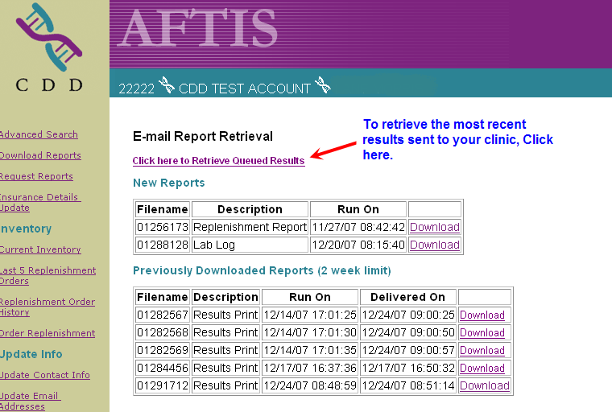
To retrieve Invoices, Lab Logs, Monthly Stats, go to the “New Reports” section and click “Download.”
(Individual reports sent to your clinic manually by CDD will appear under the “New Reports” section)

All previous viewed reports will store in this section for 2 weeks. (Examples: Results, Lab Logs, Invoices, Monthly Stats, etc.)

When the requested reports are ready to be retrieved, click the “Click here to download the report” link.

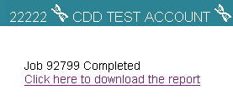
All reports will appear in a PDF format and may have multiple pages. The example below is for Results. There will be a summary page, and then individual reports will follow. Print report when ready.

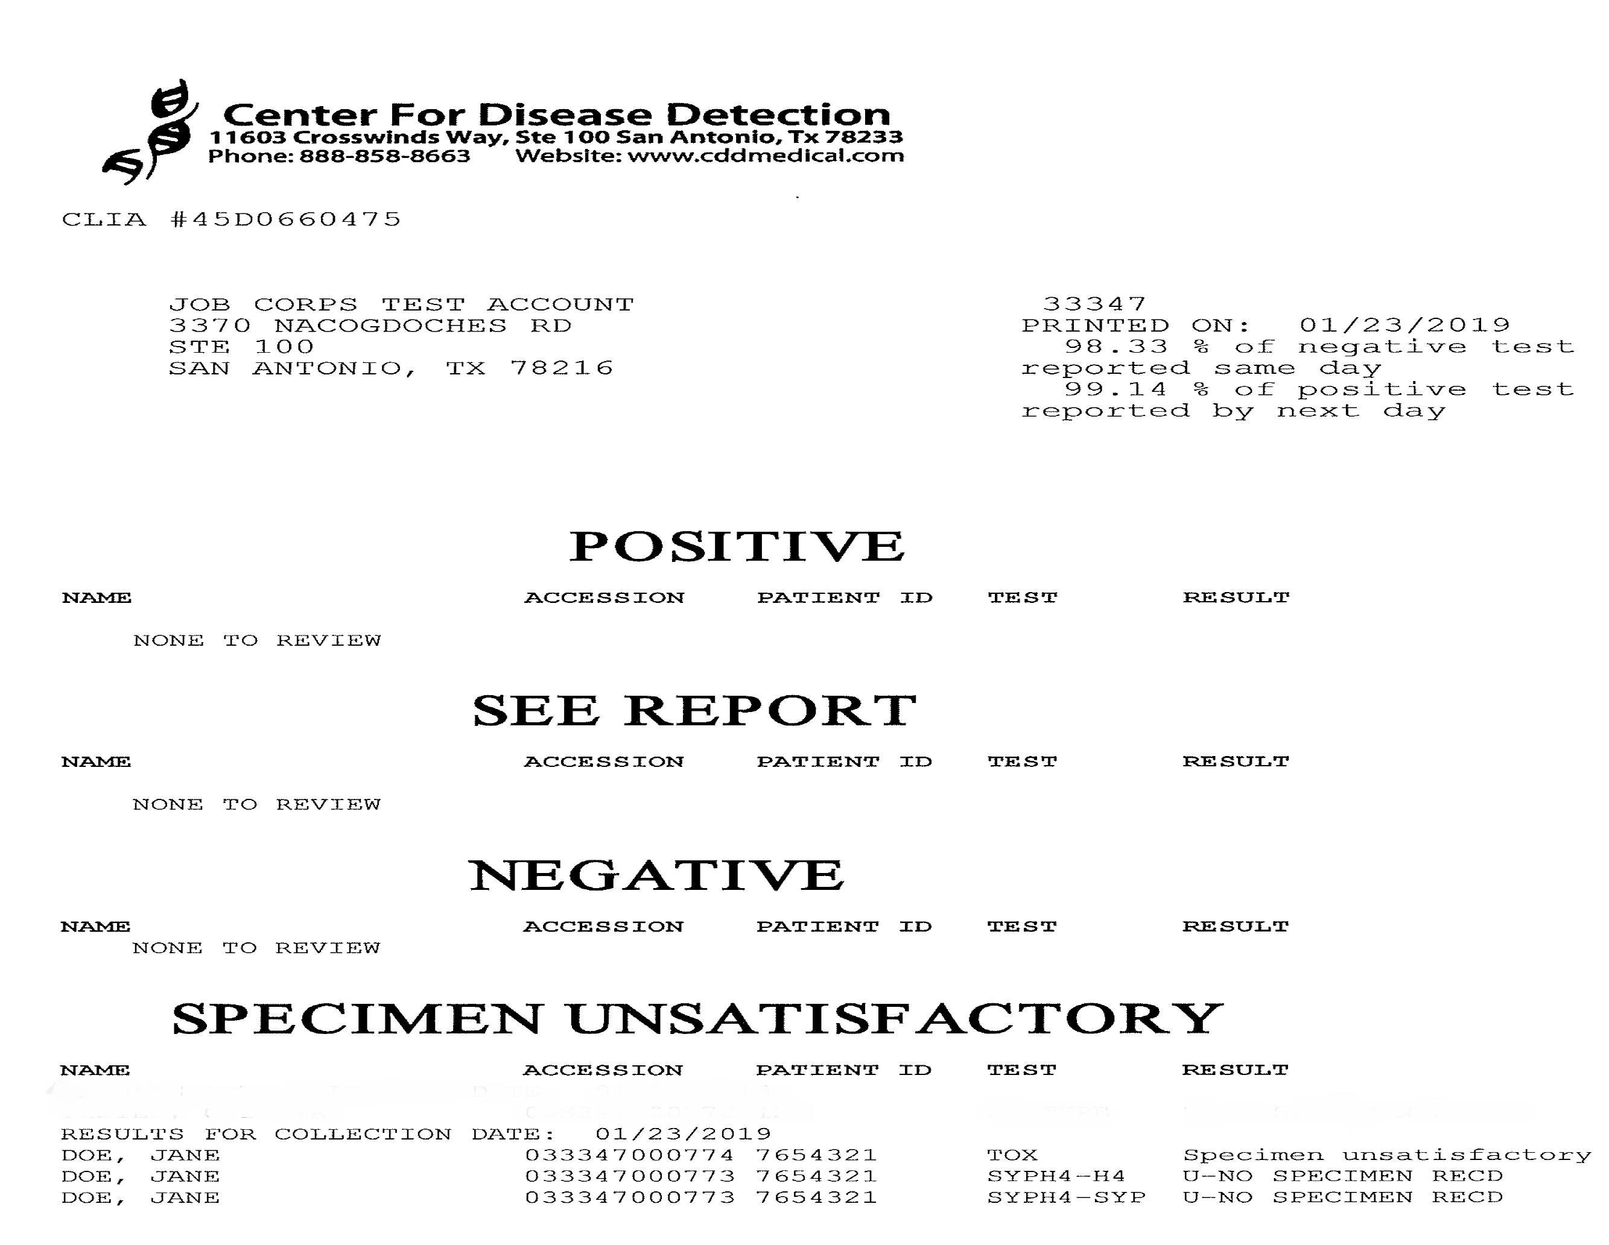

Web Signon – Advanced Search

Retrieving Past Results Data Using Advanced Search.

In AFTIS, you are able to access historical results by clicking the Web Signon icon, and accessing the Advanced Search feature.

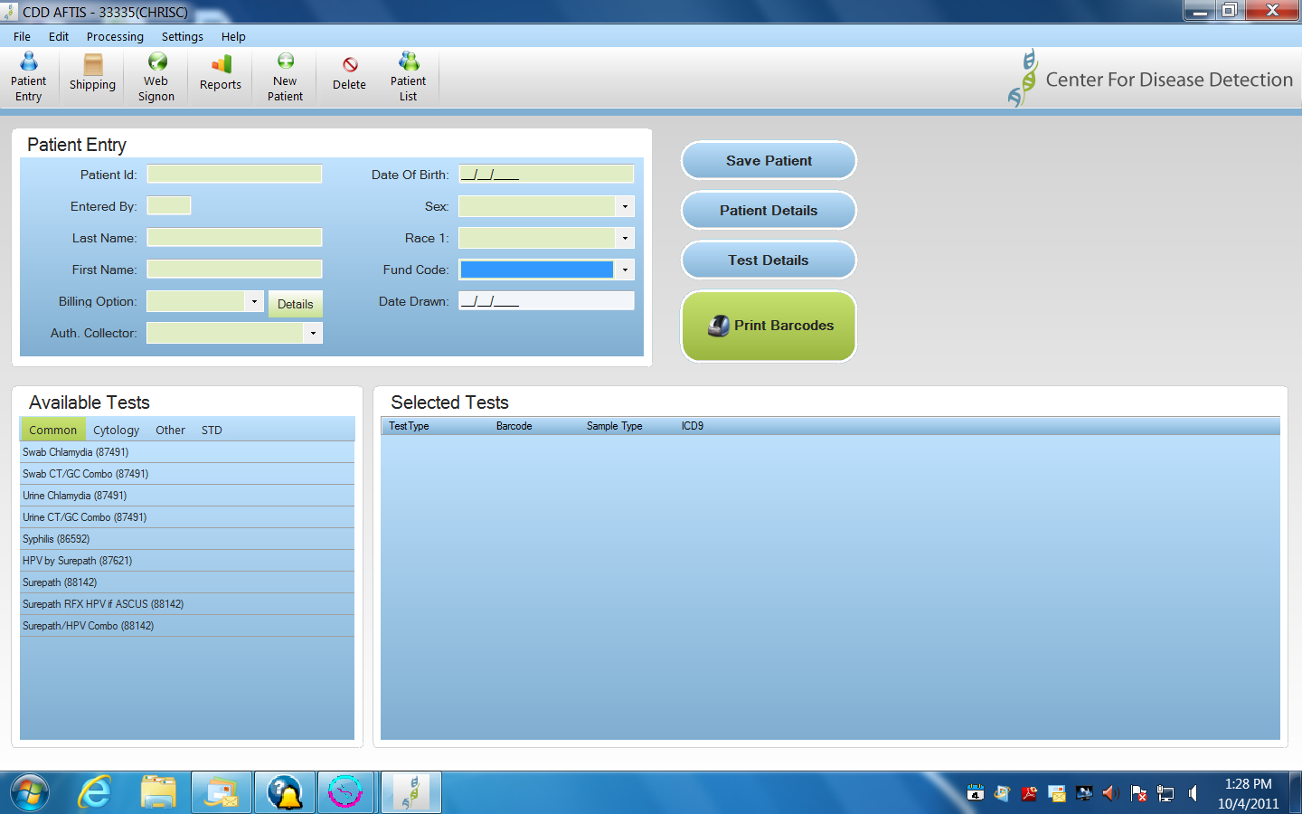

Advanced Search allows you to pull up data after the daily results are given.

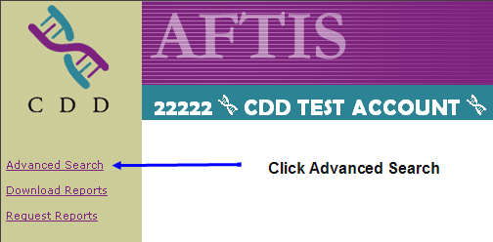

Advanced search gives you the ability to enter certain criteria such as Exam Date Range or Test Type to view historical results for your Patients.

You are able to access data by choosing one of the required fields that are marked with a “*”.

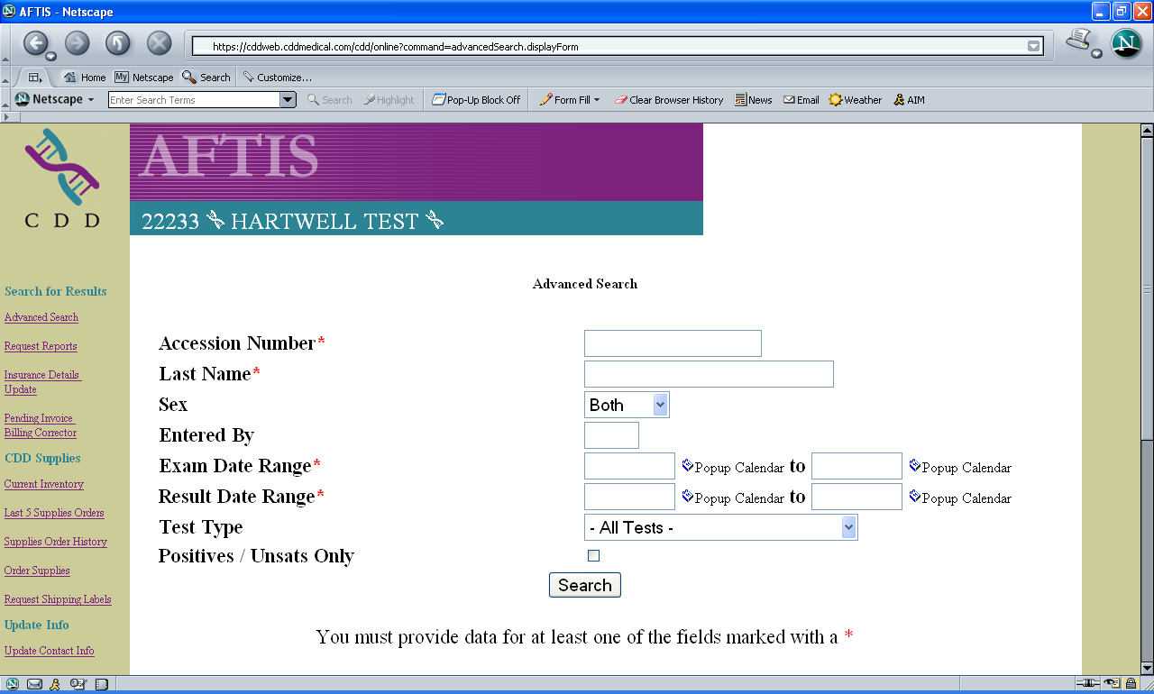
Example: Enter patient’s last name

The system may take a few seconds while it searches for your requested data.
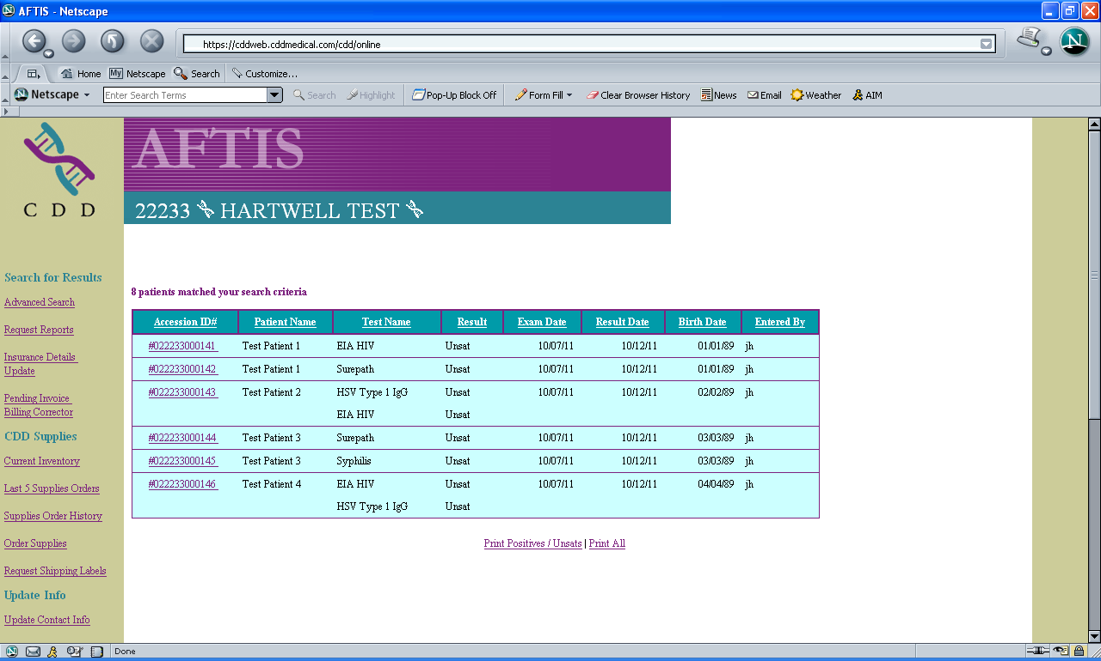

Click the Accession ID# to access the result.

After the Accession ID# is selected, this screen will appear while it is searching for the requested data.

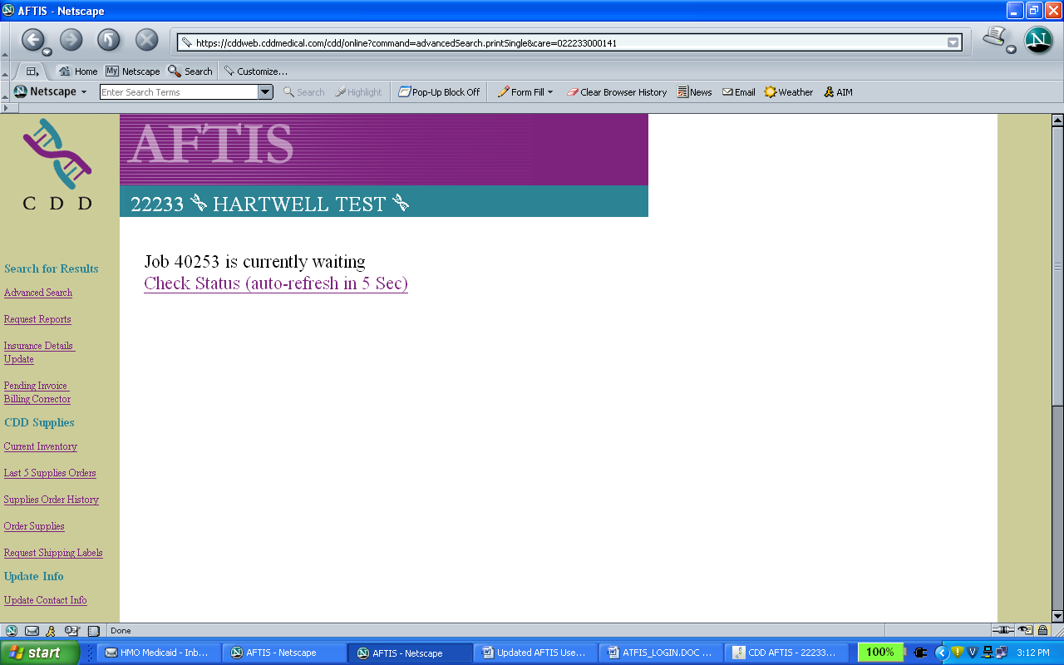

Once the system has completed its search, you can now click to access the report.

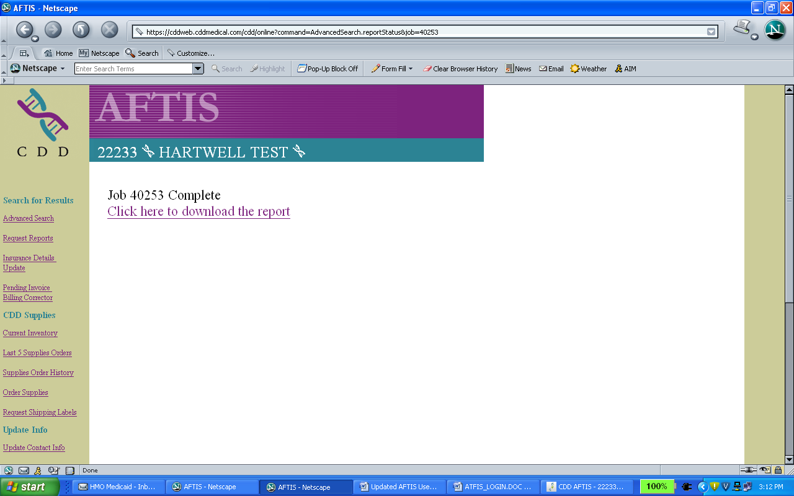

The result comes in an Adobe format so you can file the result or print the result to a hard copy.

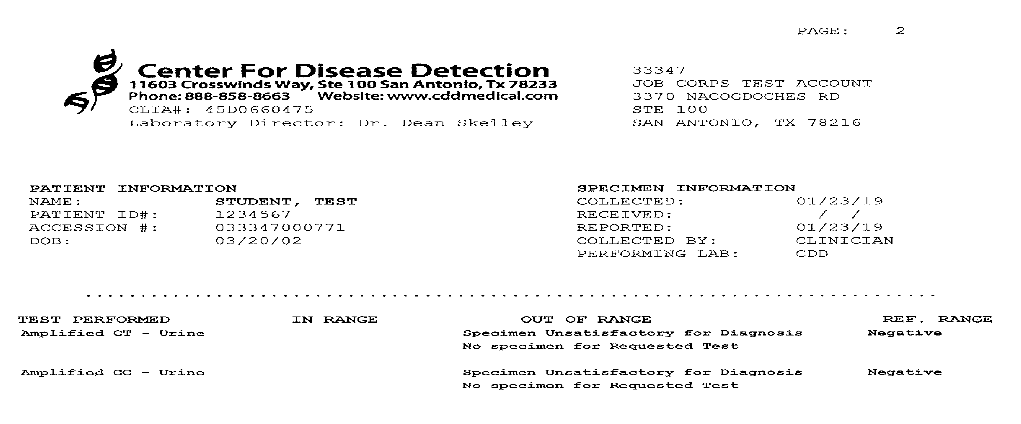

You may also utilize the Requests Reports link listed below the Advanced Search link to search for up to 10 specific Accession Numbers at once.

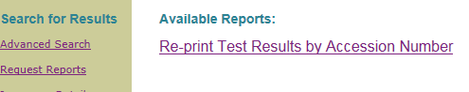

Web Signon - Inventory

By clicking the Web Signon icon, you will be able to access Supplies for on-hand information and ordering supplies.

CDD Supplies

The links related to supplies in Web Signon allow you to view past supply orders, update on hand quantities of supplies (recommended every quarter) and print additional shipping labels for specimens, as required.

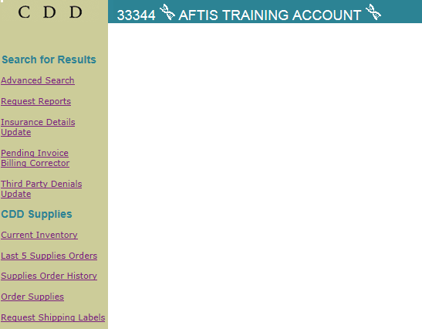

Web Signon – Update Information

By clicking the Web Signon icon, you will be able to review and update Contacts, Clinicians, Users and permissions for the clinic.

Update Information

Within Web Signon, there are several functions that allow Users with Administrative privileges to update information.

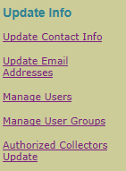

Administrative Users can update any information about the clinic via these links. Updates may be made to:

- Adding/Removing Authorized Collectors/Clinician list displayed in AFTIS
- Changing email addresses for notifications/announcements
- Adding/Removing Users and permissions
- Updating Users to receive reports, results, etc.
- Changing permissions for users to allow/disallow administrative functions.

Web Signon – Forms & References

By clicking the Web Signon icon, you will be able to print and view forms and other reference materials related to testing done at CDD.

Forms, Training Videos and Quick Test Help

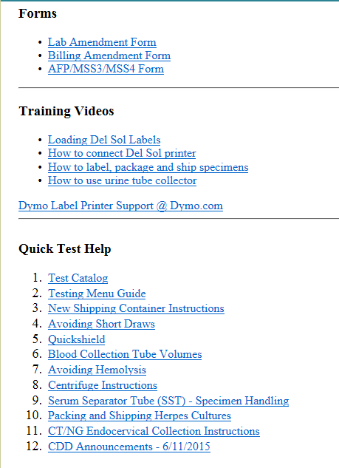

Note: This section of Web Signon is updated frequently, so please check back frequently.

Laboratory Amendment Form

End of Day

At the end of the day when you exit AFTIS, you will be prompted to perform end of day operations. End of Day retrieves any results waiting, reports, and program updates.

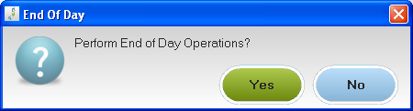

By selecting “Yes,” AFTIS will automatically retrieve any results waiting and print them out. Any changes made to your account will also be updated by performing the End of Day operation.

Thank you for doing business with CDD.

We strive to provide exceptional customer service and ensure all your laboratory needs are met. For any assistance or questions, please call your Account Managers listed on the first page.

