TREATMENT GUIDELINES FOR HEALTH STAFF
Anxiety Disorders (including Panic and Phobic Disorders)
COMMON SYMPTOMS OF ANXIETY
Emotional/Cognitive | Physical | Panic Attack
- Fear/worry  - Irritability  - Restlessness  - On edge/watching for signs of danger  - Mind going blank, feeling distracted  - Feelings of apprehension or dread  - Trouble concentrating  - Feeling tense and jumpy  - Anticipating the worst | - Pounding/racing heart  - Sweating  - Stomach upset or nausea  - Dizziness/faintness  - Frequent urination or diarrhea  - Shortness of breath  - Feeling shaky  - Feeling dizzy, lightheaded  - Muscle tension  - Headaches  - Fatigue  - Insomnia | - Sudden, intense fear  - Pounding heart, chest pain**  - Trouble breathing/shortness breath**  - Nausea  - Trembling or shaking  - Hot flashes or chills  - Sense of losing control, going “crazy” or dying  - Dizziness, lightheadedness  - Derealization (things don’t feel real)  - Depersonalization (feeling detached from oneself)
** It can be difficult to differentiate between panic attack and heart attack symptoms. A medical assessment must occur ASAP in students without a history of panic attacks.

Authorized health and wellness staff may treat students with symptoms of anxiety as follows:

WHAT TO DO FIRST
- Provide a private, supportive space where the student feels safe to talk about their feelings.
- Movement can be helpful when someone is anxious—consider walking with the student or offering them a fidget object such as rubber bands, paper clips, a stress ball, or other small objects that can be manipulated in a student’s hands.
- If the student is afraid of a specific object or situation, separate the student from it.
- Speak in a calm tone of voice and avoid saying phrases like “Calm down,” “Relax” or “Stop panicking” as these statements are not helpful.
- Suggest (say) to the student, “Taking several deep breaths will help to calm the nervous system. I will show you how. We can do it together.” If the student is open to the suggestion, provide gentle coaching: “Breathe in slowly through your nose and then breathe out slowly through your mouth.”
- Try to help the student identify what is happening. For example, “It looks like you’re feeling anxious” or “It looks like you’re having a panic attack. It’s uncomfortable, but you’ll be okay. I’ll stay with you.” This can help the student calm down and regain a sense of control.
- Consider helping the student stay in the present by asking them to describe out loud 2 things they can see in the room, 2 things they can hear and give them something they can feel (e.g., cotton ball, a rubber band, paper clips, etc.).

ASSESS SYMPTOMS AND BEHAVIORS
- Listen to the student non-judgmentally and with empathy and genuine concern.
- Give the student as much personal space and sense of control as possible.
- Allow the student to express their current feelings and concerns. Acknowledge the student’s feelings. For example, “I can see you’re having a hard time right now” or “I can see how that could be upsetting.”
- Speak clearly and use short sentences in a calm and reassuring tone of voice. Do not overwhelm the student with words as this will likely cause the student to become more stressed and anxious.
- Avoid offering advice, lecturing, or trying to “fix” the situation. Listening in an attentive way is the most helpful thing you can do to comfort a student.
- Ask “What’s going on for you right now? What’s making you feel this way?”
- Ask “On a scale of 1 to 10, where 10 is the worst, how would you rate your anxiety right now?”
- If the student is not able to describe why they are feeling anxious, consider asking the following 3 questions, as appropriate:
- “Have you recently had any energy drinks or drinks with a lot of caffeine?” If the student answers “yes,” ask about the names of the drinks, how much the student drank and how much they usually consume. If the student reports, or is suspected of, having consumed energy drinks in excess, involve the Center Physician (CP).
- “Have you recently taken any of your own medications or someone else’s prescription medications?” If the student answers “yes,” ask about the names of the medications, the number of pills/capsules they took, and what time they were taken. If the student reports, or is suspected of, mis-using their own or someone else’s medications, involve the CP.
- If there are concerns about alcohol/drug use, ask “Have you recently used any alcohol or drugs?” If the student answers “yes,” ask about the types of alcohol or drugs and how much and what time the substances were consumed. If the student reports, or is suspected of, having used a substance, involve the TEAP specialist, if possible, and/or follow Alcohol or Drug Use Behavior Treatment Guideline.
- If there are any concerns about self-harm or suicide, assess for thoughts of self-harm by asking:
- "Sometimes people feel that life is not worth living. How are you feeling about living right now?" [wait]
- "Have you ever thought of harming yourself or trying to end your own life?
- If the student answers “yes,” ask "Are you feeling that way now?"
- If self-harm thoughts are present or questionable, follow the Suicidal Self-Directed Violence Treatment Guideline (“What to Do Next”). Do not leave the student alone.
- If the student is not willing to participate in the assessment, ask the student if they would like to speak to the Center Mental Health Consultant (CMHC) (if available) or if there is a trusted staff member who can provide support, then determine if that person is available to come assist.
- After the acute distress has been addressed, discuss with the student how a referral to the CMHC could be helpful to develop strategies for managing stress and anxiety better.

WHAT TO DO NEXT
- Students who have difficulty coping with anxiety or panic attacks should be encouraged to meet with the CMHC, so that the CMHC can determine whether an evaluation and/or treatment such as brief therapy and/or medication would be helpful.
- If the student is already in treatment for anxiety, determine whether the student has been adherent with any prescribed medications or therapeutic interventions. Consider how to address any issues of non-adherence.
- Students who express an interest in starting medication to assist with anxiety symptoms should be referred to the CMHC for assessment and to the CP for follow-up.
- If the student is willing to meet with the CMHC/CP, consider asking them to complete an anxiety screening measure, such as the Generalized Anxiety Disorder-7 (GAD-7) (GAD-7 in Spanish) which can be found on the following pages. Make sure the completed GAD-7 is then attached to the CMHC referral form, so the CMHC can score and interpret it.
- If the student does not want to meet with the CMHC, it is recommended that health and wellness staff alert the CMHC so the student can be discussed at the next case management meeting and help identify ways for the counselor to support the student. The counselor can refer the student to the CMHC in the future, if needed.
- If the student has received treatment for anxiety in the past, consider obtaining a signed Authorization for Release of Information from the student (or, if minor, parent/guardian) so that prior treatment records can be obtained and reviewed.

NAME: | DATE:

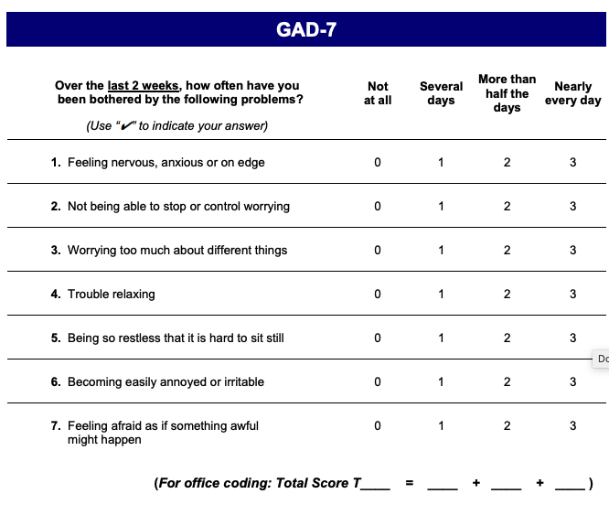

Developed by Drs. Robert L. Spitzer, Janet B.W. Williams, Kurt Kroenke and colleagues, with an educational grant from Pfizer Inc. No permission required to reproduce, translate, display or distribute.

Source: Patient Health Questionnaire (PHQ) Screeners GAD-7

NOMBRE: | FECHA

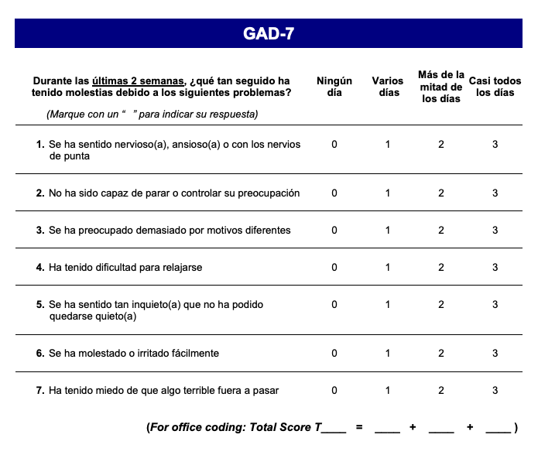

Elaborado por los doctores Robert L, Spitzer, Janet B.W. Williams, Kurt Kroenke y colegas, mediate una subvención educative otorgada por Pfizer Inc. No se require permiso para reproducer, traducer, presentar or distribuir.

Source: Patient Health Questionnaire (PHQ) Screeners GAD-7 (in Spanish)
Interpreting the GAD-7 Score

Respondents are asked to rate how bothered they have been by each of 7 items in the past 2 weeks on a 4-point Likert scale ranging from 0-3. Items are summed to provide a total severity score (range = 0-21).

0 = Not at all 1 = Several days 2 = More than half the days 3 = Nearly every day

Total Score | Interpretation
0-4 | None to minimal anxiety
5-9 | Mild anxiety
10-14 | Moderate anxiety
15-21 | Severe anxiety
≥10 | Possible diagnosis of GAD; confirm by further evaluation

Though designed as a screening and severity measure for Generalized Anxiety Disorder, the GAD-7 also has moderately good operating characteristics for three other common anxiety disorders – Panic Disorder, Social Anxiety Disorder, and Post-Traumatic Stress Disorder (PTSD). When screening for anxiety disorders, a recommended cut point for further evaluation is a score of 10 or greater.

Source: Patient Health Questionnaire (PHQ) Screeners GAD-7

