TREATMENT GUIDELINES FOR HEALTH STAFF

Post-Traumatic Stress Disorder (PTSD)/Acute Stress Disorder

COMMON SYMPTOMS OF PTSD AND ACUTE STRESS DISORDER
Intrusive (where the mind is reliving the traumatic event) | Avoidance | Negative Thoughts and Feelings | Reactivity
- Repeated, distressing memories of the trauma  - Nightmares about the traumatic event  - Flashbacks, where it feels like the event is happening again | - Avoidance of people or situations that trigger memories of trauma  - Avoid talking or thinking about the trauma | - See people and the world differently (e.g., the world may feel more dangerous, people untrustworthy)  - Withdrawal from people  - Decreased interest in activities  - Difficulty experiencing positive emotions (happiness, excitement) and/or may feel stuck in negative emotions (anger, shame, guilt, numbness) | - Look keyed up or jittery  - Have anger outbursts  - Easily startled  - Problems concentrating  - Difficulty sleeping  - Reckless behavior
Note: Trauma symptoms fall into these four main groups. It is important to remember that trauma is experienced differently, and symptoms may vary between students.
Authorized health and wellness staff may treat acute symptoms of trauma and post-traumatic stress disorder (PTSD) as follows:

WHAT TO DO FIRST
- Provide a private, supportive space where the student feels safe to talk.
- Stay with the student—but give them as much personal space and sense of control as possible.
- Speak in a calm tone of voice and avoid saying phrases like “Calm down” or “Relax” as these statements are not helpful. Instead, try to help the student identify and label what is happening. For instance, “It looks like you’re feeling overwhelmed right now. I’ll stay with you.”
- If student seems afraid or disoriented, remind the student where they are and that they are safe: “You’re in the H&W center with me, and you’re safe.”
- Suggest (say) to the student, “Taking several deep breaths will help to calm the nervous system. I will show you how. We can do it together.” If the student is open to the suggestion, provide gentle coaching: “Breathe in slowly through your nose and then breathe out slowly through your mouth.”
- Consider helping the student stay in the present by asking them to focus on their senses: describe 2 things they can see in the room, describe 2 things they can hear, and give them something they can feel (e.g., cotton balls, rubber bands, paper clips, etc.).

ASSESS SYMPTOMS AND BEHAVIORS
- Listen to the student non-judgmentally and with empathy and genuine concern.
- Allow the student to express their current feelings and concerns. Acknowledge the student’s feelings. (Example: “I can see you’re having a hard time right now.”)
- Speak clearly and use short sentences in a calm and reassuring tone of voice. Do not overwhelm the student with words as this will likely cause the student to become more stressed and anxious.
- Avoid giving advice, lecturing, or trying to “fix” the situation. Listening in an attentive way is the most helpful thing you can do to comfort a student.
- Ask “What’s going on for you right now? Why do you think you’re feeling this way?” The student may be aware of what triggered their trauma response. Triggers can be external (person, place, sound, anniversary date) or internal (physical pain, strong emotion). If student can identify trigger, then empathize with them by saying something like, “That must be hard.”
- Ask “On a scale of 1-10, where 10 is the worst, how would you rate your [anxiety] right now?”
- If the student is not able to describe why they are feeling such intense emotion, consider asking the following 2 questions, as appropriate:
- “Have you recently taken any of your own medications or someone else’s prescription medications?” If the student answers “yes,” ask about the names of the medication/s, number of pills/capsules …. If the student reports, ….... involve the Center Physician (CP).
- If there are concerns about possible alcohol/drug use: “Have you recently used any alcohol or drugs?” If the student answers “yes,” ask about the types of alcohol or drugs and how much and what time the substances were consumed. If the student reports, or is suspected of, having used a substance, involve the TEAP specialist, if possible, and/or follow Alcohol or Drug Use Treatment Guideline.
- If there are any concerns about self-harm or suicide, assess for thoughts of self-harm by saying:
- "Sometimes people feel that life is not worth living. How are you feeling about living right now?" [wait]
- "Have you ever thought of harming yourself or trying to end your own life?
- If the student answers “yes,” ask "Are you feeling that way now?"
- If self-harm thoughts are present or questionable, follow the Suicidal Self-Directed Violence Treatment Guideline (“What to Do Next”). Do not leave the student alone.
- If the student is not willing to participate in the assessment, ask the student if they would be willing to talk with the CMHC (if available) or if there is a trusted staff member who could provide support, then determine if that staff member is available to come assist.
- After the acute distress has been addressed, discuss with the student how a referral to the CMHC would be helpful to develop strategies for managing stress and their symptoms better.

WHAT TO DO NEXT
- If assistance is needed to determine whether an emergency psychiatric evaluation is warranted, contact the CMHC and/or CP.
- Students who have difficulty coping with trauma should be encouraged to meet with the CMHC, so that the CMHC can determine whether an evaluation and/or treatment such as brief therapy and/or medication would be helpful.
- If the student is already in treatment, determine whether the student has been adherent with medications and/or therapeutic interventions. Consider how to address any issues of non-adherence.
- Students who express an interest in starting medication to help with trauma should be referred to the CMHC, for assessment, and the CP for follow-up.
- If the student is willing to meet with the CMHC/CP, consider having the student complete a trauma checklist such as the PTSD Checklist for DSM-5 (PCL-5) (PCL-5 in Spanish), which can be found on the following pages. Make sure the completed PCL-5 is then attached to the CMHC referral form, so the CMHC can score and interpret it.
- If the student does not want to meet with the CMHC/CP, it is recommended that H&W staff alert the CMHC so that the student can be discussed at the next case management meeting and help identify ways for the counselor to support the student. The counselor can refer the student to the CMHC in the future, if needed.
- If the student has received treatment for PTSD in the past, consider obtaining a signed Authorization for Release of Information from the student (or, if minor, parent/guardian) so that prior treatment records can be obtained and reviewed.

NAME: | DATE:

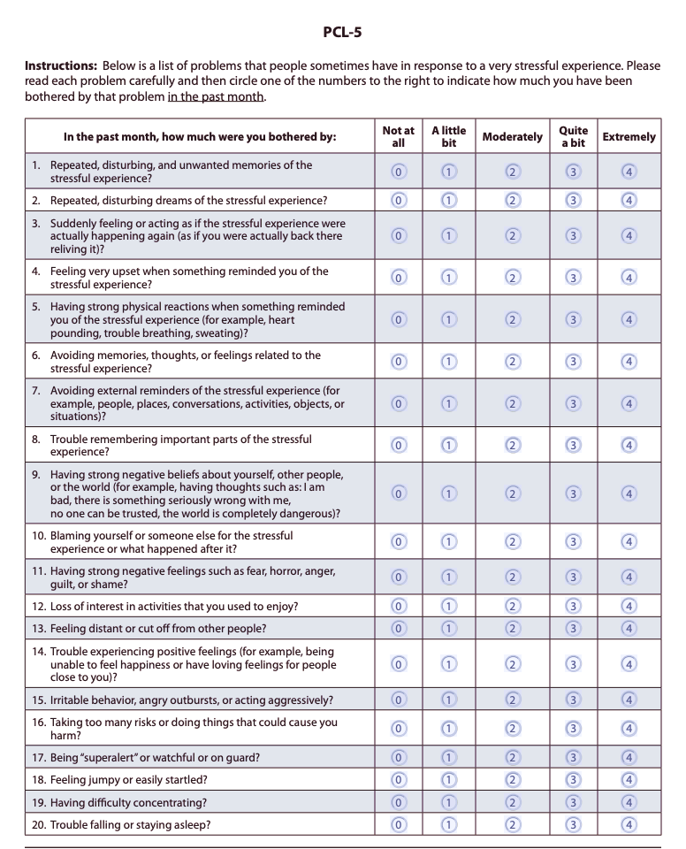

Source: https://www.ptsd.va.gov/professional/assessment/documents/PCL5_Standard_form.PDF

NOMBRE: | FECHA:
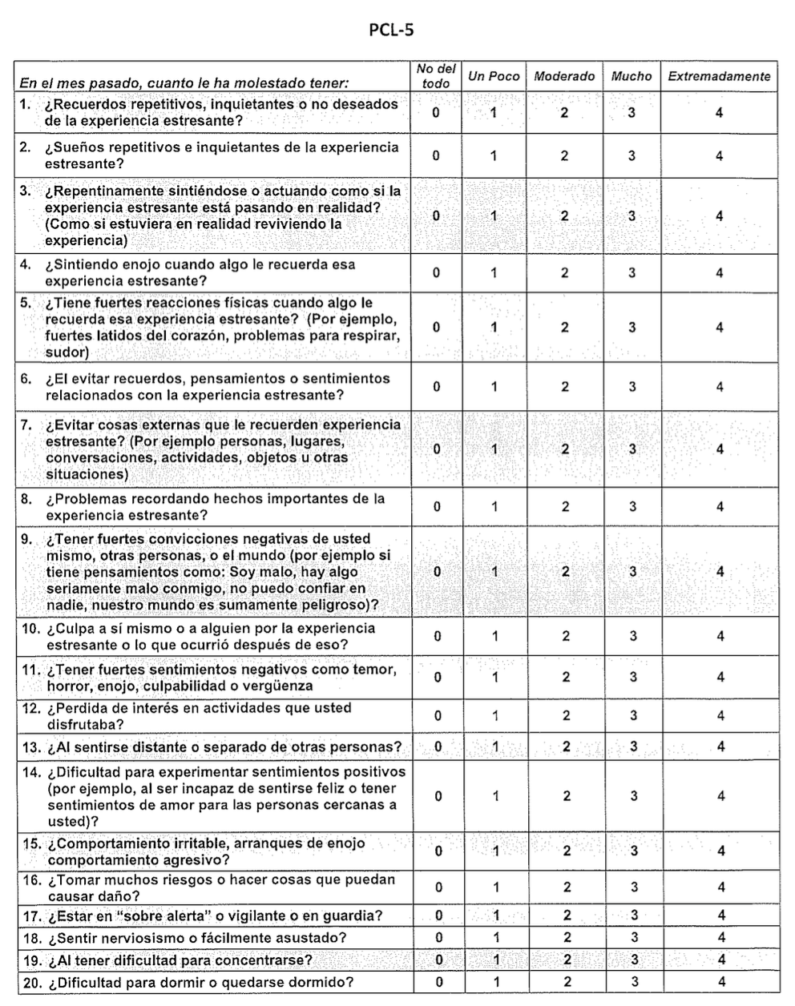
Source: https://riww.org/wp-content/uploads/2019/05/PCL-5-Spanish.pdf
Using the PTSD Checklist for DSM-5 (PCL-5)

The PTSD Checklist for DSM-5 is a 20-item self-report measure that assesses the presence and severity of PTSD symptoms. Items on the PCL-5 correspond with DSM-5 criteria for PTSD. The PCL-5 has a variety of purposes, including:

- Quantifying and monitoring symptoms over time
- Screening individuals for PTSD
- Assisting in making a provisional diagnosis of PTSD

The PCL-5 should not be used as a stand-alone diagnostic tool. When considering a diagnosis, the clinician will still need to use clinical interviewing skills, and a recommended structured interview (e.g., Clinician-Administered PTSD Scale for DSM-5, CAPS-5) to determine a diagnosis.

The PCL-5 is a self-report measure that can be read by respondents themselves or read to them either in person or over the telephone. It can be completed in approximately 5-10 minutes. The preferred administration is for the patient to self-administer the PCL-5.

Respondents are asked to rate how bothered they have been by each of 20 items in the past month on a 5-point Likert scale ranging from 0-4. Items are summed to provide a total severity score (range = 0-80).

0 = Not at all 1 = A little bit 2 = Moderately 3 = Quite a bit 4 = Extremely

The PCL-5 can determine a provisional diagnosis in two ways:

- Summing all 20 items (range 0-80) and using a cut-point score of 31-33 appears to be reasonable based upon current psychometric work. However, when choosing a cutoff score, it is essential to consider the goals of the assessment and the population being assessed. The lower the cutoff score, the more lenient the criteria for inclusion, increasing the possible number of false positives. The higher the cutoff score, the more stringent the inclusion criteria and the more potential for false negatives.
- Treating each item rated as 2 = “Moderately” or higher as a symptom endorsed, then following the DSM-5 diagnostic rule which requires at least: 1 Criterion B item (questions 1-5), 1 Criterion C item (questions 6-7), 2 Criterion D items (questions 8-14), 2 Criterion E items (questions 15-20). In general, use of a cutoff score tends to produce more reliable results than the DSM-5 diagnostic rule.

If a patient meets a provisional diagnosis using either of the methods above, he or she needs further assessment (e.g., CAPS-5) to confirm a diagnosis of PTSD. There are currently no empirically derived severity ranges for the PCL-5.

The entire 4-page instructional pamphlet can be found at:
https://www.ptsd.va.gov/professional/assessment/documents/using-PCL5.pdf

