Oral Hygiene

Bad Breath
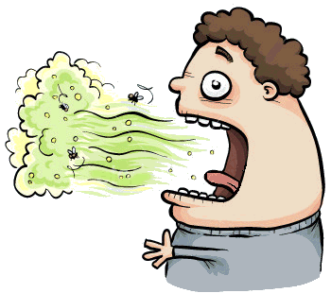
Bad breath is also called halitosis. If you don't brush and floss daily, particles of food can remain in the mouth, collecting bacteria, which can cause bad breath.
Dry mouth occurs when the flow of saliva decreases. Without enough saliva, food particles are not cleaned away and the food starts to rot in your mouth.
Smoking and tobacco can add to bad breath.

Floss
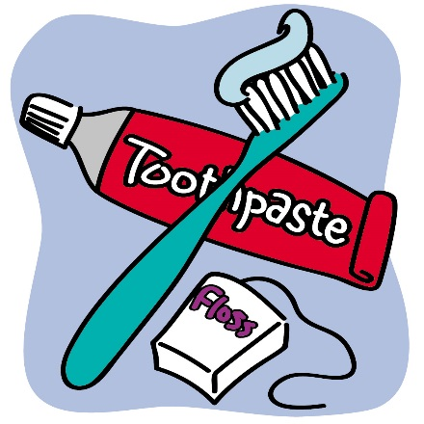
Tooth decay-causing bacteria linger between teeth where toothbrush bristles can’t reach. Floss and interdental cleaners help remove plaque and food particles between the teeth and under the gum line.

Fluoride
Often called, “nature’s cavity fighter,” fluoride helps repair the early stages of tooth decay even before the decay can be seen. Research shows that fluoride makes teeth more resistant to the acid attacks that cause cavities.

Toothbrush
A worn toothbrush will not do a good job of cleaning your teeth and brushing your teeth is an important part of your oral hygiene routine. For a healthy mouth and smile, brush your teeth twice a day with a soft-bristled brush. The size and shape of your brush should fit your mouth allowing you to reach all areas easily.

Teeth and Gums

Tobacco
If you use tobacco, alcohol, or drugs with these symptoms, contact the TEAP Specialist. See the center dentist if have a:
- White or red patch on the inside of mouth
- A mouth sore that does not heal
- Tongue pain
- Unexplained bleeding in the mouth

Tooth bleaching (whitening)
There are several types of teeth bleaching or whitening products. At-home bleaching products contain peroxide-containing whiteners to bleach the tooth enamel. They typically come in a gel and are placed in a mouth guard. There are potential side effects, such as increased sensitivity or gum irritation. Whitening toothpastes have special chemical or polishing agents that provide additional stain removal effectiveness. Unlike bleaches, whitening toothpastes do not change the color of teeth because they can only remove stains on the surface. At Job Corps, basic oral care does not include teeth bleaching.
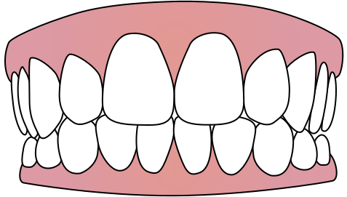

Missing Teeth
Job Corps only replaces missing front teeth.

Wisdom Teeth (third molars)
In Job Corps, these teeth are only removed if they are diseased or students have pain over and over again that cannot be managed by the dentist.

Abscessed Tooth
An abscess is caused by infection when a decayed tooth, gum disease or a crack tooth enable bacteria to enter the pulp (the inside of a tooth that contains nerves, blood vessels and connective tissue) and can lead to pulp death. When pus builds up at the root tip in the jaw bone, it forms a pus-pocket called an abscess. If the abscess is not treated, it can lead to a serious infection in the jaw bone, teeth and surrounding tissues. Symptoms of an abscess include: pain, swelling, gum redness, bad taste in the mouth, and fever.

Oral Disease

Gingivitis
If you have bleeding gums and want it treated, make an appointment with the dental hygienist. The dental hygienist can treat gingivitis but it requires daily brushing and flossing to cure it and prevent it.
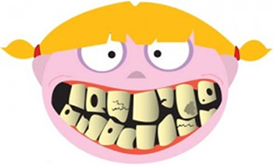

Gum Disease
The early stage of gum disease is called gingivitis. At this stage, the disease is still reversible and can usually be eliminated by a professional cleaning at your dental office, followed by daily brushing and flossing. Otherwise, it will advance to periodontitis. Chronic periodontitis can lead to the loss of tissue and bone that support the teeth and it may become more severe over time. If it does, your teeth will feel loose and start moving around in your mouth. This is the most common form of periodontitis in adults but can occur at any age.

Plaque
When you eat or drink foods containing sugars and cooked starches in processed foods, the bacteria in plaque produces acids that attack tooth enamel. The stickiness of the plaque keeps these acids in contact with your teeth and over time the enamel can break down. This is when cavities form.

Herpes or Herpes Simplex
Herpes Simplex also called “a cold sore,” is caused by the Herpes Simplex virus and is transmitted through oral secretions or sores on the skin, can be spread through kissing or sharing objects such as toothbrushes or eating utensils. A person is contagious from the time the skin turns itchy or red until the sores heal. Sometimes, the virus can even be spread through the saliva of an infected person.

Canker Sore
Canker sores are sores or irritations that can develop in and around the mouth. They are not contagious and may occur as one sore or several. Their exact cause is uncertain, but some experts believe that immune system problems, bacteria or viruses may be involved. In some cases, trauma to the mouth’s soft tissues can cause a canker sore.
Canker sores usually heal on their own after one or two weeks.

Oral Care

Missing Teeth Replacements
Bridges are anchored to teeth adjacent to the missing teeth. They can be removable or fixed by cement. Dentures are removable. Implants are screwed into your jaw. Job Corps only provides dentures to replace missing front teeth.

Dental Insurance
Medicaid is a type of public dental insurance for low-income individuals that may cover dental treatment. Oral health care is a Job Corps benefit for students much like the dental insurance that jobs provide as an employee benefit.

Importance of Seeing a Dentist
Job Corps only covers basic oral care. If dental problems become bigger, they may not be covered by Job Corps and if those problems cannot wait to be treated until the student graduates, the student may need to be Medically Separated with Reinstatement Rights to get it treated. Students must consent to and receive an oral examination before they receive basic oral care. The oral exam is voluntary on the students’ part. Once the student agrees to an oral exam, there is no timeframe during which it must be completed.
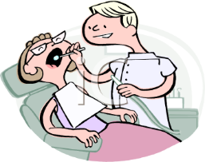

Importance of an oral exam
Job Corps only covers basic oral care. If dental problems become bigger, they may not be covered by Job Corps and if those problems cannot wait to be treated until the student graduates, the student may need to be Medically Separated with Reinstatement Rights to get it treated. Students must consent to and receive an oral examination before they receive basic oral care. The oral exam is voluntary on the students’ part. Once the student agrees to an oral exam, there is no timeframe during which it must be completed.

Basic Oral Care
Students have to consent to and receive an oral exam before they receive treatment. Treatment is based upon the priority classification of their need for care.

Braces (Orthodontics)
Job Corps does not cover braces. Students who have braces are required to keep their appointments with their orthodontists and pay for their braces and transportation.

Diet

Snacks
If you snack choose healthy foods that do not have added sugar or cooked starches. Fruit, vegetables, nuts and cheese are examples of healthy snacks.
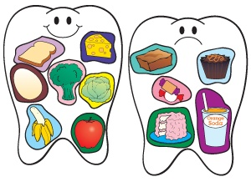

Starch
All starch is not bad; only the starch cooked in processed foods. It is not the amount of cooked starchy foods eaten, but how often you eat them. It is better to eat a bag of potato chips all at the same time than to snack on it.

Healthy Foods
Foods that contain sugars of any kind can contribute to tooth decay. To control the amount of sugar you eat, read the nutrition facts and ingredient labels on foods and beverages and choose options that are lowest in sugar.

