CBT DIAGRAM

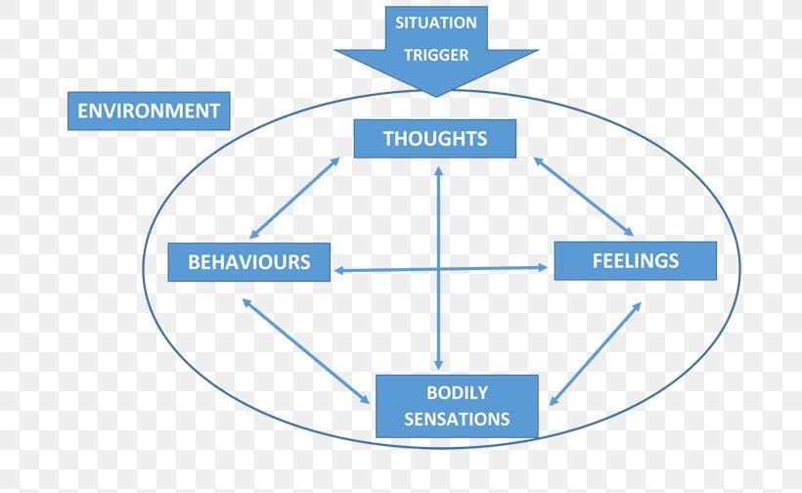

EXPERIENCE





