CIS 3g Wellness Accommodation Access Graphic for Reasonable Accommodation, Reasonable Modification in Policies, Practices, or Procedures, and Auxiliary Aids and Services (RA/RM/AAS)
CIS 3g Wellness and Accommodation Disability Data Collection Entry Screen
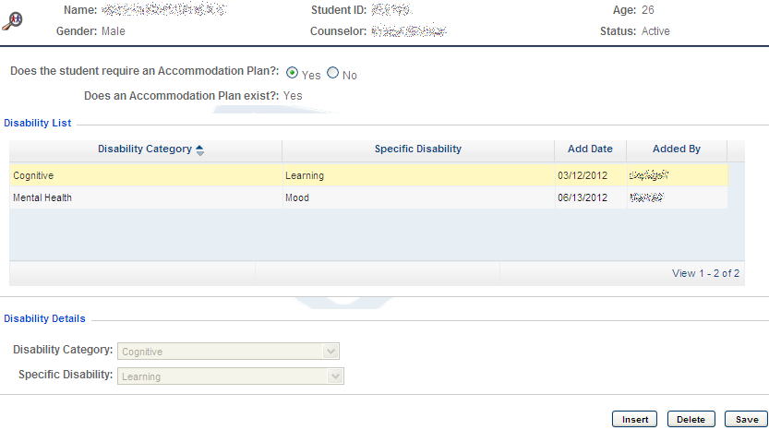
Disability Data Entry Drop-Down Menu
Purpose: Allows Disability Coordinator(s) to enter disability-related data on each student with a disability who enrolls in Job Corps regardless of whether an accommodation plan is requested.
Who Can Access: Only Disability Coordinator(s).
Authorization in CIS: WelAcc - Disability Data Collection, Module: Health & Wellness
CIS 3g Wellness and Accommodation Plan and Notes Entry Screen
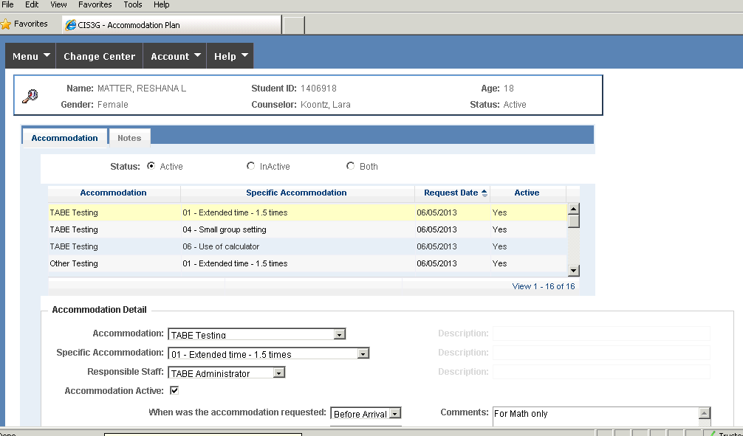
Notes Tab
Purpose: Allows Disability Coordinator and/or designee to document the Disability Accommodation process for students with accommodation plans. Notes should include pre-entry contact information, updates on accommodation effectiveness, Disability Accommodation Committee (DAC) meetings with the student and transition meetings.
Who Can Access: Only Disability Coordinator(s) and/or designee.
Authorization in CIS: WelAcc - Accommodation Plan, Module: Health & Wellness

Accommodation Plan Entry Drop-Down Menu
Purpose: Allows Disability Coordinator and/or designee to enter approved RA/RM/AAS for a student with a disability. Diagnostic information or specifics of the underlying condition must not be included.
Who Can Access: Only Disability Coordinator(s) and/or designee.
Authorization in CIS: WelAcc - Accommodation Plan, Module: Health & Wellness

CIS 3g Wellness and Accommodation Disability Reports
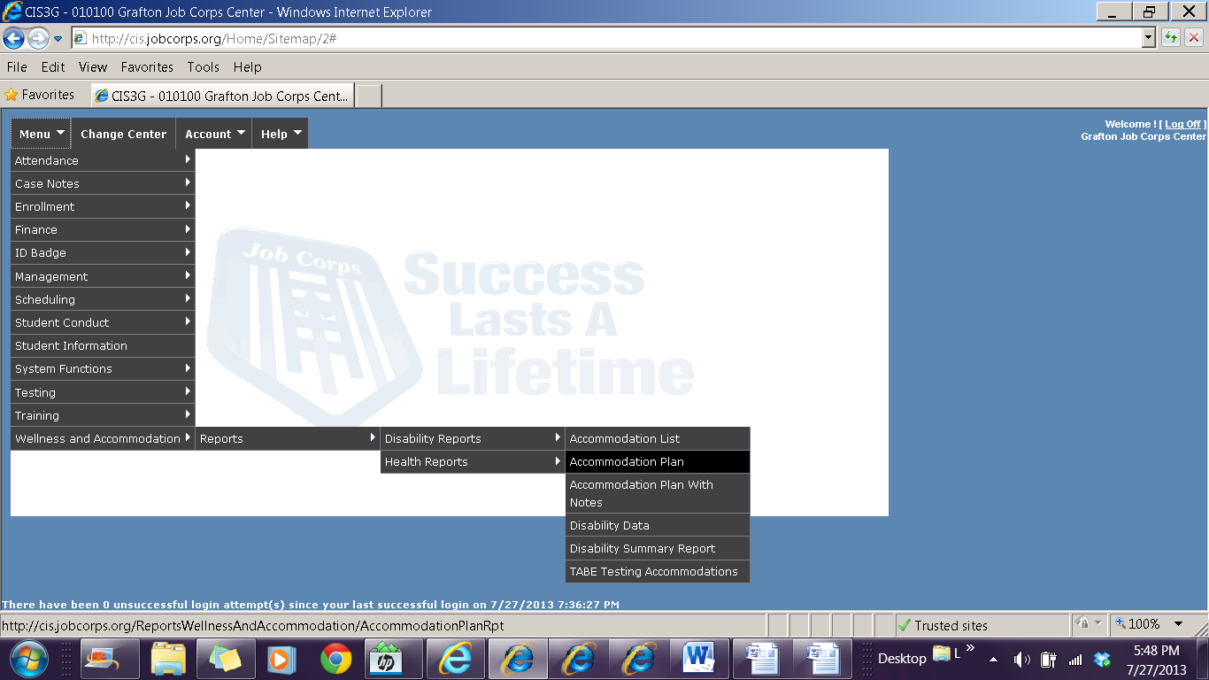
Accommodation Plan with Notes
Purpose: Provides the accommodation plan for individual or multiple students and all the disability accommodation notes.
Who Can Access: Only Disability Coordinator(s)
Authorization in CIS: WelAcc-Rpt - Accommodation Plan with Notes Report, Module: Health & Wellness Rpt
Accommodation Plan Report
Purpose: Provides the accommodation plan for individual or multiple students.
Who Can Access: All center staff.
Authorization in CIS: WelAcc-Rpt - Accommodation Plan Report, Module: Health & Wellness Rpt
Disability Accommodation List Report
Purpose: Provides a list of the dropdown choices for the RA/RM/AAS fields within the accommodation data entry screen. This list is not all-inclusive and “other” RA/RM/AAS may be entered into the accommodation plan screen, as RA/RM/AAS are determined on an individualized basis.
Who Can Access: All center staff.
Authorization in CIS: WelAcc-Rpt - Accommodation List Report, Module: Health & Wellness Rpt
TABE Testing Accommodations Report
Purpose: Provides a list of TABE Testing Accommodations for all students with TABE testing Accommodations on center.
Who Can Access: Only Disability Coordinator(s), and TABE Administrator.
Authorization in CIS: WelAcc-Rpt - TABE Testing Accommodations, Module: Health & Wellness Rpt
Disability Data Report
Purpose: Provides a list of individual or all students with disabilities on center.
Who Can Access: Only Disability Coordinator(s).
Authorization in CIS: WelAcc-Rpt - Disability Data Report, Module: Health & Wellness Rpt

System Functions - Staff Access Authorization Reports
Purpose: Provides the center's POC access to reports to verify that staff have appropriate access to disability-related entry screens and reports.
Who Can Access: Center POC.
CIS3g: System Functions - Reports - Authorizations-Staff
Disability Summary Report
Purpose: Provides summary information about the number of students with a particular disability who have separated from the center. It also provides information on the types of RA/RM/AAS provided. This report is customizable by date.
Who Can Access: All center staff.
Authorization in CIS: WelAcc-Rpt - Disability Summary Report, Module: Health & Wellness Rpt

