Center Applicant File Review Form:
Form 1-06

Health and Wellness Director’s Responsibilities in Applicant File Review (AFR)
The Center Applicant File Review Form is a form that documents the initial applicant file review of the Health and Wellness Director (HWD) and may be found on the Job Corps Disability Support Services Website.
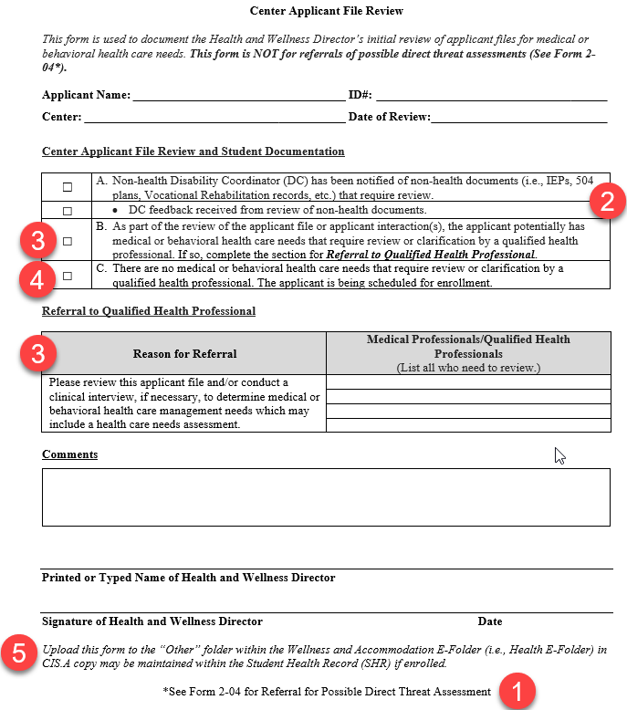
This form from PRH Form 1-06 should be completed for all applicant file reviews UNLESS there is reasonable belief, based on objective evidence, that the individual has a medical condition or disability that may pose a significant risk of substantial harm to the health or safety of others, then the HWD must complete a similar form in Form 2-04 instead. See Item #1 on the form.
Some Center Mental Health Consultants (CMHCs) routinely review these documents. If so, note that the CMHC is reviewing these documents in the comments section of this form. The center may forgo the Non-health DC's review if the CMHC is reviewing; however, the Non-health DC's participation in still encouraged given their background and experience reading these types of documents.
Item #4: Part C – If there are no disclosures of health conditions, concerns about health care needs or concerns about direct threat to others, then the HWD documents the decision to enroll by checking the box here.
Item #5: Storage – Upload the completed form to the “Other” folder within the Health E-Folder in CIS (and a copy may be maintained within the Student Health Record (SHR) if enrolled).
See next page for Center Applicant File Review Form Guidance for Health and Wellness Directors graphic.
Item #3: Part B – If the HWD determines, as part of the review of the applicant file or applicant interaction(s), the applicant potentially has medical or behavioral health care needs that require review or clarification by a qualified health professional, then Part B of the Center File Review Form and the Reason for Referral sections must be completed.
In the Medical Professional/Qualified Health Professionals section, list the name/title of each qualified health professional being assigned review of the file. Ensure that all reviewers are listed if there are multiple disciplinary areas of review needed (i.e., both the CMHC and the TEAP Specialist, for example).

Center Applicant File Review and Applicant Documentation
Item #2: Part A – If there is non-health documentation in the file such as an Individualized Education Program or 504 plan, then the HWD should assign review of those non-health documents to the Non-health or Full -Time DC, as applicable to your center. The Non-health DC must provide written feedback to the HWD. This feedback should be provided promptly so the HWD may determine whether a center qualified health professional also needs to review the information. As a reminder, the center must complete the AFR process within the required 30-day timeframe.
Key points – This is a paper review and does not require any contact with the applicant by the Non-health DC. If one of the center qualified health professionals is completing a Health Care Needs Assessment or a Direct Threat Assessment, then a DC (HWD or Non-health DC or Full Time DC) may be assigned with the responsibility of contacting the applicant to discuss accommodations identified as those that potentially reduce the barriers to enrollment on the assessment. However, DCs should not be contacting applicants to discuss disability accommodations needed to participate in the Job Corps program until the applicant has been cleared for enrollment.
Examples of feedback the Non-health DC might provide:
- Adaptive living skills challenges (self-help and activities of daily living challenges)
- Aggression or assaultive behaviors
- Presence of functional behavior assessments or behavior intervention plans
- Presence of other health plans for medical management purposes

Center Applicant File Review Form Guidance
for Health and Wellness Directors

