Dual Reviews in AFR

Applicant File Review (AFR) Process Overview
When More Than One Qualified Health Professional (QHP) Reviews an Applicant File
Refer to “AFR Snapshot” tool for additional AFR guidance and tips

Health Professionals (QHPs) to conduct a documentation review and potentially, a clinical interview. The members of the FRT determine if a health care needs or a direct threat assessment is necessary or if there is a need to revisit the eligibility factors. The non-health Disability Coordinator (DC) is assigned review of any IEPs/504 plan.
QHPs are selected based on whether there are potential health care needs that exceed basic care and/or direct threat concerns related to their specific areas of expertise, [e.g., substance use (TEAP Specialist), mental health (Center Mental Health Consultant (CMHC)), medical (Center Physician), and oral health (Dentist)]. Each QHP on the FRT is expected to review the documentation in the file, and if needed, conduct an interview with the applicant.
Multiple Conditions/Areas of Concern:
- When there is an applicant file that requires a review in more than one clinical area, the QHP related to the PRIMARY reason that poses the greatest barrier to enrollment should begin the review process.
If a center QHP position is vacant, contact the Regional Health Specialist in that respective area to confirm which QHP should cover in the vacant specialist’s capacity. For example, if the center does not have a TEAP Specialist, contact the Regional TEAP Specialist.
Step 1 – Records Dept. receives file electronically from Outreach and Admissions (OA). File is in “Pending Center Review” status.
Step 2 – Records notifies the HWD that applicant files are ready for review in the Health and Disability E-Folders.
Step 3 – HWD completes initial review of applicant file and documents on Form 1-06, Center Applicant File Review Form (health care needs) or on the corresponding form in Form 2-04 (direct threat).
The HWD completes a review of the "Job Corps Health Questionnaire" (ETA 653) and the medically-related documentation to determine the health care needs of the applicant and whether JC can meet those needs, and if the applicant presents a direct threat to others.
Step 4 – Initial Review Completed.
HWD either informs the Records Dept. that the initial review is complete or completes the date of the initial review on the AFR log.
Cleared for enrollment: The HWD informs Records that the applicant is cleared for enrollment.
Step 5 – Identifying the File Review Team (FRT) (Not cleared for enrollment in the initial review.)
The HWD designates one or more Qualified

Page 1
11
Step 6 – Non-health DC provides written feedback.
The DC provides written feedback to the HWD in a timely manner so the HWD may determine if a QHP needs to review the non-health information (IEP, 504 plan, etc.)/contact the applicant to discuss.

Step 7 – QHP makes an enrollment decision.
After the file review and clinical interview, the members of the FRT also determine if a health care needs assessment (HCNA) (Form 2-05) or a direct threat assessment (DTA) (Form 2-04) is necessary or if there is a need to revisit the eligibility factors. The QHP/s must decide if:
- The applicant’s health care needs exceed those of Job Corps’ basic health care responsibilities as per Exhibit 2-4 and completes Form 2-05.
- The applicant poses a direct threat to others and completes Form 2-04.
- The applicant is cleared for enrollment.
If an HCNA or DTA is not necessary, schedule the applicant for enrollment (also making sure, prior to arrival, to conduct the interactive process to determine disability accommodation needs if the applicant is a person with a disability). (See Form 2-03 for definition of a disability).
Step 8 – Make a recommendation to enroll or recommend denial of enrollment (QHP).
The QHP makes a final decision based upon the findings of the assessment.
Enrolling Applicant
When the PRIMARY clinician has interviewed the applicant and is NOT recommending denial:
- This QHP should document their findings in the SHR (e.g., applicant medical file) to summarize their interview, note their recommendation for enrollment, and document that the file needs additional review by a second clinician/other clinicians.
If the SECONDARY reviewer also is not recommending denial, then both center clinicians document their findings in the Student Health Record (SHR) and the individual is scheduled for enrollment.
Step 9 – If a person with a disability, the QHP completes the Post Assessment.
The QHP (in collaboration with the DC)

Identifies disability accommodations (DA) that potentially reduce the barriers to enrollment, if possible, and documents on the HCNA or DTA. Either the QHP, a DC, or both contact the applicant to discuss DA.
Step 10 – QHP makes final enrollment decision.
The QHP completing the assessment considers if DA would sufficiently reduce/remove the identified barriers to enrollment in their respective area and makes a decision to enroll or recommend denial of enrollment to the Regional Office.
DUAL REVIEWS (One primary area)
If there is a history of multiple areas of concerns (i.e., mental health and medical, for example), and the primary basis for recommending denial will be for mental health and not medical, follow the steps below:
CMHC and Center Physician consult and arrange for the Center Physician to add their review/interview summary and recommendation for enrollment on the assessment (e.g., HCNA or DTA) being completed by the CMHC.
Subsequently, the CMHC who IS recommending denial should make sure that the Center Physician’s review/interview summary and recommendation is included in the completed assessment (e.g., HCNA or DTA). The HWD may write the statement that there are no concerns on behalf of the Center Physician but the statement also must include that the HWD consulted with the Center Physician.
Once complete, the CMHC uploads a completed HCNA or DTA to the respective container in the Health E-Folder.
DUAL REVIEWS (Both are primary)
If the basis for recommending denial is based on mental health AND other clinical concerns such as substance use, the CMHC and the TEAP Specialist must have interviewed the applicant and documented their findings on the assessment; then both must co-sign the assessment.
After the first QHP and second QHP add their respective interviews, assessment responses, and signatures to the assessment, the center uploads the assessment to the respective Health E-Folder is uploaded and ready for their use.

IMPORTANT!
The identification of the file review team (by the HWD) should always include the individuals with the highest level of credential in a particular area of related specialty. For example:
- If the applicant has significant oral health issues, then the Center Dentist should review.
- If there are mental health and TEAP issues, then both the CMHC and the TEAP Specialist should review.

There is a general expectation that when there is an applicant file for dual clinical review, BOTH clinicians will consult with each other and if a recommendation of denial will be submitted for one or both of the conditions, both reviewers will need to document their findings (recommend enrollment or denial) on the HCNA or DTA.

Page 2

Who
to Contact
Contact your Regional Disability Coordinator if you have file review “process” questions.
Contact your Regional HEALTH Specialist
if you have file review “clinical” questions.

IMPORTANT: If two QHPs have been identified to review an applicant file and one of the two is unable to reach the applicant even with the Admission’s Counselor’s assistance, the application should be processed as a withdrawal unless the file is in Regional Review. If the file is in Regional Review, please contact your Regional Disability Coordinator for guidance.
Step 11 – Submit applicant file recommended for denial to the Regional Office for review (HWD).
The center uploads all the acquired documentation, clinical notes, disability accommodation process (DAP) notes, and the assessment (e.g., HCNA OR DTA) to the applicant's respective E-Folder containers.
- The HWD selects the “Notify Regional Review” in the Health E-Folder within the Wellness and Accommodation Container in CIS and selects ONE category that represents the type of recommendation of denial.
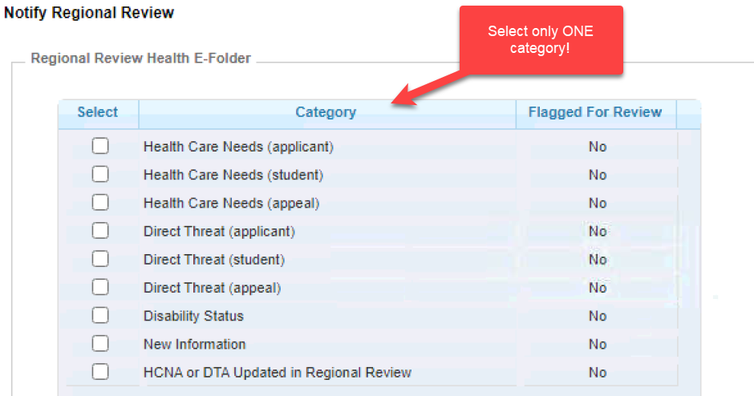
- Then the Records Manager “places” the file into Regional Review status within the “OASIS Pending Arrivals” screen in the Enrollment module in CIS and selects the type of recommendation of denial (health care needs or direct threat).
Signatures
Page 3
Page 3
Page 2
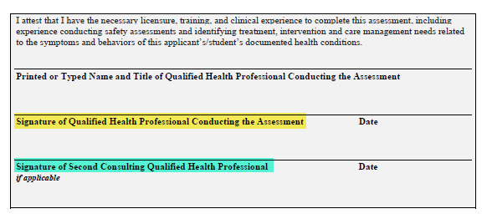
Documenting multiple QHP signatures on the HCNA
Important!

If the center does not have a specific QHP position filled, please consult with the respective Regional Health Specialist as to how to proceed with the applicant file review.

Documentation Example
Documenting multiple QHP file reviews and applicant interview findings on the HCNA
Applicant interview summary: Include current impressions from clinical interview. This may include, but not be limited to, a mini mental status exam, current level of functioning, and areas of strengths and weaknesses.

Applicant interview summary: Include current impressions from clinical interview. This may include, but not be limited to, a mini mental status exam, current level of functioning, and areas of strengths and weaknesses.
CMHC INTERVIEW
The applicant initially reported that he does not have any mental health diagnoses. When asked about the items endorsed on the ETA 653, he stated, “Yeah, I forgot about ADHD. I never took medicine for it, so it was never a problem.” When asked more specific questions, he admitted having difficulties with concentration and sustained attention. When asked about depression, he stated that he was down for a while after he got kicked out of school and when he had to go to juvenile corrections. Applicant denied any SI, HI or AVH. He endorsed the following functional limitations, symptoms, and behaviors and rated how much of a problem they are on a scale of 1-10 with higher numbers indicating greater severity.
If you are completing your first Health Care Needs Assessment with dual QHP reviews, contact your Regional Health Specialist(s) for guidance and/or to request a pre-review of your assessment.
- Have a hard time managing feelings or mood such as anger or depression (rating = 6. “I only get angry if someone makes me angry, like does something to piss me off. But I’m doing better than I used to. The Wellbutrin helps.”)
- Have problems with concentrating or staying focused on something for a period of time (rating = 6, “I can focus on something if I really want to, but I get bored easily.”)
- Have trouble falling or asleep or staying asleep (rating = 8, “Almost every night...Weed helps me wind down.”)

TEAP SPECIALIST INTERVIEW
The applicant stated that he started smoking marijuana at age 13. Before going to juvenile detention in October, he smoked every day after school and said that he helped him to sleep at night. He was forced to quit while he was in detention for 90 days. He got out just before Christmas. Since then, he stated that he has only been smoking about once per week. The TEAP program and Job Corps Zero Tolerance policy was explained to him. He said that he understood and that he would have no problem quitting before coming on center. The applicant’s marijuana use does not represent a significant barrier to enrollment.

Visit the Job Corps Disability and Health Support websites for other File Review Resources! https://supportservices.jobcorps.gov/DISABILITY/Pages/default.aspx
https://supportservices.jobcorps.gov/health/Pages/default.aspx

ttps://supportservices.jobcorps.gov/health/Pages/default.aspx
Page 3

