## Job Corps Chronic Care Management Plan

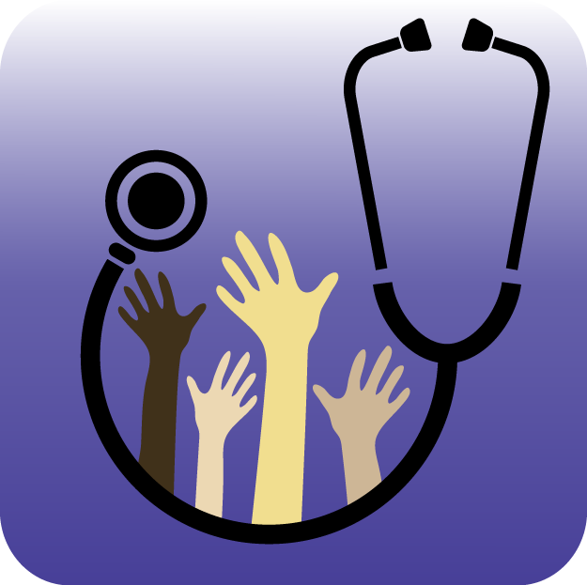

# HYPERTENSION: A FACT SHEET FOR STUDENTS

What is hypertension?

Hypertension means an unhealthy increase in blood pressure. It is a condition that you cannot feel in the early stages, and you will not know you have it unless your blood pressure is measured.

High blood pressure runs in families and is often attributed to one or more of the following:

1. Excess salt and fat in the diet
2. Not getting enough exercise and sleep
3. Excess stress in life
4. Overweight/obesity
5. Tobacco use

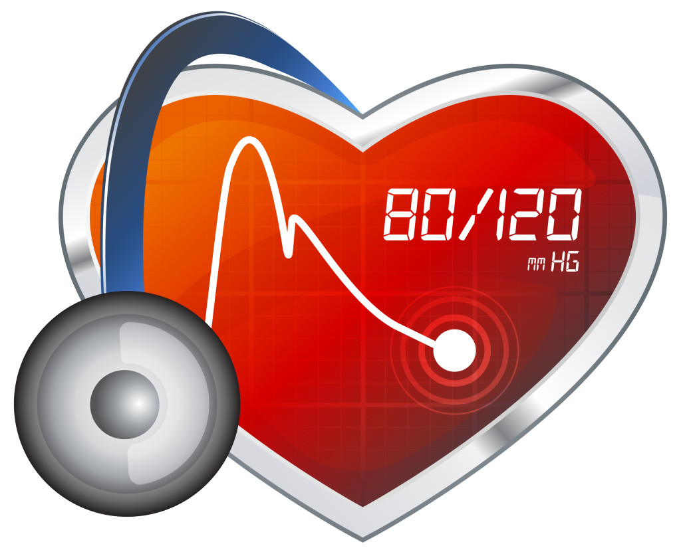

What are the symptoms of hypertension?

Again, early on there are no symptoms with high blood pressure. This is why screening is very important—that means getting your blood measured every three to six months and seeking medical help if blood pressure is high. If your blood pressure is ever high you should check it more often according to the health provider’s recommendation.

What are other problems associated with hypertension?

Although you cannot feel high blood pressure, it is damaging your body. Blood vessel injury is the major problem associated with this health problem. Since blood vessels supply food and oxygen to all parts of our body, our entire body is injured by high blood pressure. The kidneys, heart, brain, and other essential body organs are injured faster and more severely by high blood pressure.

**How can I help myself if I suspect high blood pressure is a problem?**

1. Get blood pressure checked every 3 to 6 months, especially with symptoms or if you have relatives with high blood pressure or heart/kidney disease. You can check your own blood pressure at many drug stores, grocery stores, and other community screening places.
2. Talk with health and wellness center staff about a healthy lifestyle (HEALs Program) and make healthy eating, exercise, sleep, and stress reduction a part of your daily life.
3. See a health professional to determine the need for daily medication if your blood pressure if ever measured as too high.

