## Job Corps Chronic Care Management Plan



# SLEEP APNEA: A FACT SHEET FOR STUDENTS

What is sleep apnea?

If during sleep you stop breathing for more than 10 seconds, you may have sleep apnea. Apnea means to stop breathing. In the beginning you may not be aware of the problem since you are asleep. As the problem gets more severe, you stop breathing for longer periods, 15 or more seconds 20 or more times per hour. You may or may not awaken during more severe episodes.

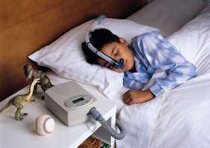

What are the symptoms of sleep apnea?

If you wake up at night snoring, choking, or feeling short of breath, this signals a possible problem with apnea during sleep and warrants getting medical help. If others, such as your roommate or family members observe you snoring, choking, and not breathing while you sleep, you should also get medical help.

Often early on there are no symptoms evident or associated with apnea during sleep since you and others are not awakened or aware of the condition. If you have relatives with sleep problems, you are at greater risk of this problem. Obesity, high blood pressure, and/or large tonsils/adenoids can also be associated with sleep apnea.

What other problems are associated with sleep apnea?

In addition to the problems listed above, morning headaches, dry throat, emotional irritability, fatigue and sluggishness on wakening and during the day, waking often during sleep, feeling like you have not slept, and poor work or school performance are associated with sleep apnea.

How can I help myself if I suspect I have sleep apnea?

If you have any of the problems listed above, go to the health and wellness center to be evaluated. A medical examination is the first step to helping you breathe better.

How can I help others be at less risk for sleep apnea?

If you notice someone snore, choke, and/or stop breathing in their sleep, tell them what you have seen and suggest they get medical help at the health and wellness center or from their primary care physician.

[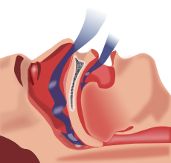](http://en.wikipedia.org/wiki/File:Obstruction_ventilation_apn%C3%A9e_sommeil.svg)