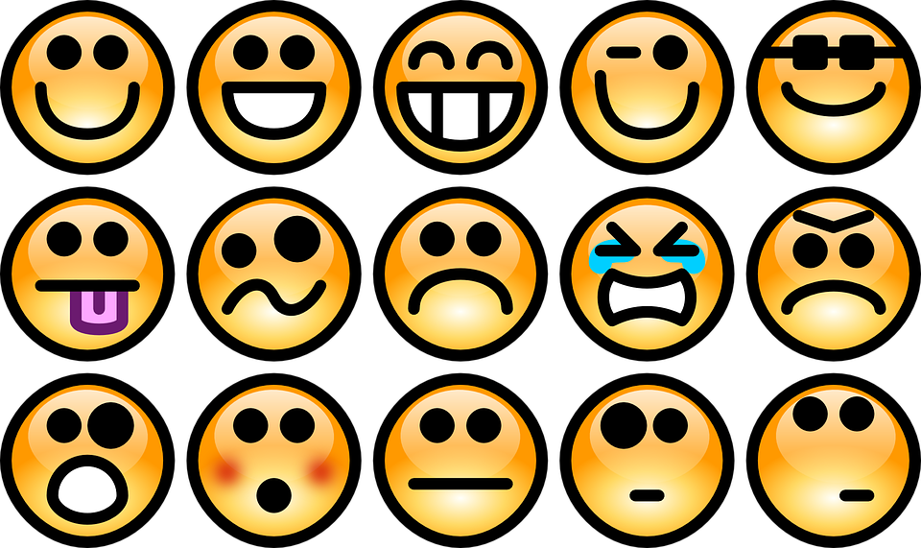

HOW DO I FEEL?

What is the emotion that I am feeling? __________________

Where in my body do I feel the emotion?

________________________________________
________________________________________

Why do I think I feel this way?

______________________________________
______________________________________
______________________________________
______________________________________
______________________________________

How is this emotion trying to help me?

______________________________________
______________________________________
______________________________________
______________________________________

