TREATMENT GUIDELINES FOR HEALTH STAFF

USE OF INTRANASAL NARCAN FOR SUSPECTED OPIOID OVERDOSE
Administer first aid and CPR as indicated. Where permitted by state law, properly trained and authorized center health and non-health staff may administer intranasal naloxone (Narcan) for suspected opioid overdose.

Identifying an overdose

- Suspect if student is unconscious or excessively sleepy and cannot be aroused with a loud voice or sternal rub (a painful stimulus induced by pressing and rubbing the knuckles up and down the victim’s breastbone).
- Suspect if slow or shallow breathing or no breathing. A “death rattle” from respiratory secretions may be mistaken for snoring.

Responding to an overdose

Call 911 immediately and report a suspected drug overdose.

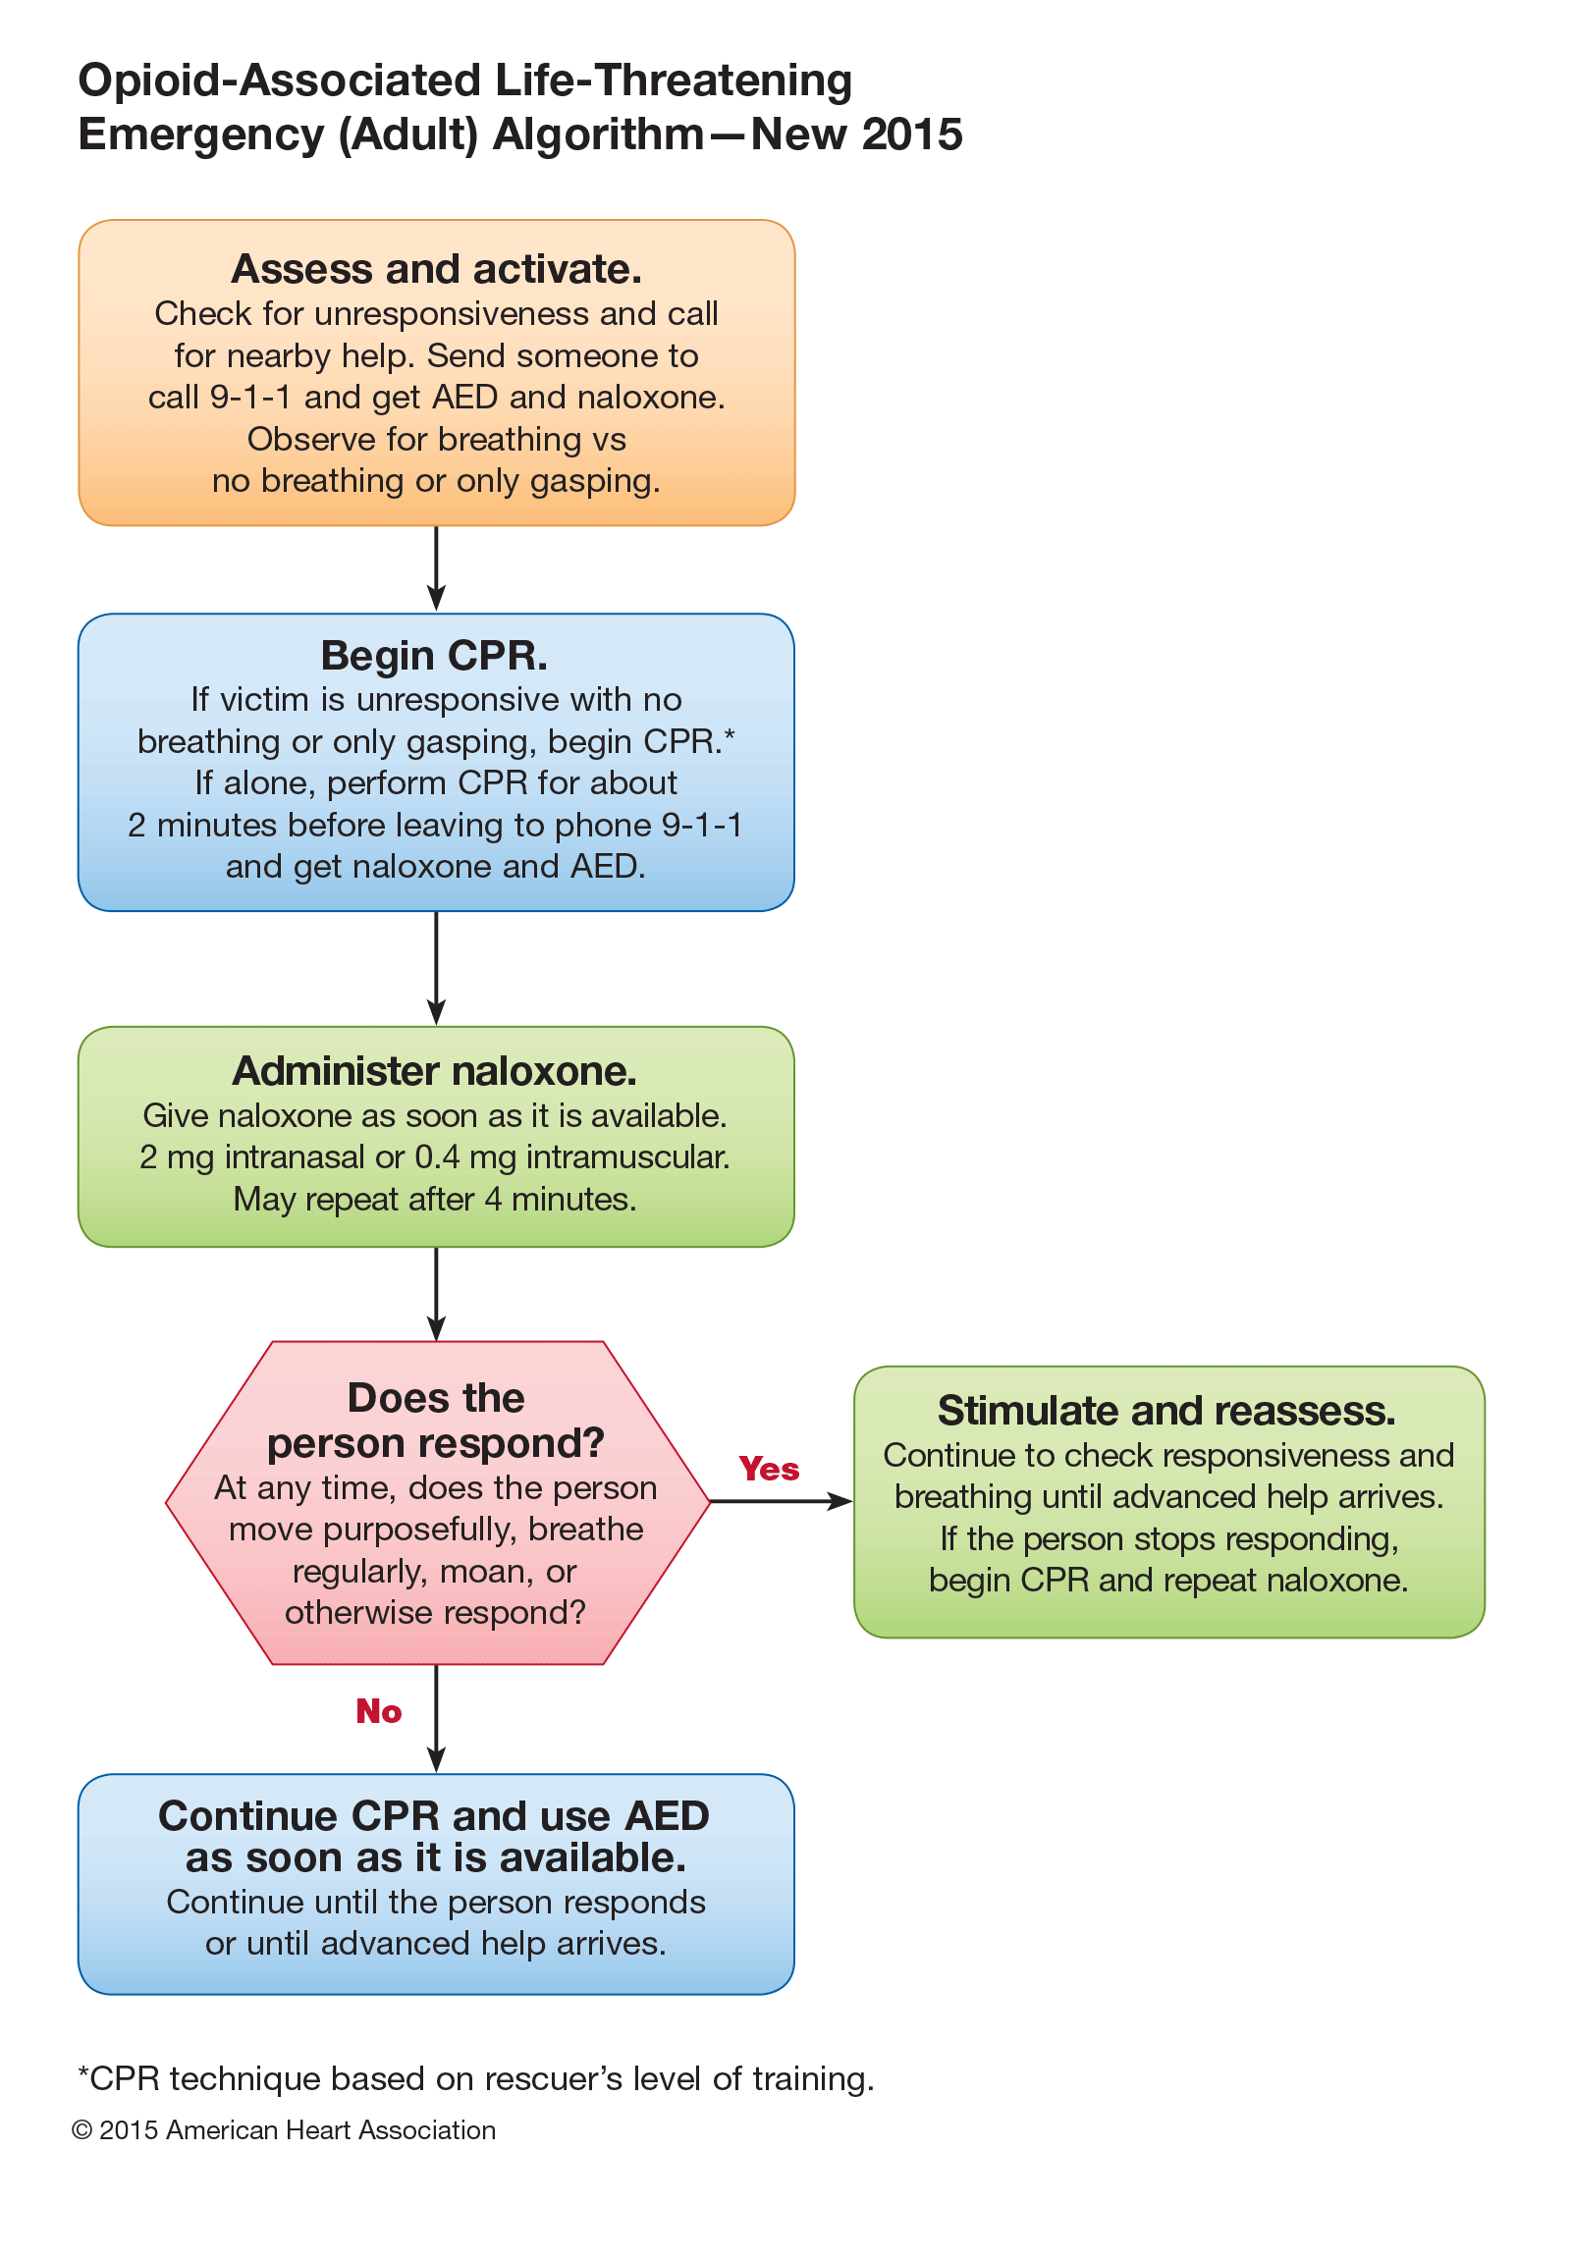
Administer intranasal naloxone (brand name Narcan)

Naloxone is a life-saving, short-acting drug for emergency use in opioid overdose. It should be administered as soon as possible. Naloxone can precipitate opioid withdrawal, but this is not life threatening.

- Using Narcan nasal spray 4 mg in a prepackaged atomizer, depress the plunger to administer a single dose in one nostril only. Do not test or prime the device prior to use. This is easiest formulation for non-health staff to use. May repeat after 4 minutes.

- Using naloxone hydrochloride 1 mg/mL solution (requires preparation by staff at time of use)

- If the person isn’t breathing, do rescue breathing for a few quick breaths first.
- Next, attach the nasal atomizer (the soft white cone) to the needleless syringe and then assemble the glass cartridge of naloxone solution.
- Tilt the person’s head back and spray half of the naloxone up one side of the nose
(1 mL) and half up the other side of the nose (1 mL). Don’t worry if it isn’t exactly half
per side.
- If the person isn’t breathing or breathing continues to be shallow, continue to perform rescue breathing while waiting for the naloxone to take effect or EMS to arrive.
- If there is no change in about 4 minutes, administer another dose of naloxone following the steps above and continue rescue breathing for the person.

If the second dose of naloxone is not effective, then something else is wrong—either it has been too long and the heart has stopped, there are no opioids present, non-opioid drugs are the primary cause of the overdose (even if opioids were also taken), or the opioids are unusually strong and require even more naloxone (as with Fentanyl, for example).

If naloxone is mistakenly administered, no adverse effects will occur in a healthy individual. Naloxone does not alter mental status, produce tolerance or cause physical or psychological dependence. When administered in usual doses in the absence of opioids, naloxone exhibits essentially no pharmacologic activity.

Do not give the victim anything to drink. Do not induce vomiting. Do not put the victim in a bath. Do not apply ice to the victim. Do not try to stimulate the victim in a way that could cause harm, such as slapping, kicking, or burning.

WHEN TO REFER TO THE CENTER PHYSICIAN

- The center physician should be informed of all suspected drug overdose events, but notification should not delay treatment.

