TREATMENT GUIDELINES FOR HEALTH STAFF
BIPOLAR DISORDERS

Common Symptoms of Mania Associated with Bipolar Disorder
- Increased energy or activity
- Irritability or agitation
- Inability to sleep for 2 to 3 days
- Hyper-verbal (excessive talking) or pressured/rapid speech
- Grandiosity (unrealistic thoughts of superiority and invulnerability)
- Euphoria (intense happiness and excitement)
- Racing thoughts or difficulty focusing
- Delusions or hallucinations
- Hypersexuality/promiscuity
- Increased use of alcohol or illicit substances
Authorized health and wellness staff may treat symptoms and associated features of Bipolar Disorder as follows:

WHAT TO DO FIRST
- If the student is agitated or their behavior cannot be managed safely due to the severity of symptoms (e.g., mania poses a risk of harm to self/others), take steps to ensure your safety and the student’s safety. For example, make sure that others are around, that you have access to a telephone, and that you can exit the room or area if needed. Do not leave the student unsupervised. If you must put some physical distance between you and the student, always keep an eye on the student. Contact center security for assistance or follow your center operating procedure (COP) for Mental Health Emergencies. Alert HWD about the situation, if needed.
- If the student with manic symptoms is not agitated and their behavior is not a safety threat, encourage the student to join you in a private, supportive space where they can talk about their feelings and concerns. Mania can be accompanied by unpredictable behavior so you should continue to use precaution to ensure your and the student’s safety.
- If the student is not willing to talk and participate in an assessment, offer them a safe, comfortable space where they can relax. Do not leave the student alone.
- If the student is rambling and difficult to understand, avoid asking too many questions. Instead, listen and note any information that might give insight into what might have led up to the episode.

ASSESS SYMPTOMS AND BEHAVIORS
- Listen to the student non-judgmentally and with empathy and genuine concern.
- Give the student as much personal space and sense of control as possible.
- Allow the student to express their current feelings and concerns. Acknowledge the student’s feelings. For example, “That must be hard for you” or “I can see how that can be upsetting/frustrating.
- Speak clearly and use short sentences in a calm and reassuring tone of voice. Do not overwhelm the student with words as this will likely cause the student to become more stressed and anxious.
- If student’s concerns seem irrational, do not argue, or attempt to reason with the student. Instead, use active listening so that the student feels heard.
- If the student does not start talking right away or you need to focus the student, ask “What’s going on with you right now? What’s making you feel this way?”
- If the student is not able to describe why they are feeling the way they are, consider asking the following 2 questions, as appropriate:
- “Have you recently had any energy drinks or drinks with a lot of caffeine?” If the student answers “yes,” ask about the names of the drinks, how much the student drank and how much they usually consume. If the student reports, or is suspected of, having consumed energy drinks in excess, involve the Center Physician (CP).
- Ask “Have you recently taken any of your own medications or someone else’s prescription medications?” If the student answers “yes,” ask about the names of the medications, the number of pills/capsules they took, and what time they were taken. If the student reports, or is suspected of, mis-using their own or someone else’s medications, involve the Center Physician (CP).
- If you have concerns about alcohol/drug use, ask “Have you recently used any alcohol or drugs?” If the student answers “yes,” ask about the types of alcohol or drugs and how much and what time the substances were consumed. If the student reports, or is suspected of, having used a substance, involve the TEAP Specialist, if possible, and/or follow Alcohol or Drug Use Behavior Treatment Guideline.
- If there are any concerns about self-harm or suicide, assess for thoughts of self-harm by asking:
- "Sometimes people feel that life is not worth living. How are you feeling about living right now?" [wait]
- "Have you ever thought of harming yourself or trying to end your own life?”
- If student answers “yes,” ask "Are you feeling that way now?"
- If self-harm thoughts are present or questionable, follow the Suicidal Self-Directed Violence Treatment Guideline (“What to Do Next”). Do not leave student alone.
- If the student’s behavior does not pose a safety threat and the student is not willing to participate in the assessment, ask the student if they would like to speak to the Center Mental Health Consultant (CMHC) (if available) or if there is a trusted staff member who can provide support, then determine if that person is available to come assist.
- Determine whether the student is having delusions (odd or unusual thoughts that are not based in reality) or hallucinations (sensory experiences—usually visual or auditory— that also are not based in reality). If hallucinations or delusions are present, follow Psychotic Disorders Treatment Guideline.
- After the acute distress has been addressed, discuss with the student how a referral to the CMHC could be helpful to develop strategies for managing their mood and stress better.

WHAT TO DO NEXT
- If assistance is needed to determine whether an emergency psychiatric evaluation is warranted, contact the CMHC and/or CP for consultation.
- Students who have difficulty coping with bipolar/manic symptoms should be encouraged to meet with the CMHC, so that the CMHC can determine whether an evaluation and/or treatment such as brief therapy and/or medication would be helpful.
- Students who express an interest in starting medication to assist with depression/bipolar symptoms should be referred to the CMHC for assessment and the CP for follow-up.
- If the student is willing to meet with the CMHC or CP, consider asking them to complete a mood screening measure, such as the Mood Disorders Questionnaire (MDQ) (MDQ in Spanish), which can be found on the following pages. Make sure the completed screener is then attached to the CMHC referral form, so the CMHC can score and interpret it.
- If the student is already in treatment for a bipolar disorder, determine whether the student has been adherent with medications and/or therapeutic interventions. Consider how to address any issues of non-adherence.
- If the student does not want to meet with the CMHC, it is recommended that health and wellness staff alert the CMHC so the student can be discussed at the next case management meeting and help identify ways for the counselor to support the student. The counselor can refer the student to the CMHC in the future, if needed.
- If the student has received treatment for a bipolar disorder in the past, consider obtaining a signed Authorization for Release of Information from the student (or, if minor, parent/guardian) so that prior treatment records can be obtained and reviewed.

NAME: | DATE:
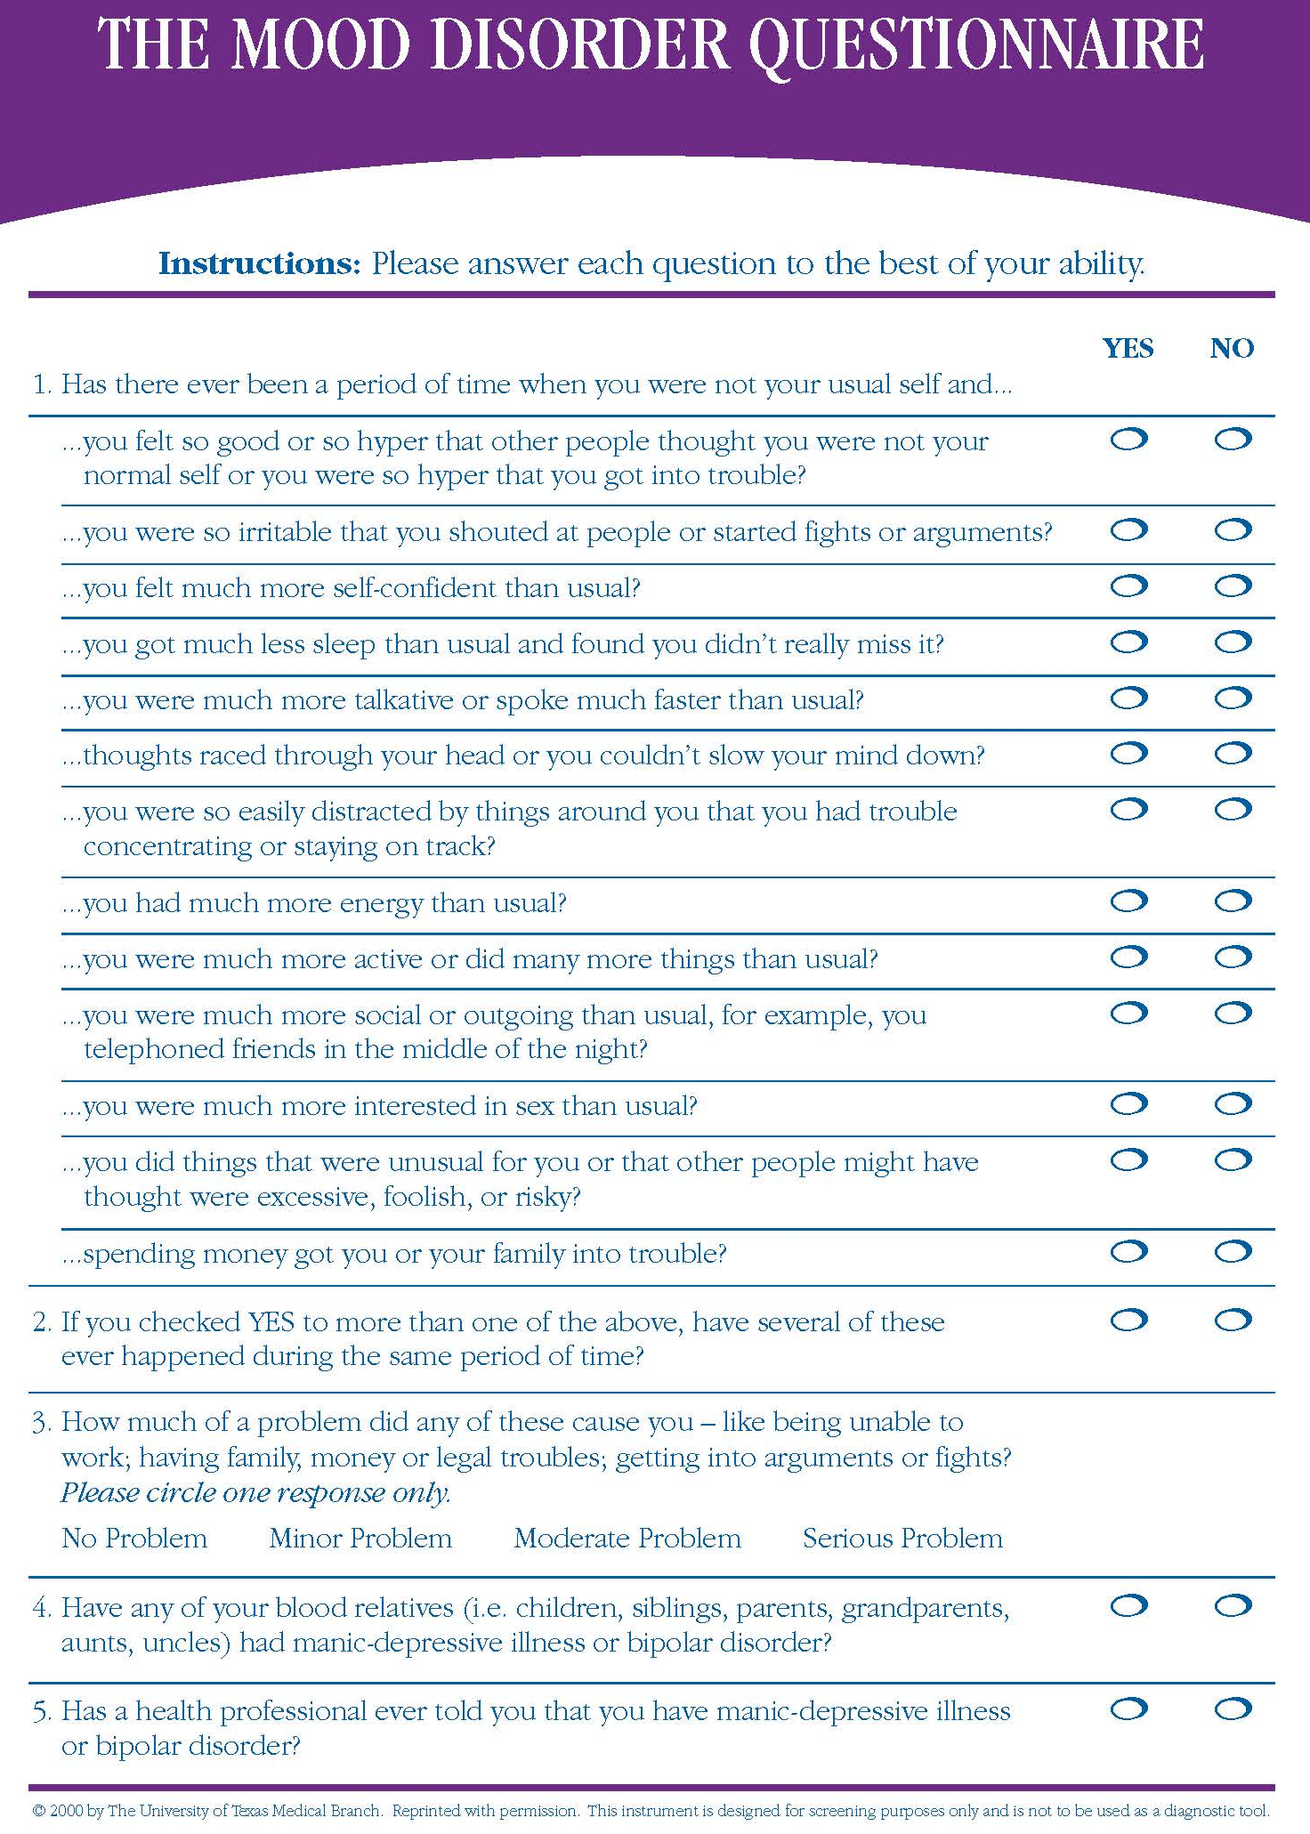
Source: https://www.sadag.org/images/pdf/mdq.pdf

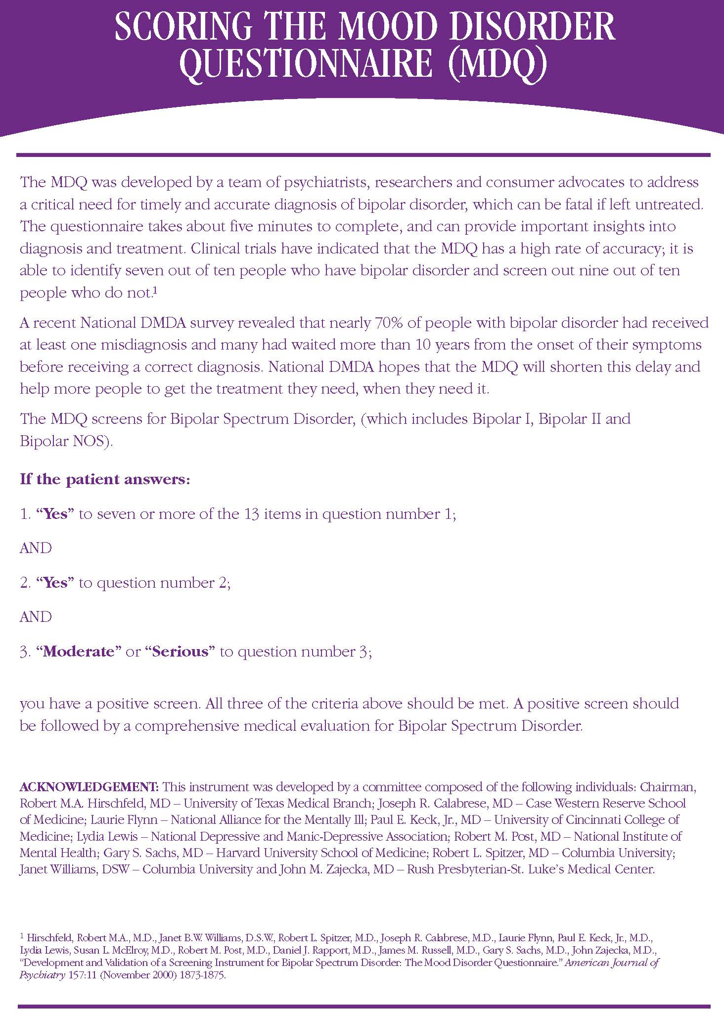
Source: https://www.sadag.org/images/pdf/mdq.pdf
NOMBRE: | FECHA:
Cuestionario de Trastornos del Humor
(Mood Disorder Questionnaire, MDQ)

Source: https://psychiatry.vegas/wp-content/uploads/2016/05/Spanish-MDQ.pdf

