TREATMENT GUIDELINES FOR HEALTH STAFF
Depression DISORDERS
COMMON SYMPTOMS OF DEPRESSION
- Suicidal thoughts or intent
- Depressed mood, irritability and/or crying
- Feelings of hopelessness, helplessness, or inappropriate guilt
- Lack of pleasure in usual activities (anhedonia) feelings of boredom
- Changes in appetite, weight, or sleep (increased or decreased)
- Decreased energy
- Restlessness or agitation
- Difficulty concentrating or making decisions
- Thoughts of death, not related to suicide
- Use of drugs or other substances
Authorized health and wellness staff may treat students with depression as follows:

WHAT TO DO FIRST
- Provide a private, supportive space where the student will feel safe to talk about their feelings and concerns.
- Start by saying to the student: “I know it might be difficult, but I will need to ask some questions about how you are feeling.”
- If the student is tearful, provide tissues. Avoid saying “Calm down” or “Stop crying” or offering empty words of reassurance like “It’s not that bad.” Instead say: “I’m here to help.”
- During active crying episodes, consider refraining from speaking to allow the student to express their emotions. Talking just to fill the silence or because you are feeling uncomfortable is often not helpful.
- Try to help the student identify what is happening. For example, “It looks like you’re feeling upset” or “I can see you’re having a hard time right now.” This can help the student calm down and regain a sense of control.

ASSESS SYMPTOMS AND BEHAVIORS
- Listen non-judgmentally and with empathy and genuine concern.
- Allow the student to express their current feelings and concerns. Acknowledge the student’s feelings. For example, “This must be hard for you” or “I can see how that could be upsetting.”
- Speak clearly and use short sentences in a calm and reassuring tone of voice. Do not overwhelm the student with words as this will likely cause the student to become more stressed and anxious.
- Avoid giving advice, lecturing, or trying to “fix” the situation. Listening in an attentive way is the most helpful thing you can do to comfort a student.
- If the student does not start talking right away, ask “What’s going on with you right now? What’s making you feel this way?”
- Ask “On a scale of 1 to 10, where 10 is the worst, how would you rate your [sad, hopeless, etc.] feelings right now?”
- Help the student explore what may have triggered the current feelings, such as the break-up of a relationship, conflict with others, loss of a loved one, or problems at home. Acute symptoms of depression can often be alleviated in the short-term by talking about thoughts and feelings.
- If the student’s concerns appear to be irrational, do not argue or attempt to reason with the student. Instead, focus on listening in an attentive manner so that the student feels heard.
- If the student is not able to describe why they are feeling or reacting the way they are, consider asking the following 2 questions, if appropriate:
- Ask “Have you recently taken any of your own medications or someone else’s prescription medications?” If the student answers “yes,” ask about the names of the medications, the number of pills/capsules, and what time they were taken. If the student reports, or is suspected of, mis-using their own or someone else’s medications, involve the Center Physician (CP).
- If there are concerns about alcohol/drug use, ask “Have you recently used any alcohol or drugs?” If the student answers “yes,” ask about the types of alcohol or drugs and how much and what time the substances were consumed. If the student reports, or is suspected of, having used a substance, involve the TEAP specialist, is possible, and/or follow Alcohol or Drug Use Behavior Treatment Guideline.
- If there are any concerns about self-harm or suicide, assess for thoughts of self-harm by saying:
- "Sometimes people feel that life is not worth living. How are you feeling about living right now?" [wait]
- "Have you ever thought of harming yourself or trying to end your own life?
- If student answers “yes,” ask "Are you feeling that way now?"
- If self-harm thoughts are present or questionable, follow the Suicidal Self-Directed Violence Treatment Guideline (“What to Do Next”). Do not leave the student alone.
- If the student is not willing to participate in the assessment, ask the student if they would like to speak to the Center Mental Health Consultant (CMHC) (if available) or if there is a trusted staff member who can provide support, then determine if that person is available to come assist.
- Determine whether the student is having delusions (odd or unusual thoughts that are not based in reality) or hallucinations (sensory experiences—usually visual or auditory— that also are not based in reality). If hallucinations or delusions are present, follow the Psychotic Disorders Treatment Guideline.

WHAT TO DO NEXT
- If assistance is needed to determine whether an emergency psychiatric evaluation is warranted, contact the CMHC and/or CP for consultation.
- Students who have difficulty coping with depression symptoms should be encouraged to meet with the CMHC, so that the CMHC can determine whether an evaluation and/or treatment such as brief therapy and/or medication would be helpful.
- If the student is already in treatment for depression, determine whether the student has been adherent with medications and/or therapeutic interventions. Consider how to address any issues of non-adherence.
- Students who express an interest in starting medication to assist with depression symptoms should be referred to the CMHC for assessment and the CP for follow-up.
- If the student is willing to meet with the CMHC or CP, consider asking them to complete a depression screening measure, such as the Patient Health Questionnaire-9 (PHQ-9) (PHQ-9 Spanish), the PHQ-A for Adolescents (ages 16-17) (PHQ-A in Spanish), which can be found on the following pages. Make sure the completed screener is then attached to the CMHC referral form, so the CMHC can score and interpret it.
- If the student does not want to meet with the CMHC, it is recommended that health and wellness staff alert the CMHC so that the student can be discussed at the next case management meeting and help identify ways for the counselor to support the student. The counselor can refer the student to the CMHC in the future, if needed.
- If the student has received treatment for depression in the past, consider obtaining a signed Authorization for Release of Information from the student (or, if minor, parent/guardian) so that prior treatment records can be obtained and reviewed.

NAME: | DATE:
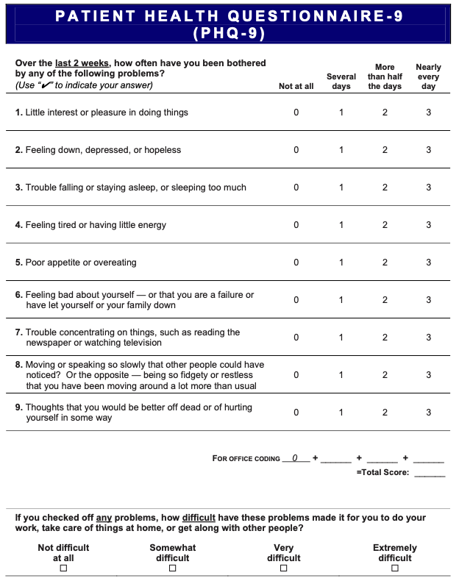
Developed by Drs. Robert L. Spitzer, Janet B. W. Williams, Kurt Kroenke and colleagues with an educational grant from Pfizer Inc. No permission required to reproduce, translate, display or distribute.
Source: Patient Health Questionnaire – Patient Health Questionnaire – 9 (PHQ-9)
NOMBRE: | FECHA:
Elaborado por lo doctors Robert L. Spitzer, Janet B. W. William, Kurt Kroenke y colegas, mediante una subvención educativa otorgada por Pfizer Inc. No se require permiso para reproducir, traducir, presentar or distribuir.
Source: Patient Health Questionnaire – CUESTIONARIO SOBRE LA SALUD DEL PACIENTE-9 (PHQ-9)

PHQ-9 Patient Depression Questionnaire: Scoring and Interpretation
For initial diagnosis:
- Patient completes PHQ-9 Quick Depression Assessment.
- If there are at least four 3s in the shaded section (including Questions #1 and #2), consider a depressive disorder. Add score to determine severity.
Consider Major Depressive Disorder
- If there are at least five 3s in the shaded section (one of which corresponds to Question #1 or #2)
Consider Other Depressive Disorder
- If there are 2-4 3s in the shaded section (one of which corresponds to Question #1 or #2)
Note: Since the questionnaire relies on patient self-report, all responses should be verified by the clinician, and a definitive diagnosis is made on clinical grounds considering how well the patient understood the questionnaire, as well as other relevant information from the patient.
Diagnoses of Major Depressive Disorder or Other Depressive Disorder also require impairment of social, occupational, or other important areas of functioning (Question #10) and ruling out normal bereavement, a history of a Manic Episode (Bipolar Disorder), and a physical disorder, medication, or other drug as the biological cause of the depressive symptoms.
To monitor severity over time for newly diagnosed patients or patients in current treatment for depression:
- Patients may complete questionnaires at baseline and at regular intervals (e.g., every 2 weeks) at home and bring them in at their next appointment for scoring or they may complete the questionnaire during each scheduled appointment.
- Add up 3s by column. For every 3: Several days = 1, More than half the days = 2, Nearly every day = 3
- Add together column scores to get a TOTAL score.
- Refer to the accompanying PHQ-9 Scoring Box to interpret the TOTAL score.
- Results may be included in patient files to assist you in setting up a treatment goal, determining degree of response, as well as guiding treatment intervention.
Interpretation of Total Score
TOTAL SCORE | 1-4 | 5-9 | 10-14 | 15-19 | 20-27
DEPRESSION SEVERITY | Minimal depression | Mild depression | Moderate depression | Moderately severe depression | Severe depression
Developed by Drs. Robert L. Spitzer, Janet B. W. Williams, Kurt Kroenke and colleagues with an educational grant from Pfizer Inc. No permission required to reproduce, translate, display or distribute.

Source: Instruction Manual Instructions for Patient Health Questionnaire (PHQ) and GAD-7 Measures
NAME: | DATE:
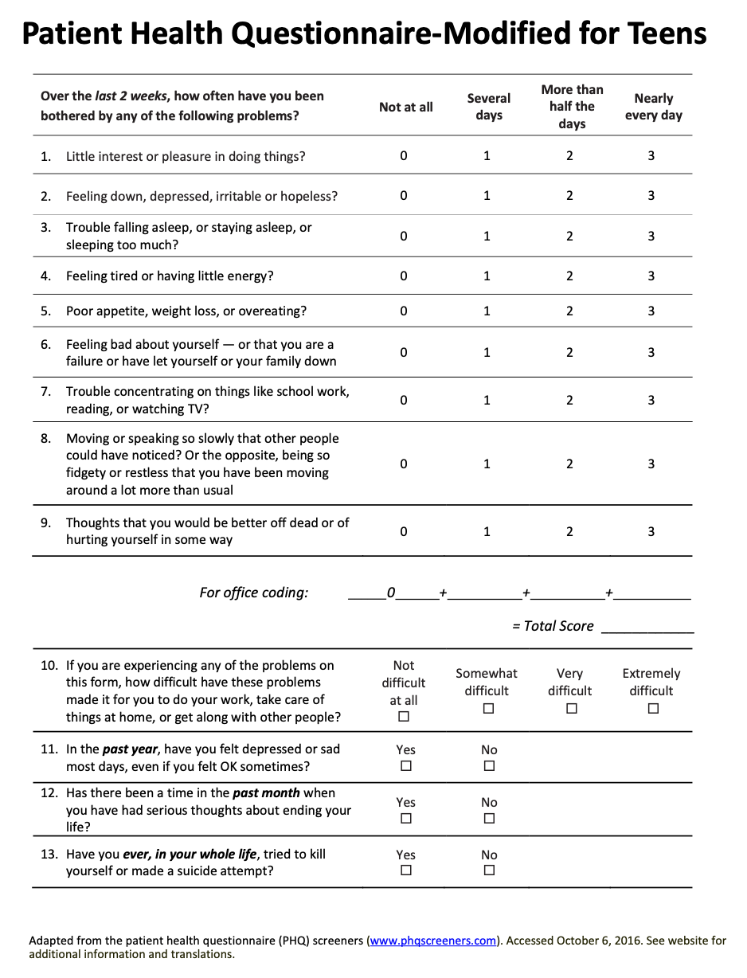
Source: HRSA's AIDS Education and Training Center (AETC) Program Patient Health Questionnaire‐Modified for Teens (Adapted from the patient health questionnaire (PHQ) screeners (www.phqscreeners.com).

NOMBRE: | FECHA:
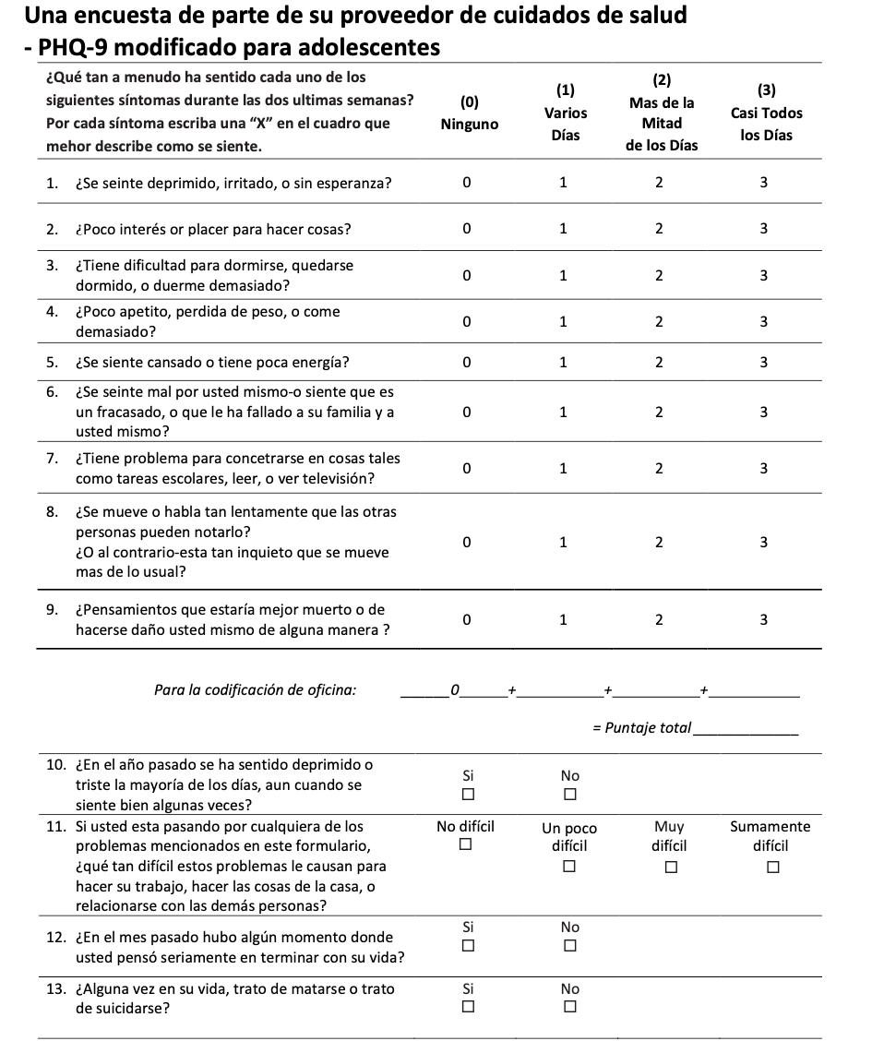
Source: HRSA's AIDS Education and Training Center (AETC) Program Una encuesta de parte de su proveedor de cuidados de salud - PHQ-9 modificado para adolescentes (Adapted from the patient health questionnaire (PHQ) screeners (www.phqscreeners.com).

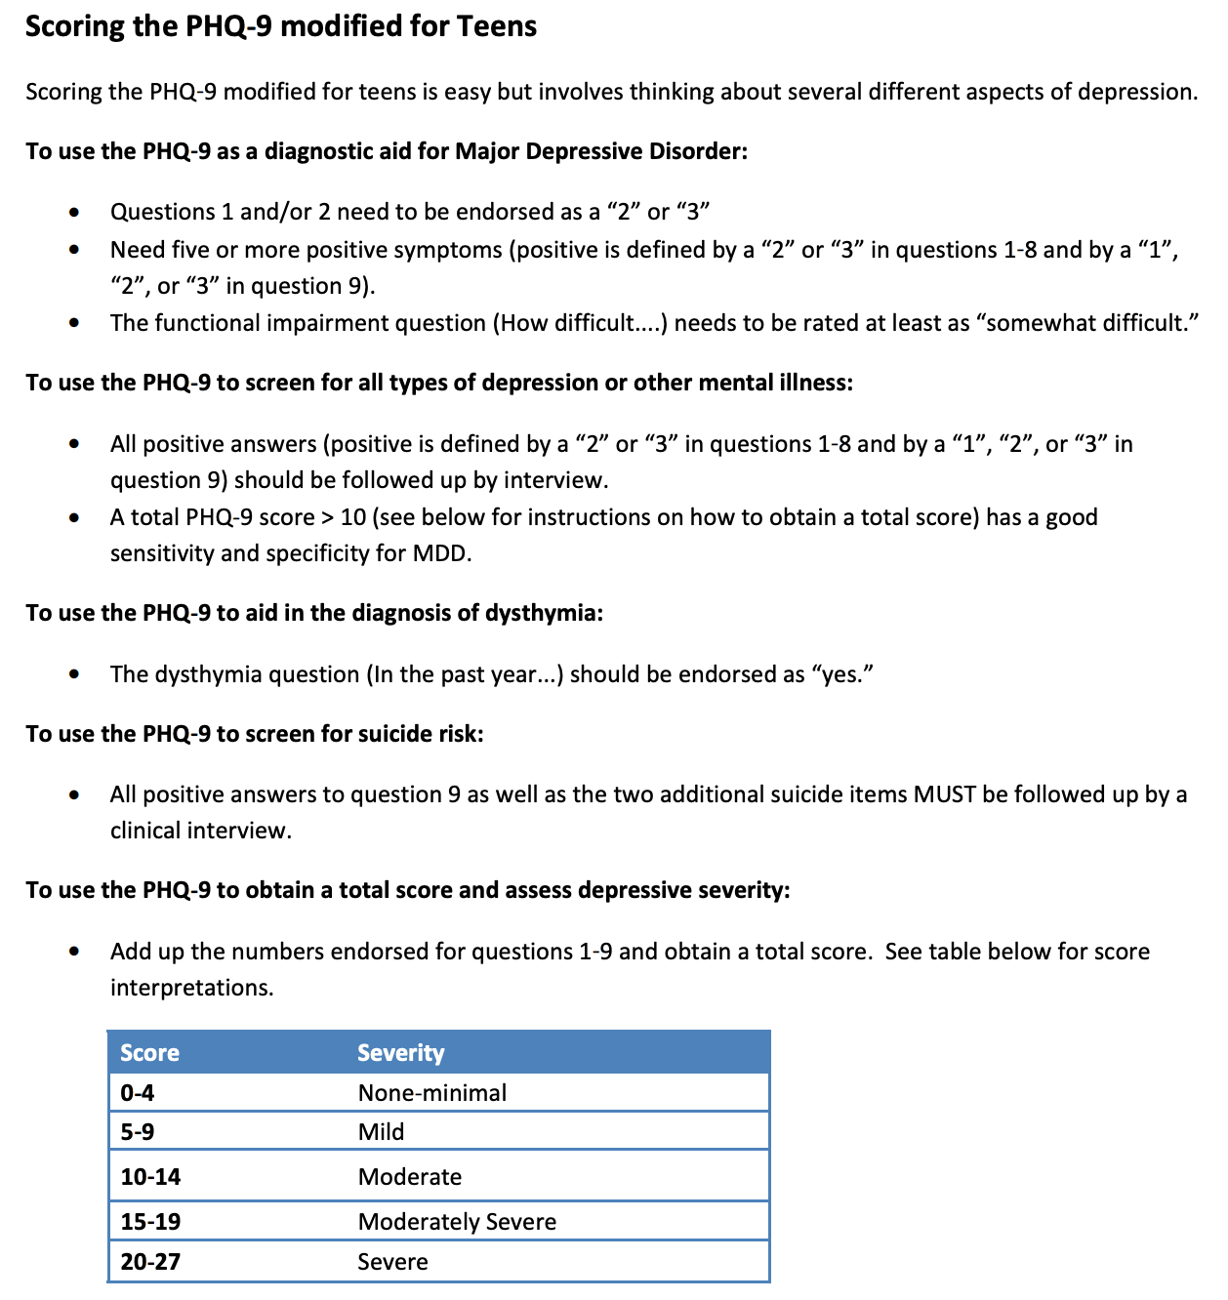

Source: HRSA's AIDS Education and Training Center (AETC) Program Patient Health Questionnaire‐Modified for Teens (Adapted from the patient health questionnaire (PHQ) screeners (www.phqscreeners.com).

